Sem-6 BLOSEM SALON SYSTEM

**1.INTRODUCTION**

* + Visiting a salon or spa without a prior appointment can keep you waiting in a queue and will take a lot of your precious time.
  + To solve this, we have developed an advanced online salon & spa booking system using python that can help the users to book an appointment in their favourite salon or spa.
  + The users can easily access the system by registering themselves on the website. The system will provide information on nearby salons/spas & their services.
  + The users can view the salons' facility, services & hair stylists' reviews, and based on that they can choose the best salon with the beautician or hairstylists suited for them and book an appointment as per their desired time & date.
  + The users can also purchase various beauty-related products online. The system will also allow the users to drop their feedback as well.

Sem-6 BLOSEM SALON SYSTEM

**2.COMPANY PROFILE**

Sem-6 BLOSEM SALON SYSTEM



* **Company name: Desire Infotech**
* **Address:** 707,7th Floor, Abhishek Complex, Sector 11, Gandhinagar
* **Contact NO:** 9574180345
* **E-mail:** [contact@desireinfotech.biz](mailto:contact@desireinfotech.biz)
* **Url:** [www.desireinfotech.biz](http://www.desireinfotech.biz/)

Sem-6 BLOSEM SALON SYSTEM

**3.PROJECT PROFILE**

Sem-6 BLOSEM SALON SYSTEM

**3.1 BLOSEM SALON SYSTEM**

* + - * + There is no existing system in Blosem salon system.
        + Can't manage old customers data, due to lack of web application or any other software.
        + During peak season difficult to manage billing.
        + No proper presence online.
        + Can not take order's online.

Sem-6 BLOSEM SALON SYSTEM

**3.2 Propose system**

* + In this system User can easily book saloon service.
  + This is a user-friendly application.
  + User can do online payment in our website.
  + This salon system is time efficient.
  + Customer data management will become easier.
  + Easy to manage billing during peak season.
  + Can create strong online availability.
  + Can take online orders.

Sem-6 BLOSEM SALON SYSTEM

**3.3 Devlopment Tools & Technology :**

* Project name: Blosem salon system
* Platform: Application
* Front end: Html5,Css3,Python
* Back end: Mysql 8.0.32
* Supporting Tools**:** Vs code version 1.72.2

Sem-6 BLOSEM SALON SYSTEM

**3.4 MODULES**

* + - * + **Admin**
        + **Client**

Sem-6 BLOSEM SALON SYSTEM

**3.4.1 Admin :**

* Login
* Mange salon owner
* View categories
* View Client
* View Appointment
* View Product
* View Payment
* View Review

Sem-6 BLOSEM SALON SYSTEM

**3.4.2Client :**

* Registration
* Login
* Manage profile
* View services
* Book/ Cancel Appointment

* Book / Cancel product
* Give payment
* Give Review

**4.ADMIN PANEL**

**4.1Admin login page**

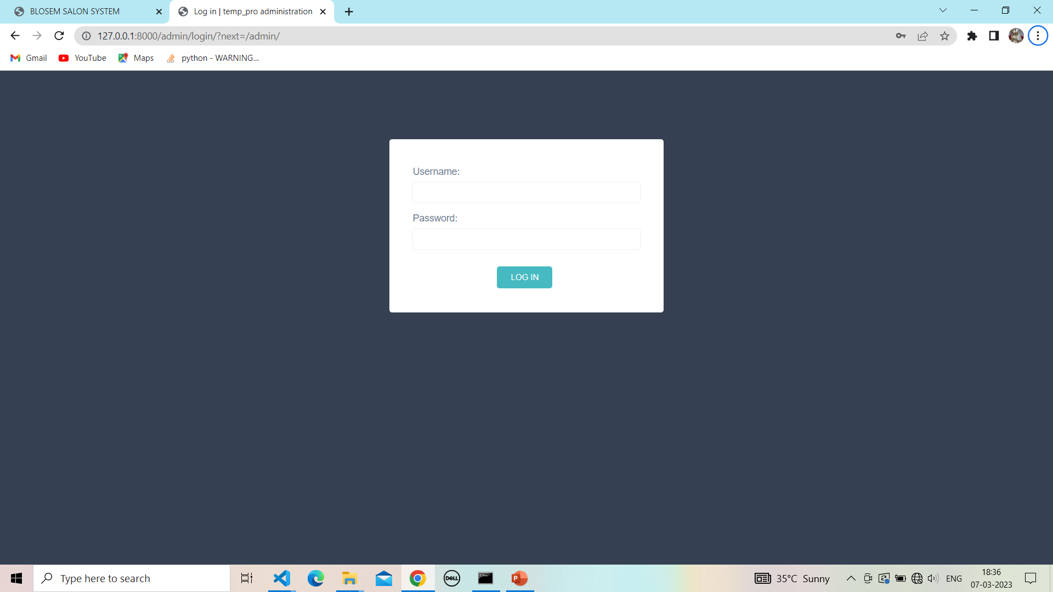

**4.2 Admin login page with password validation :**

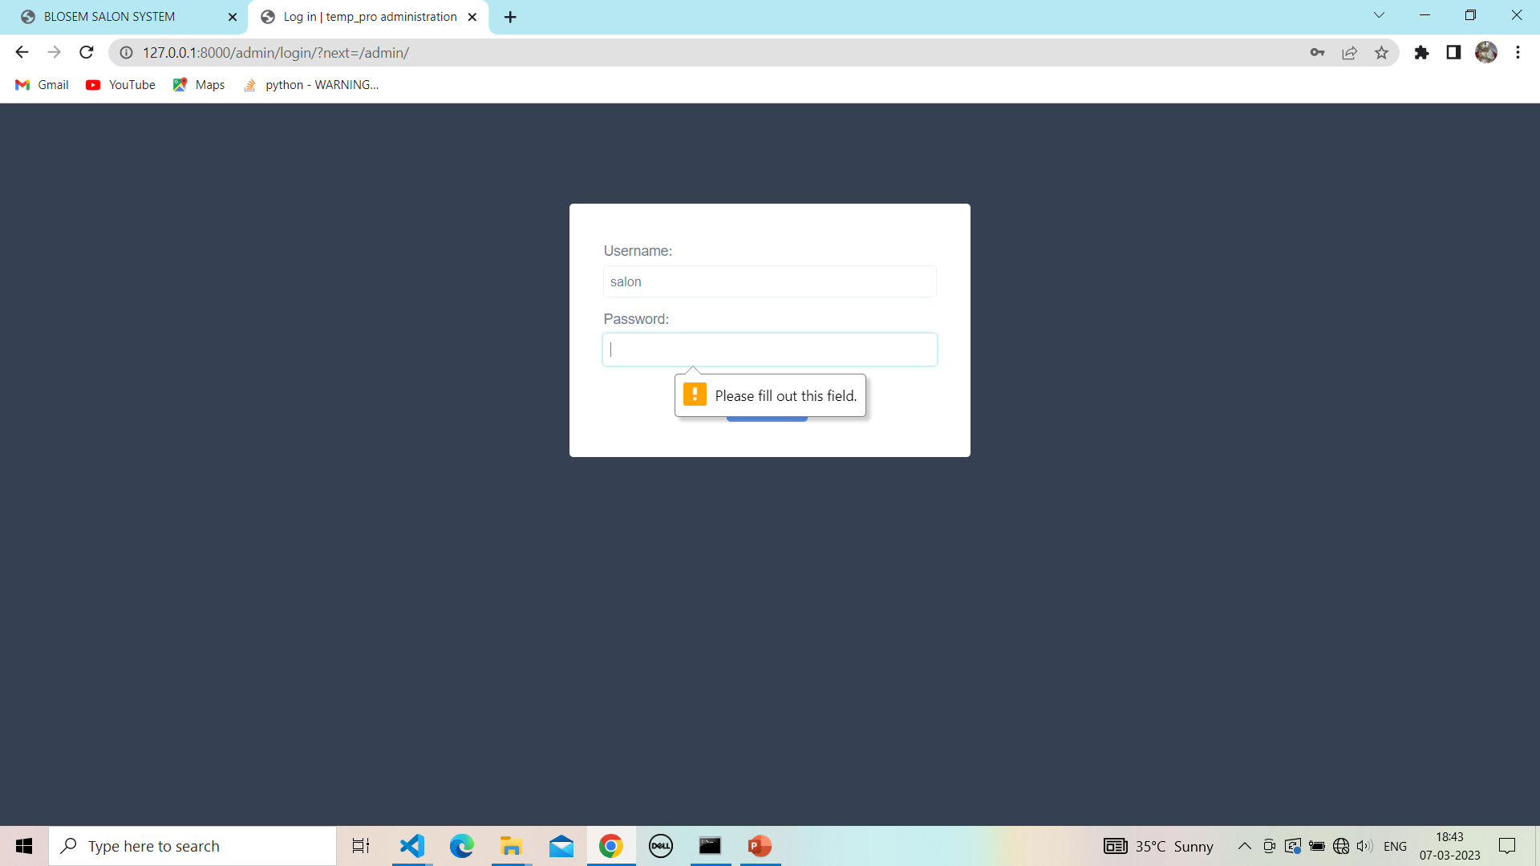

**4.3 Admin login page with details:**

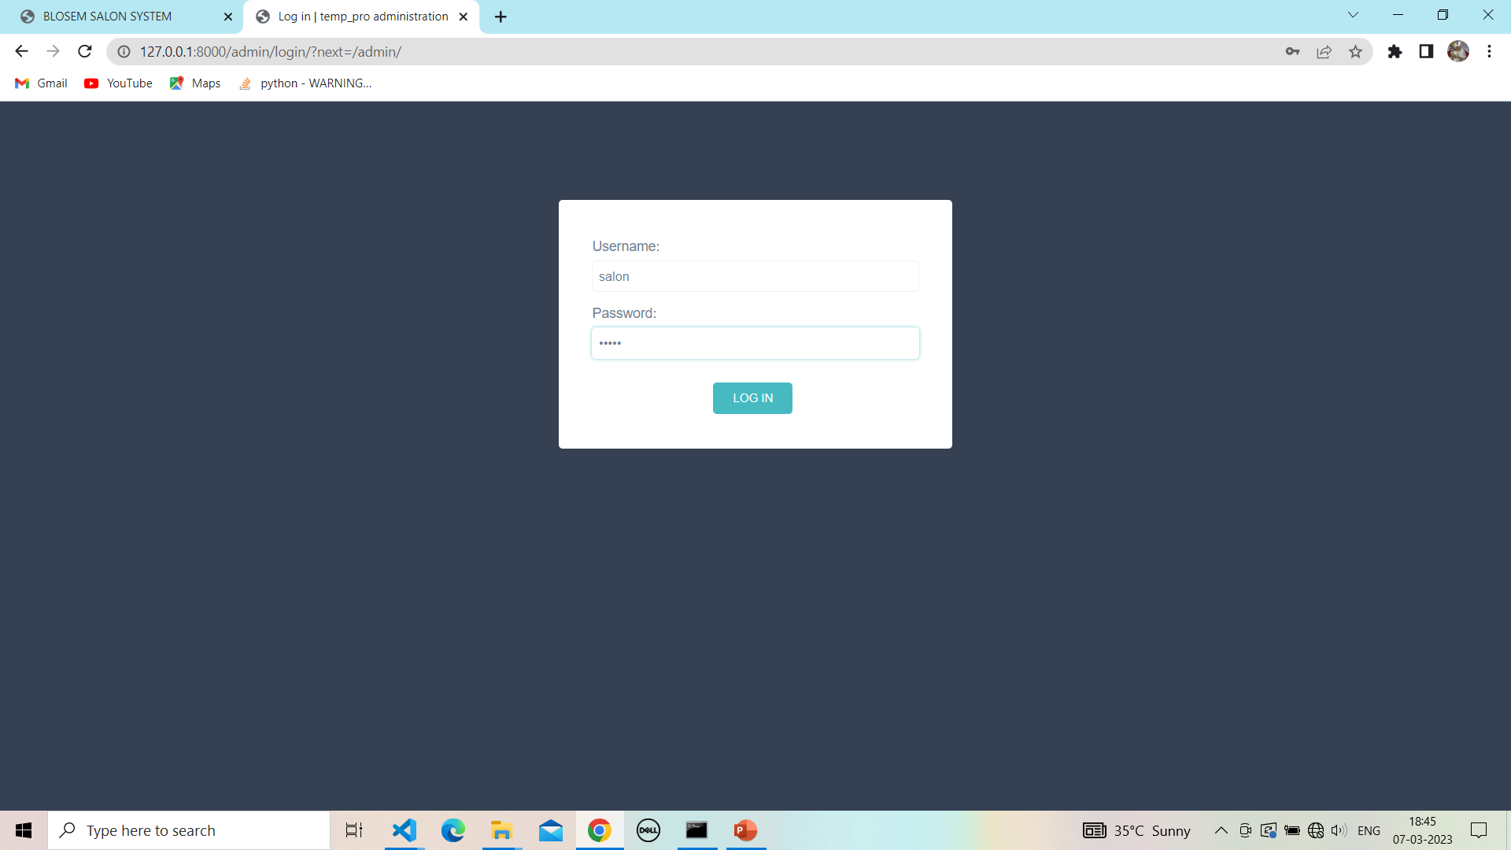

**4.4 Home page of Admin:**

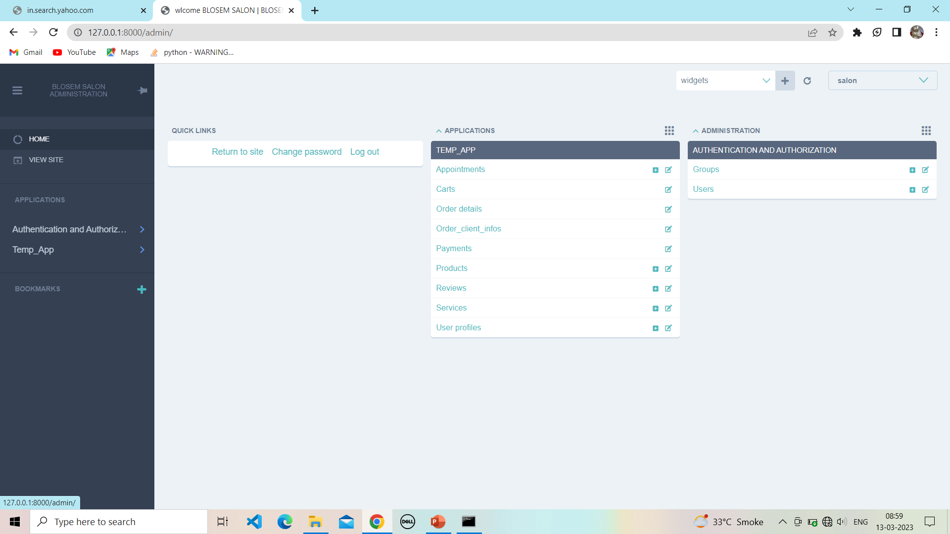

**5.Click and change password:**

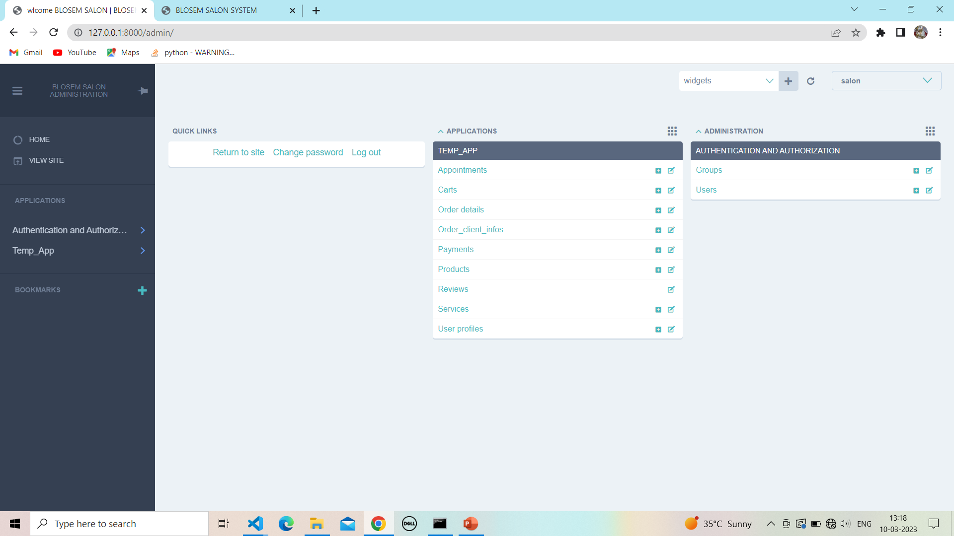

**5.1 Change password:**

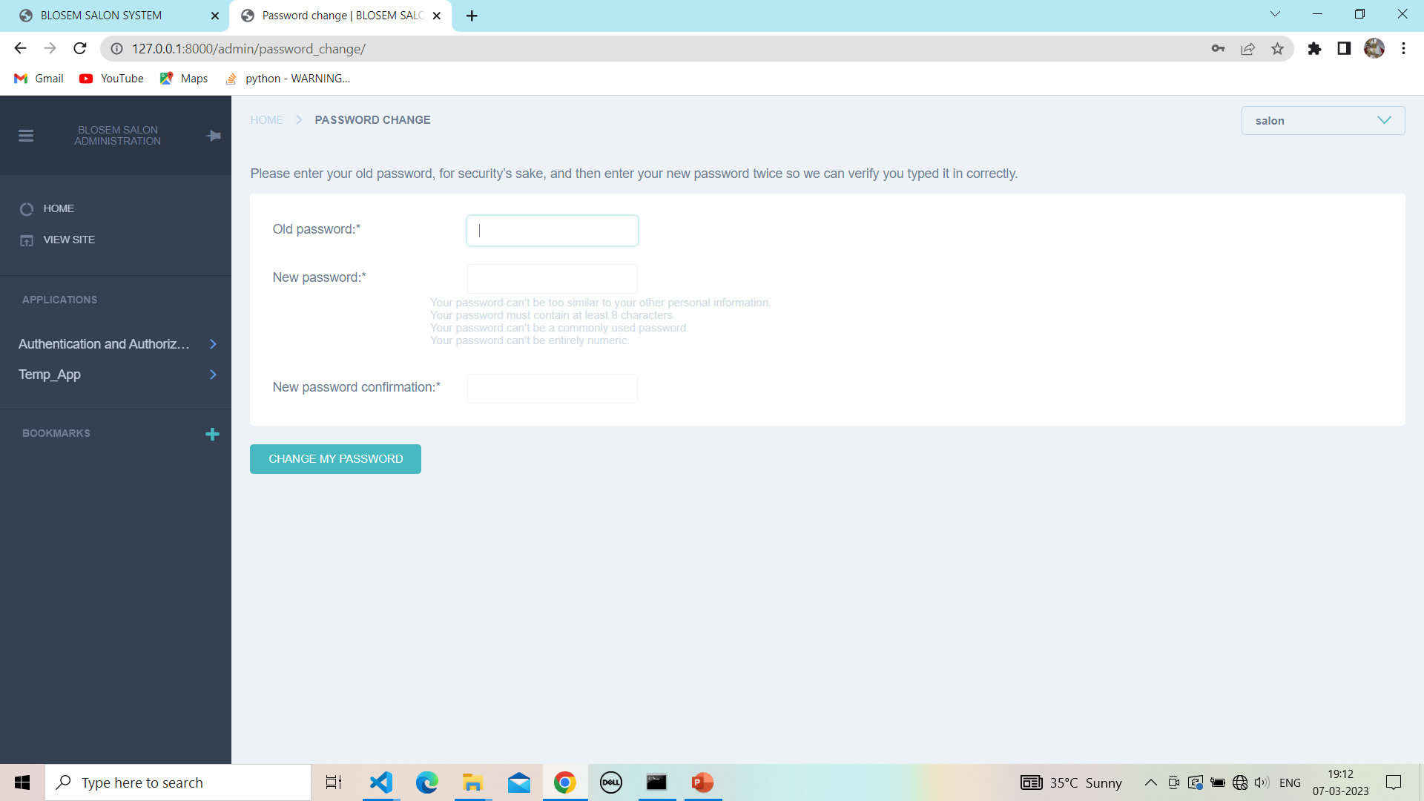

**5.2 Change password with validation:**

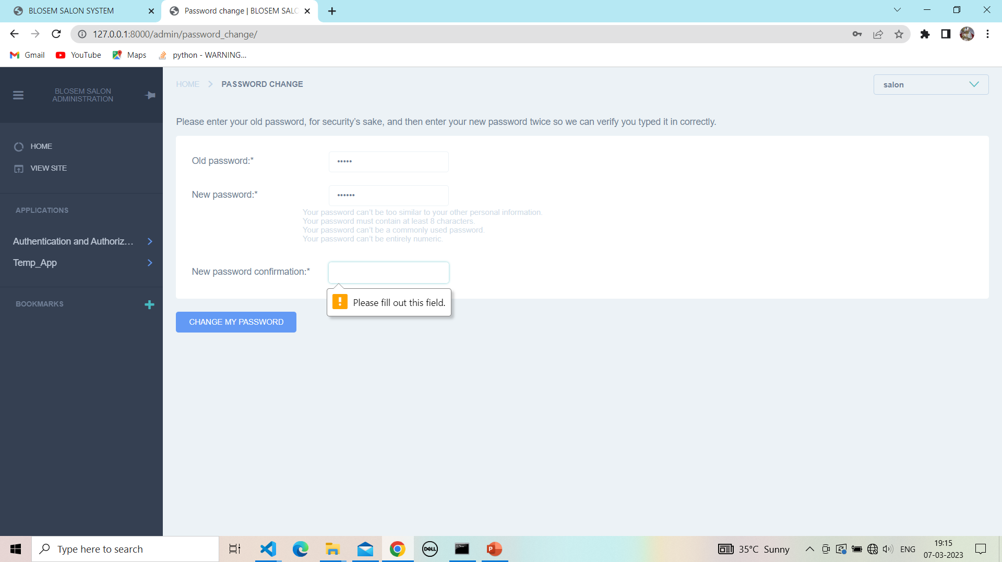

**5.3 Change Password validation:**

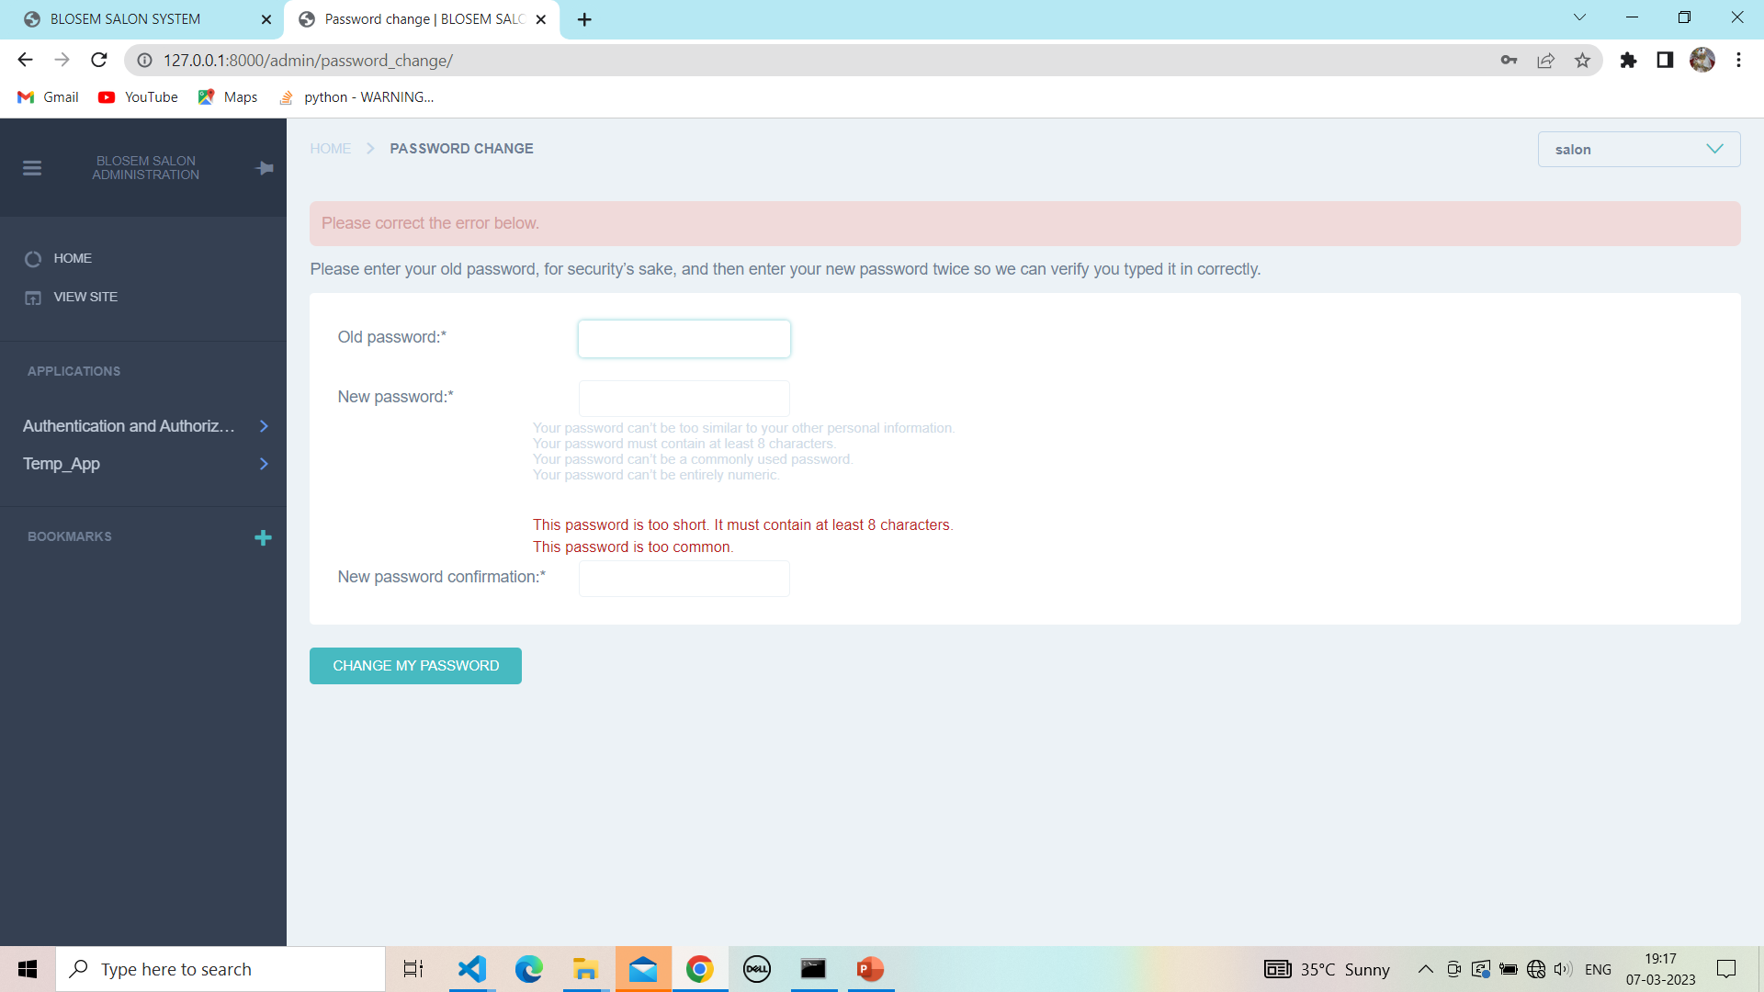

**5.4 Fill password:**

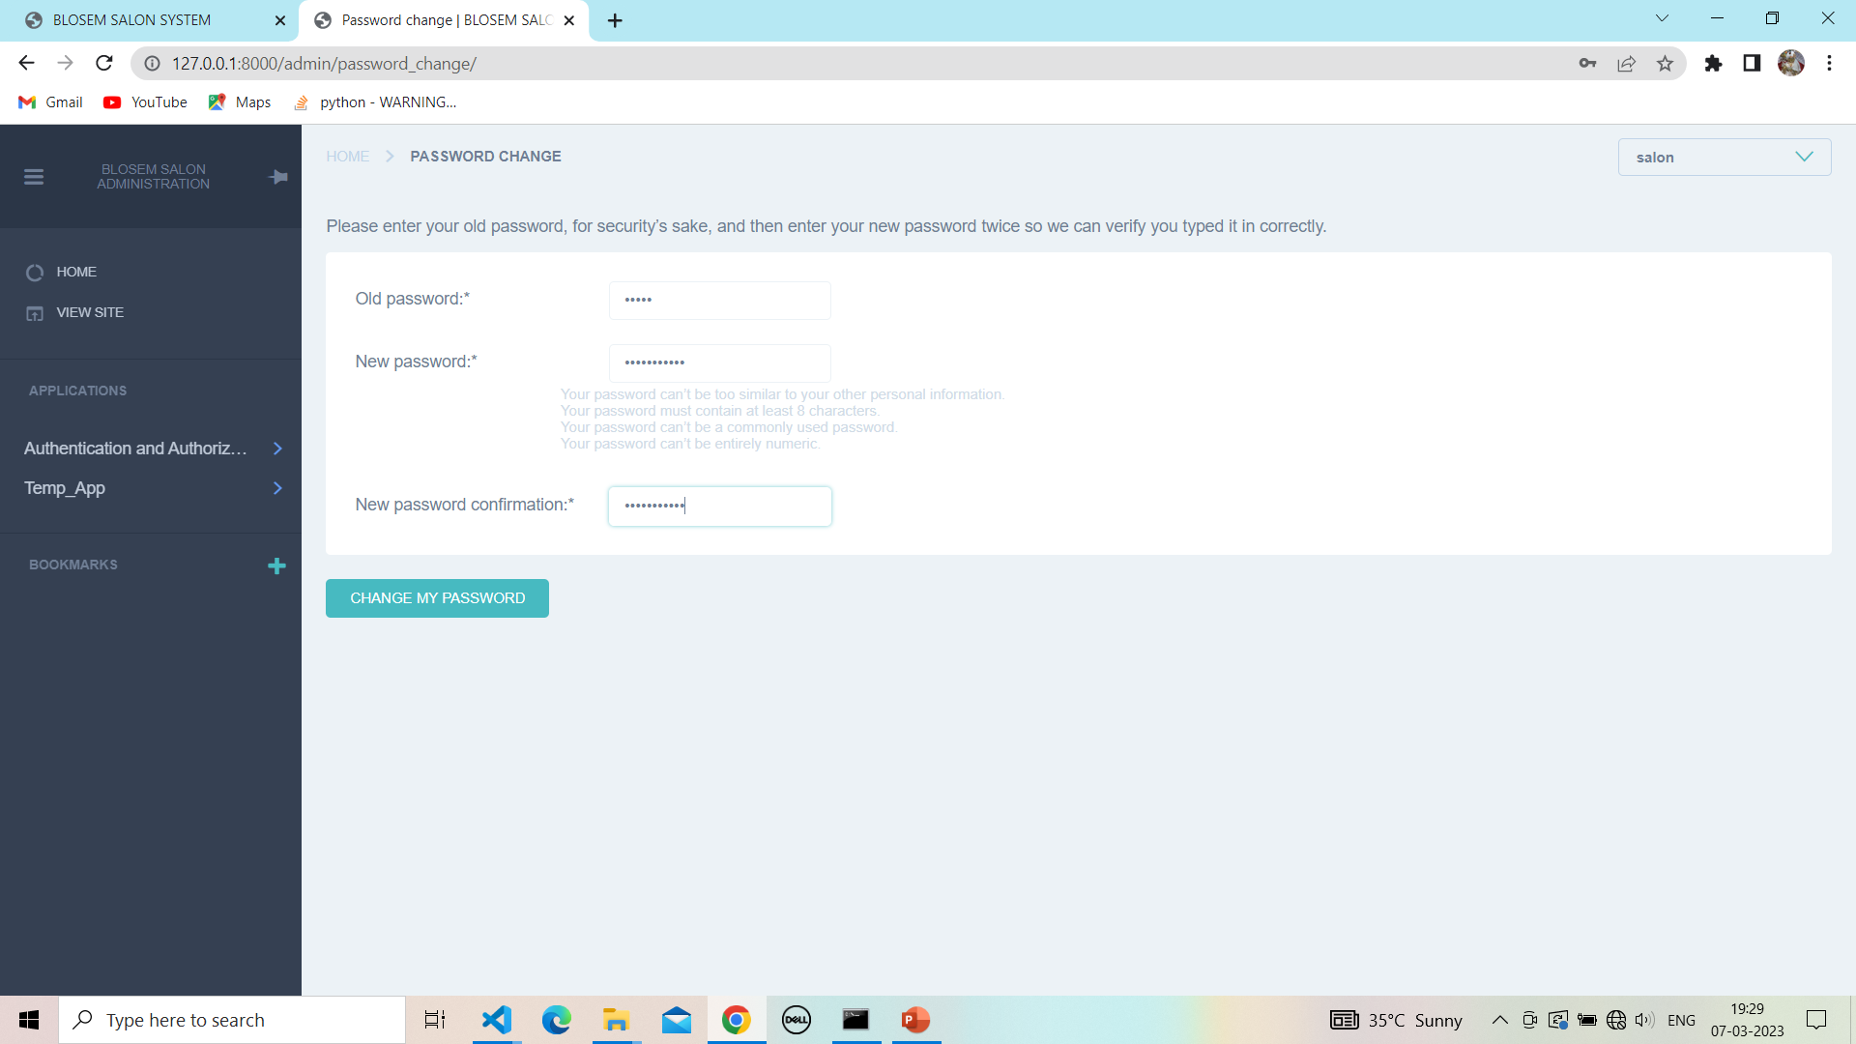

**5.5 Password change successful:**

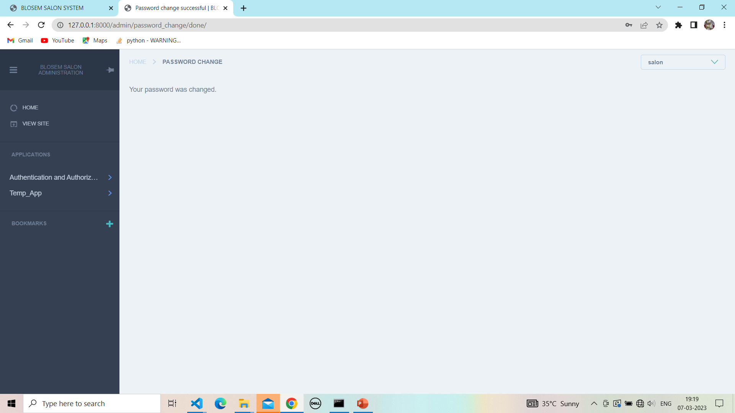

**6. Admin application page:**

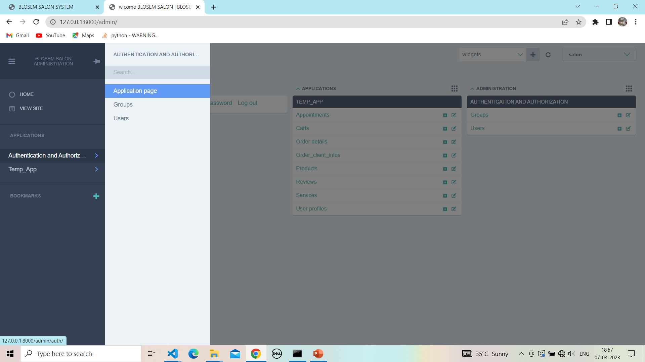

**6.1 View application page:**

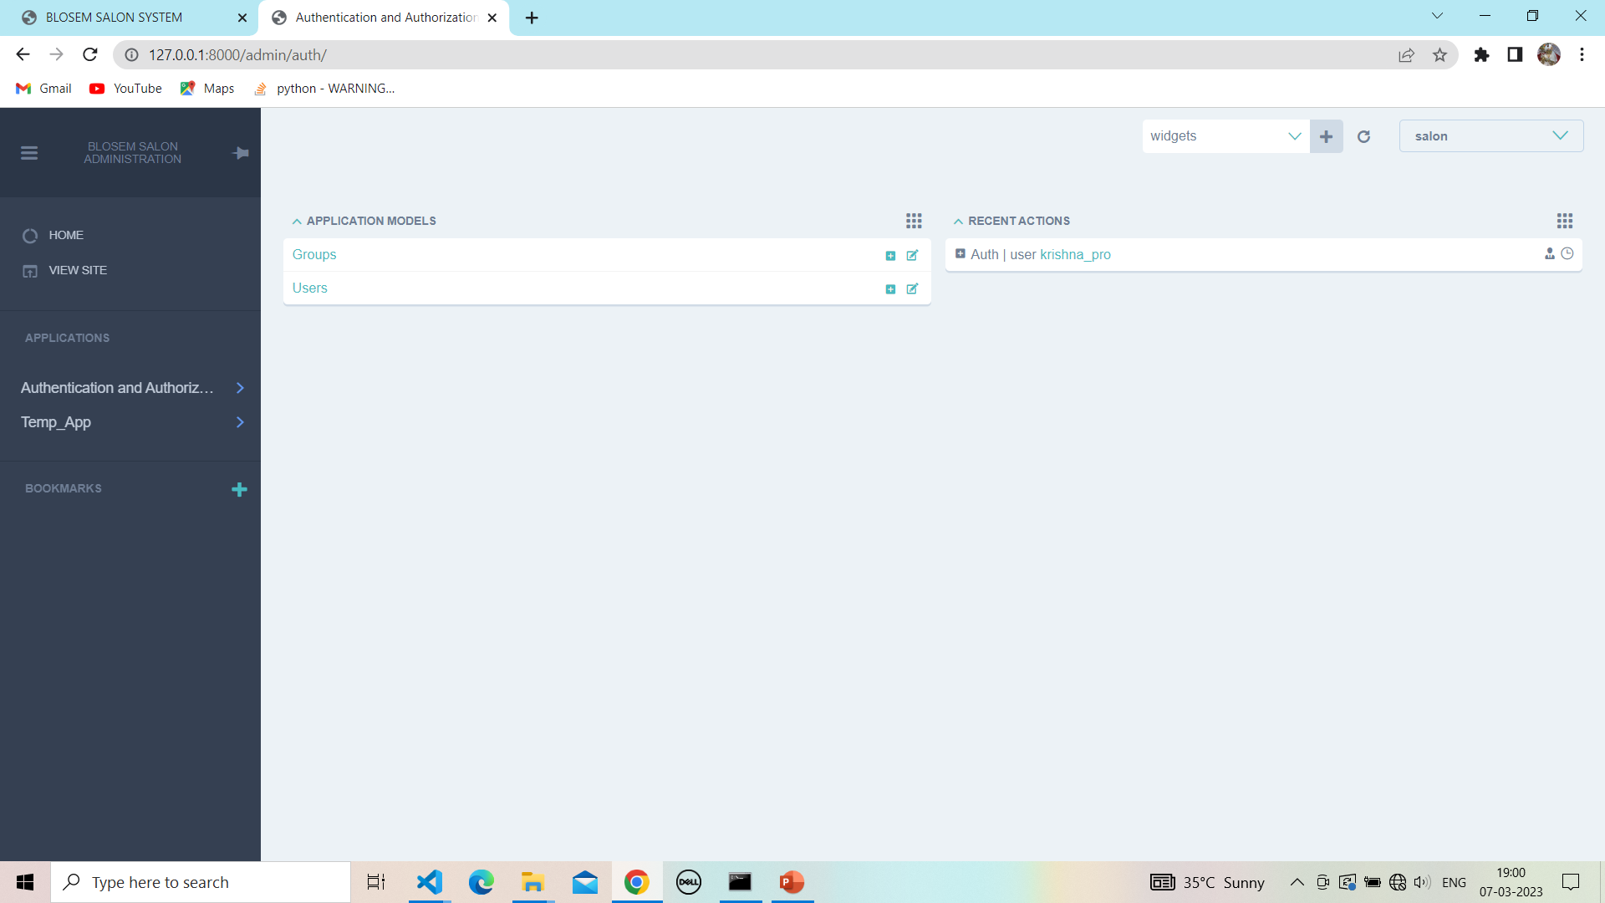

**7. Admin user page :**

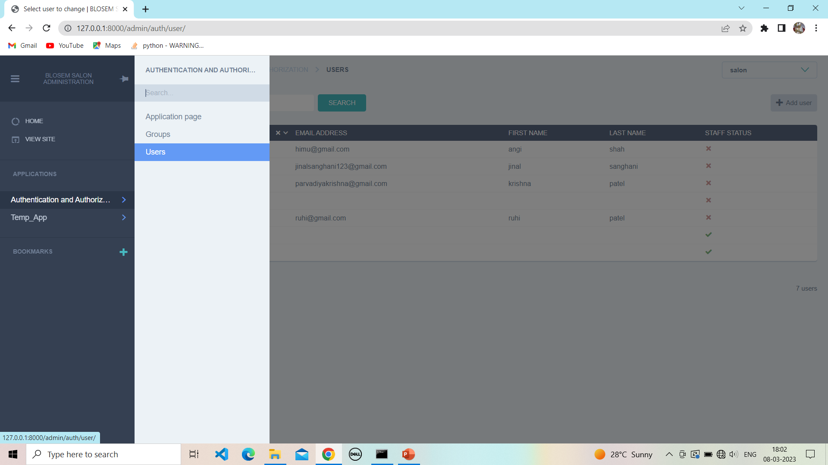

**7.1 View Admin user:**

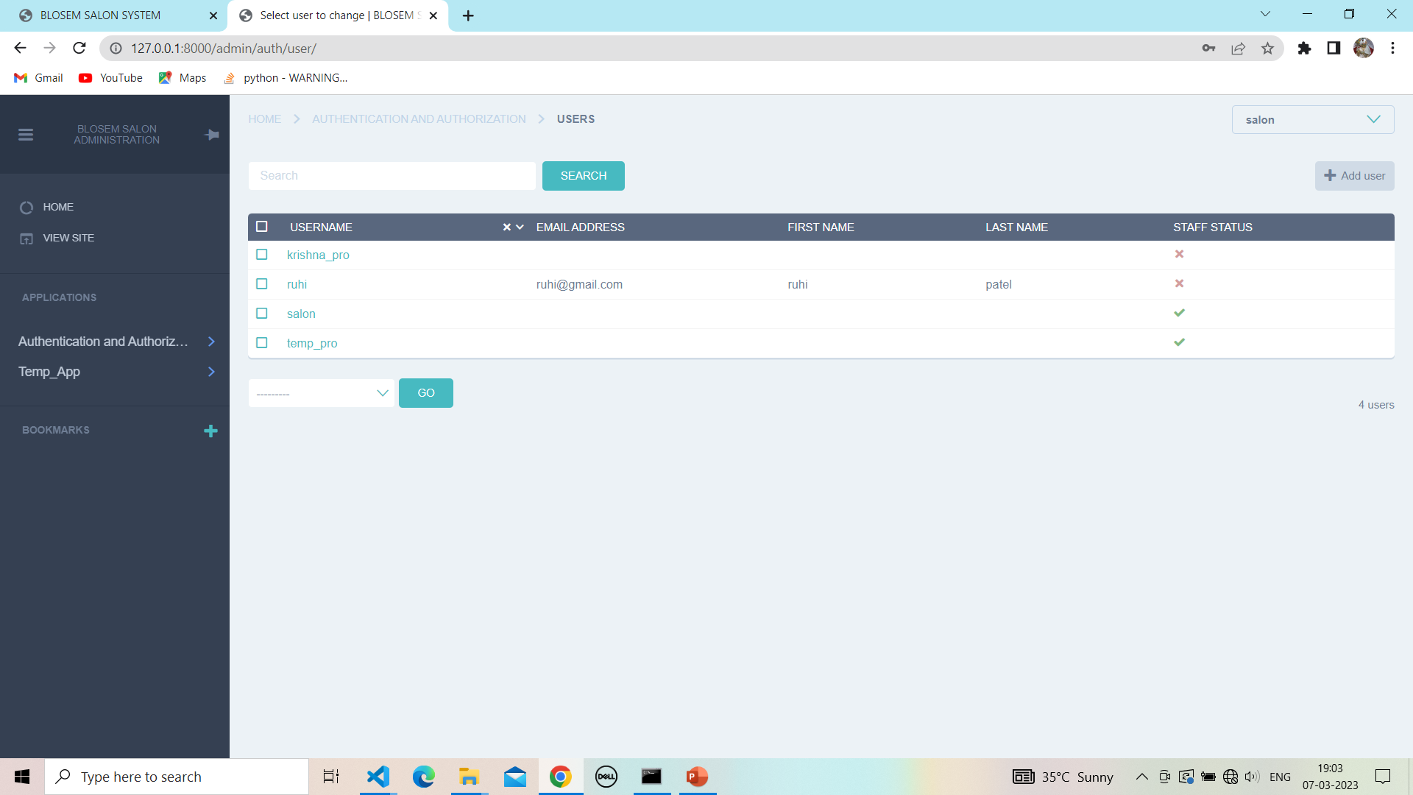

**8. Admin application:**

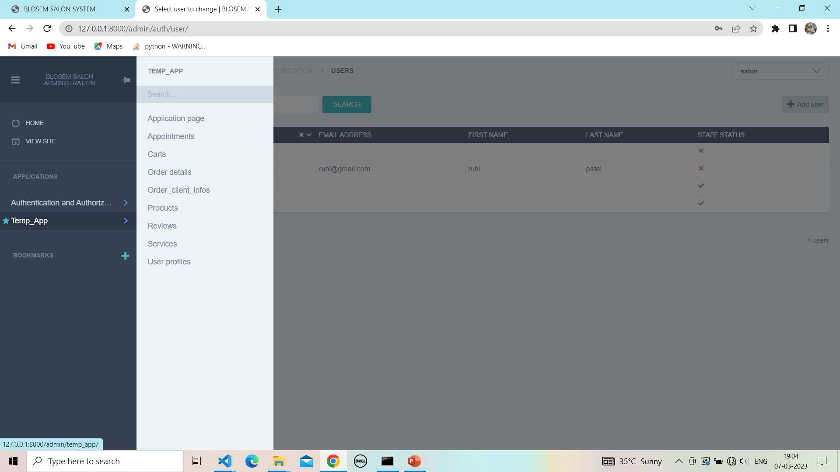

**8.1 Admin search application:**

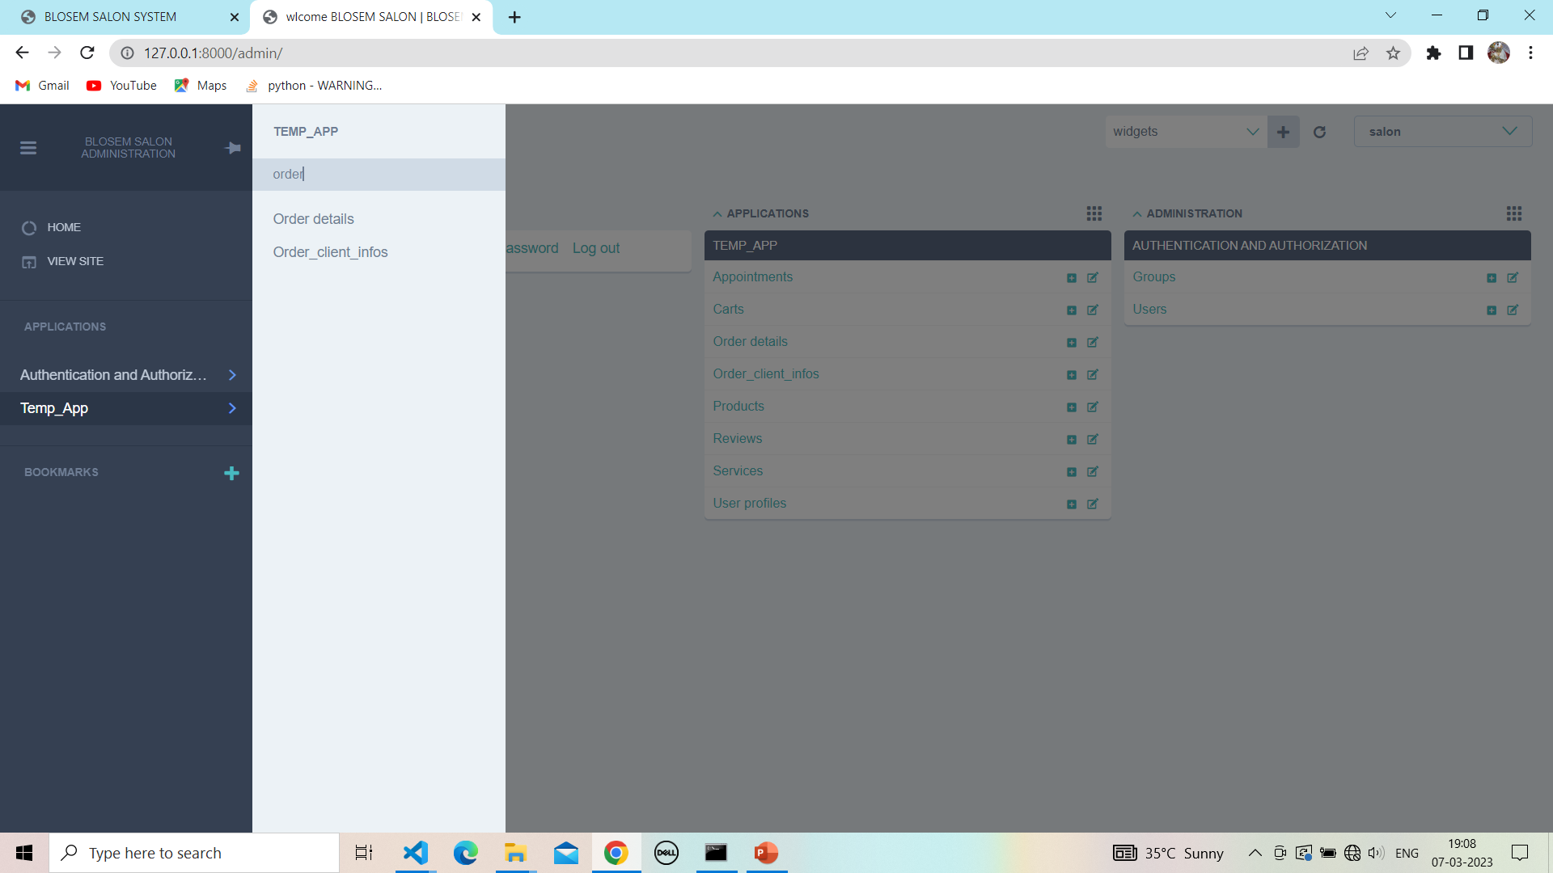

**9.User profiles:**

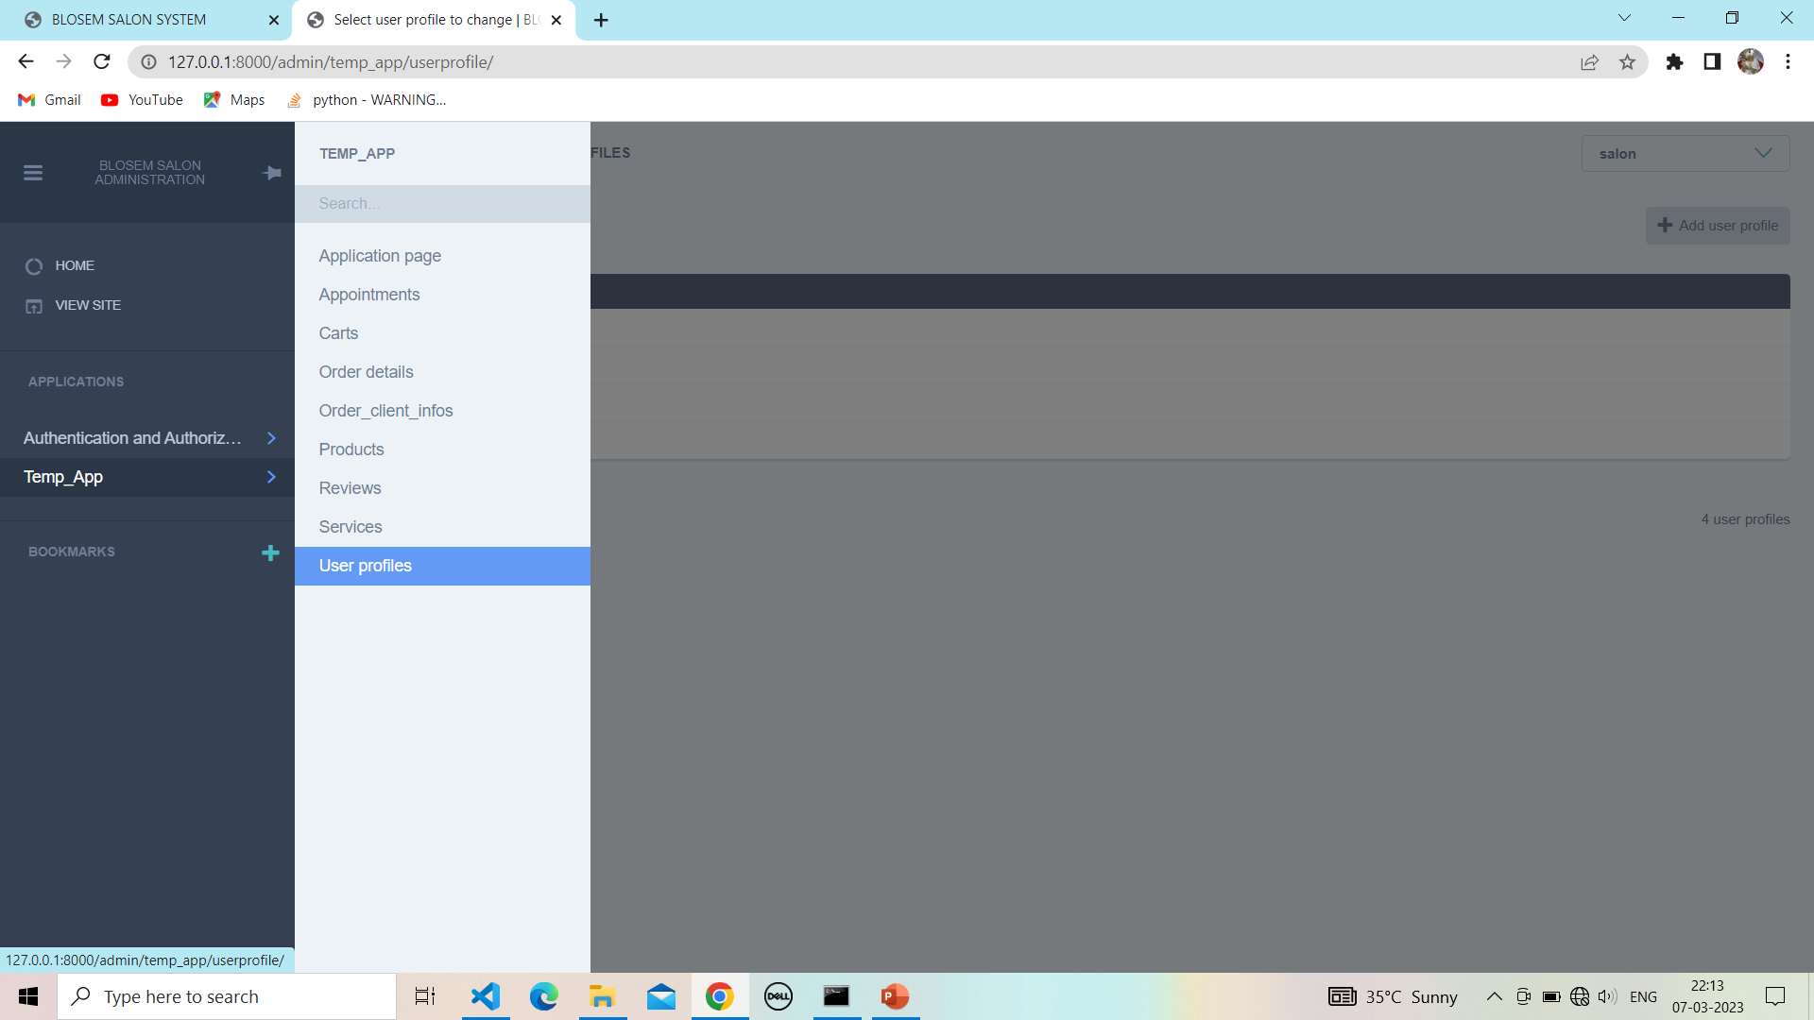

**9.1View user profiles:**

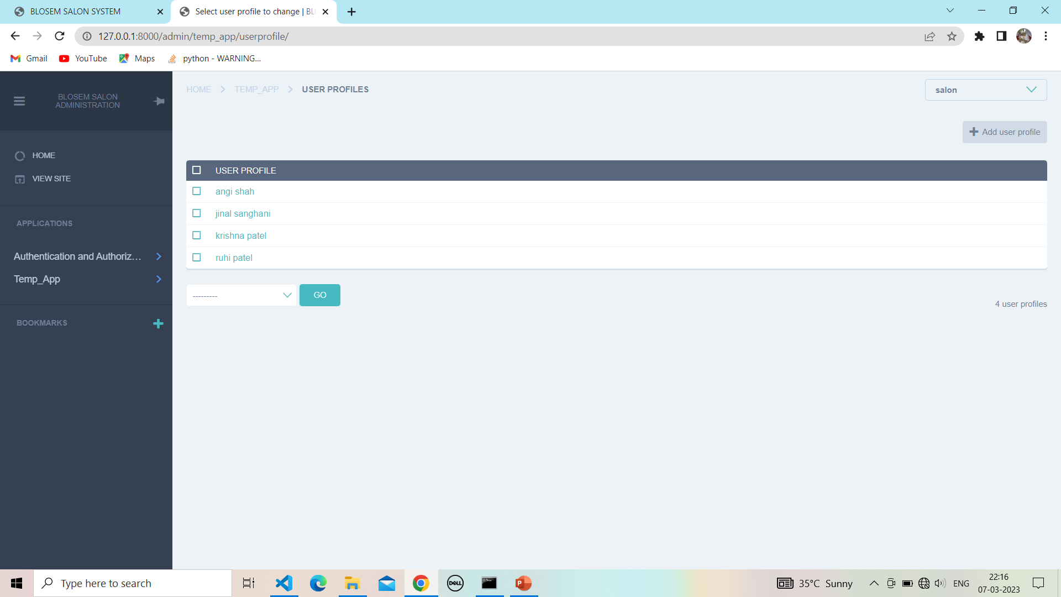

**9.2User profiles details**

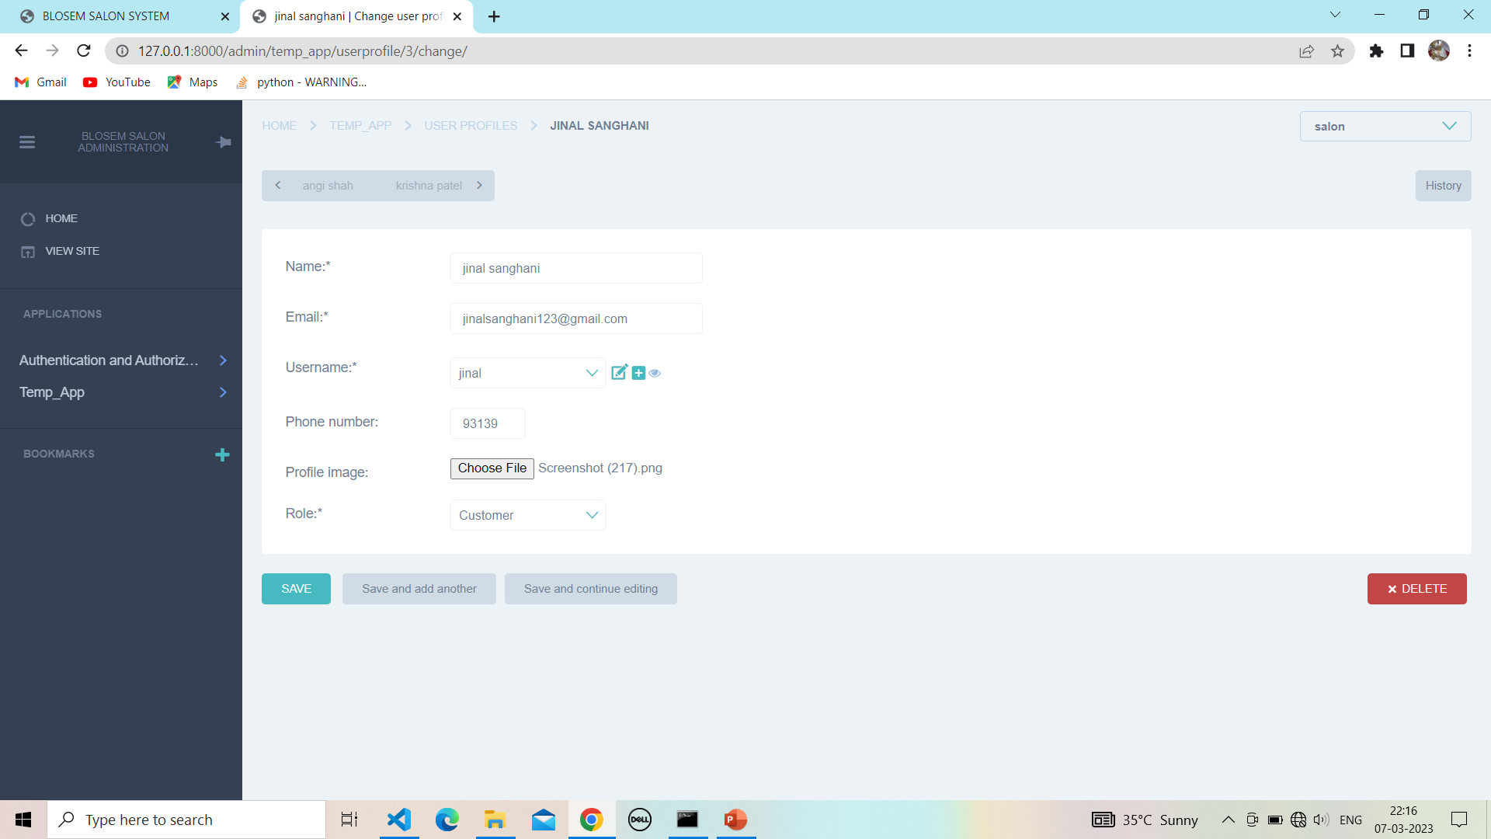

**9.3 Delete multiple user profiles :**

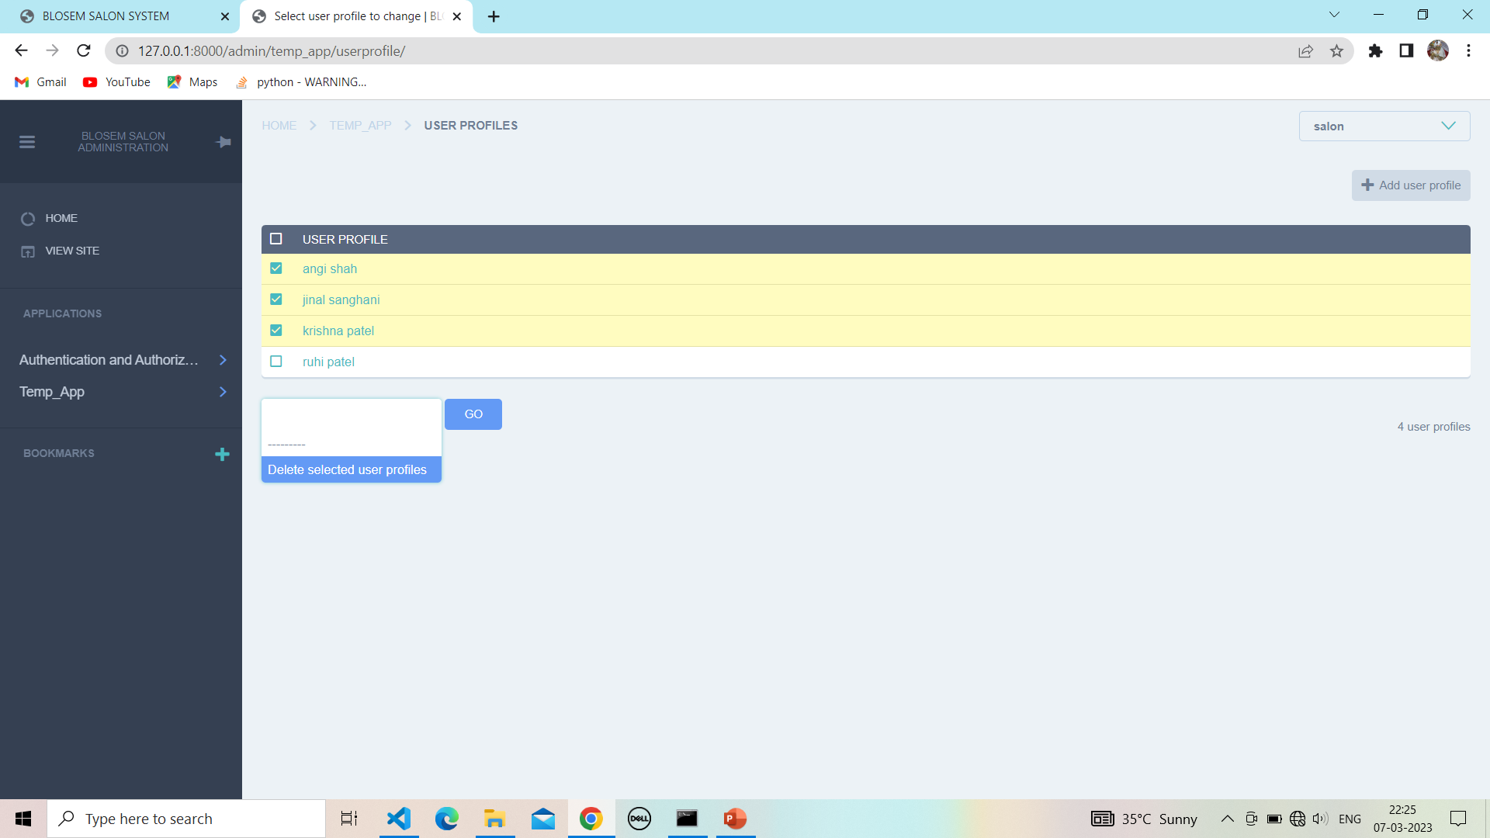

**9.4 Confirm to delete user :**

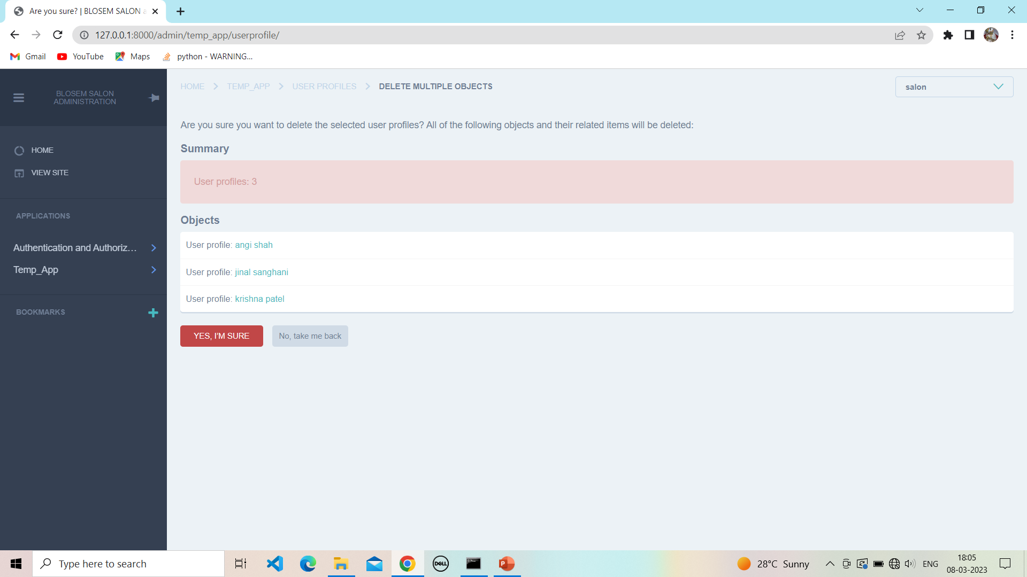

**9.5After delete multiple user :**

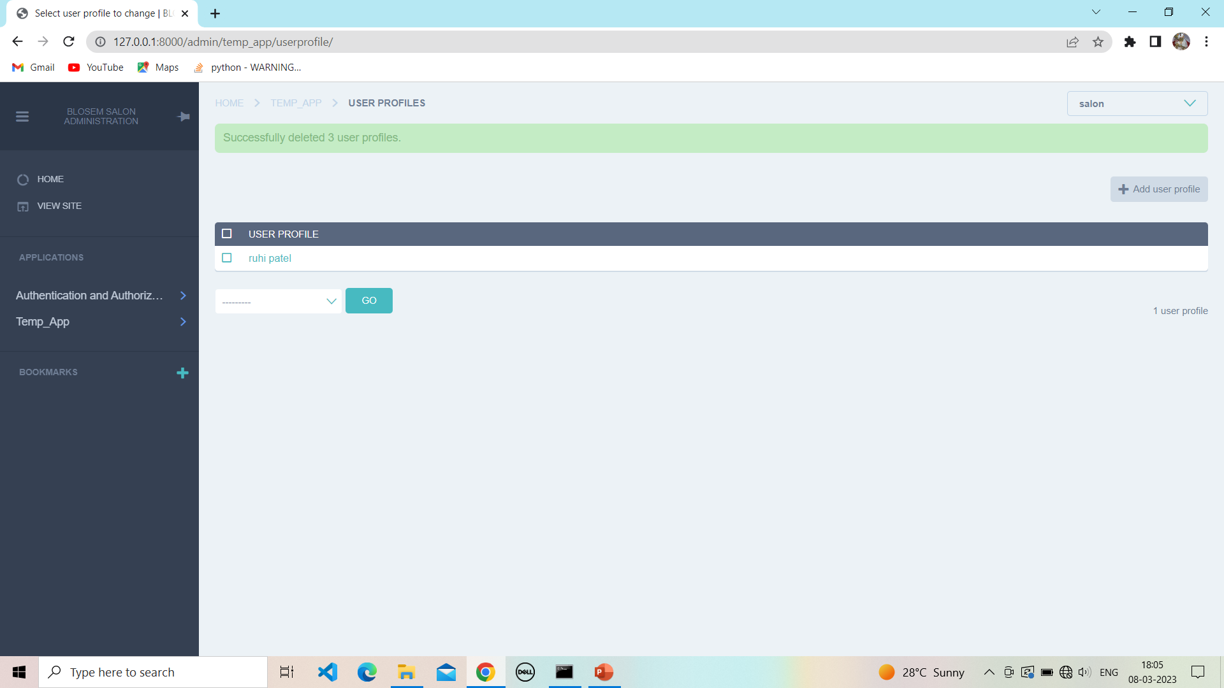

**10.Product :**

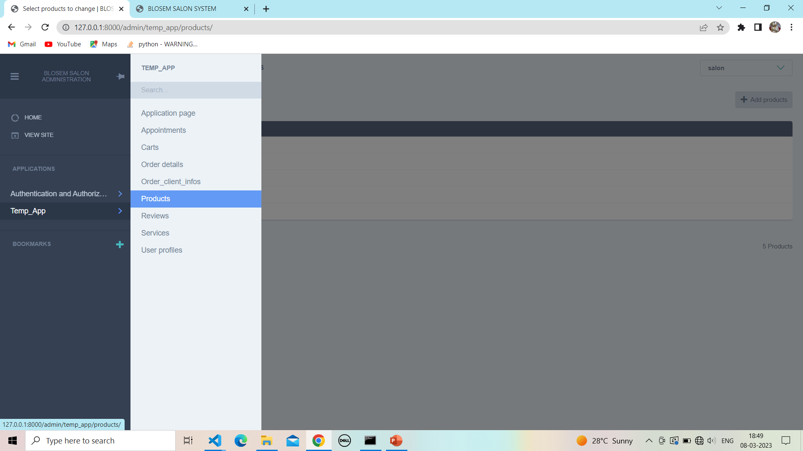

**10.1 View products:-**

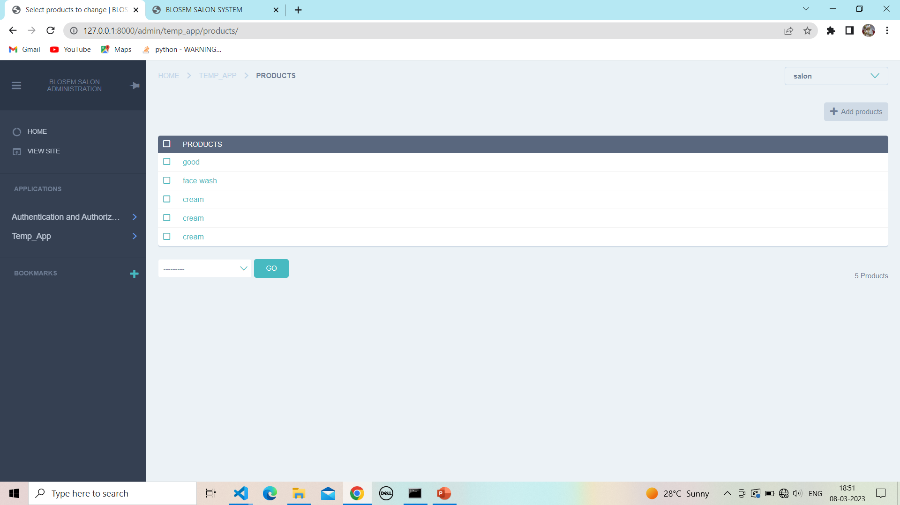

**10.2View validation :**

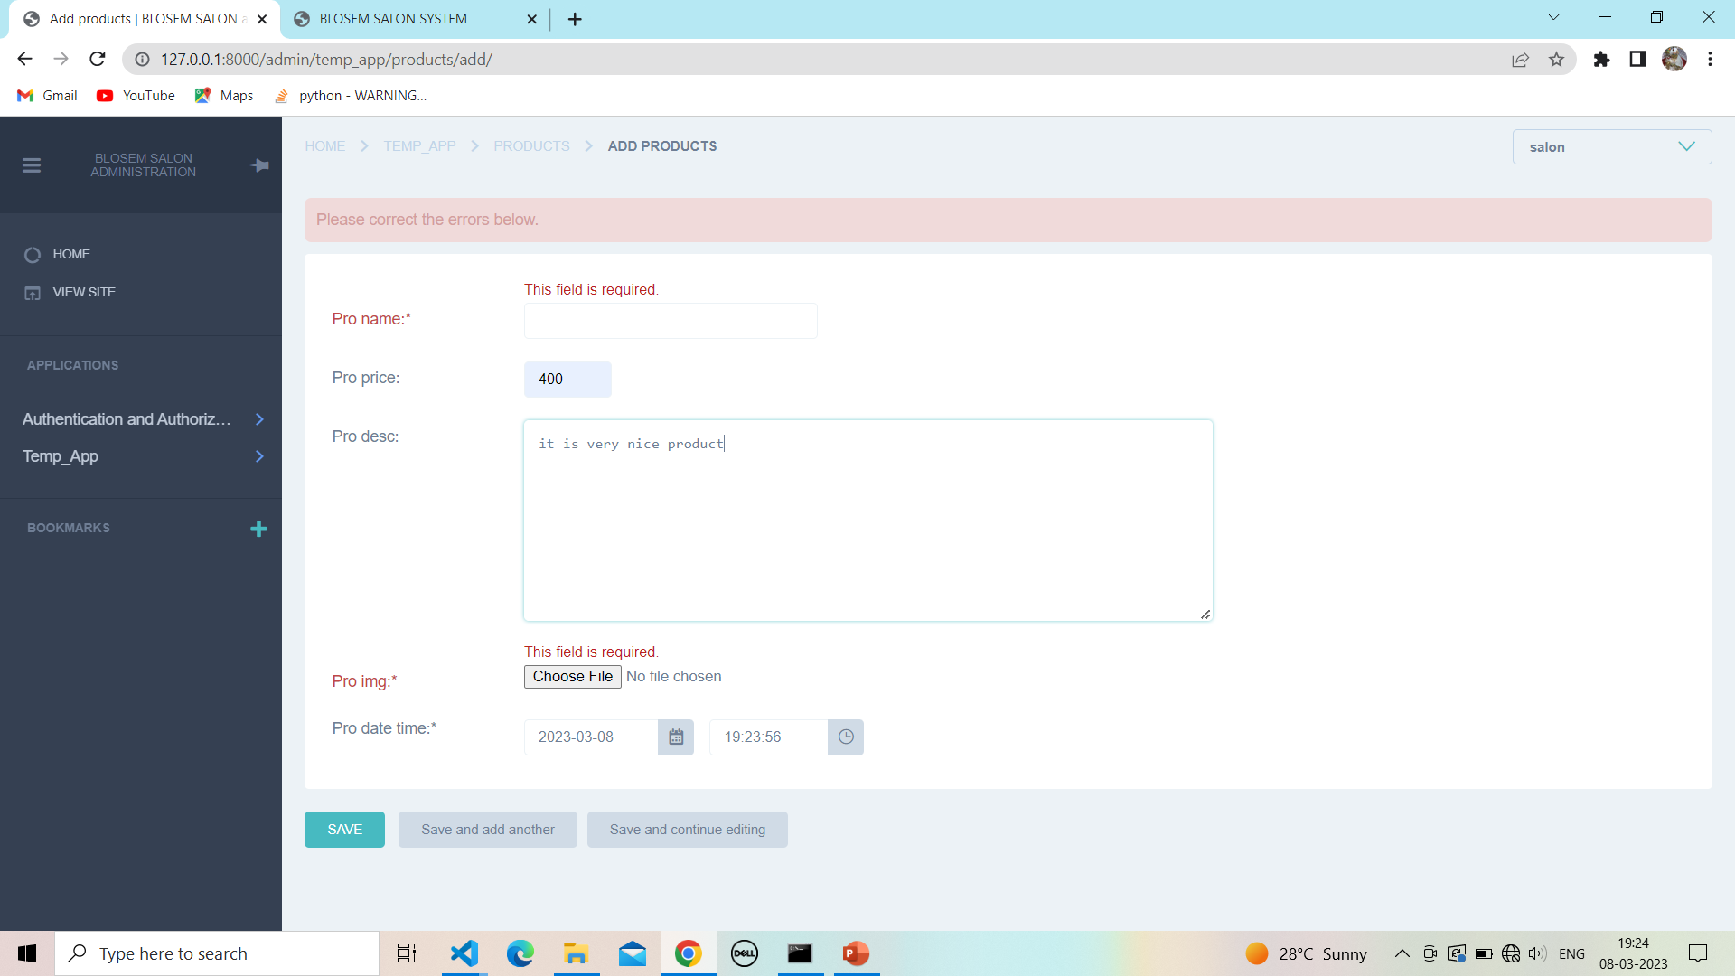

**10.3 Add product :**

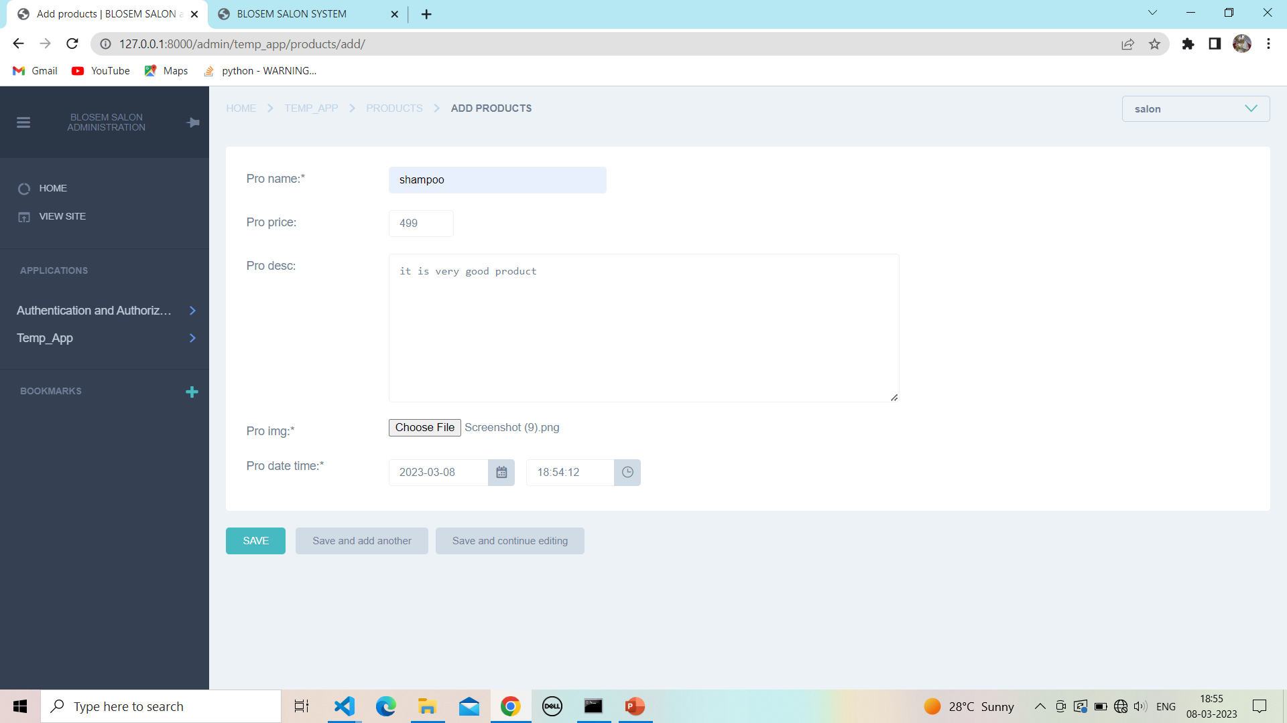

**10.4 Add successfully product :**

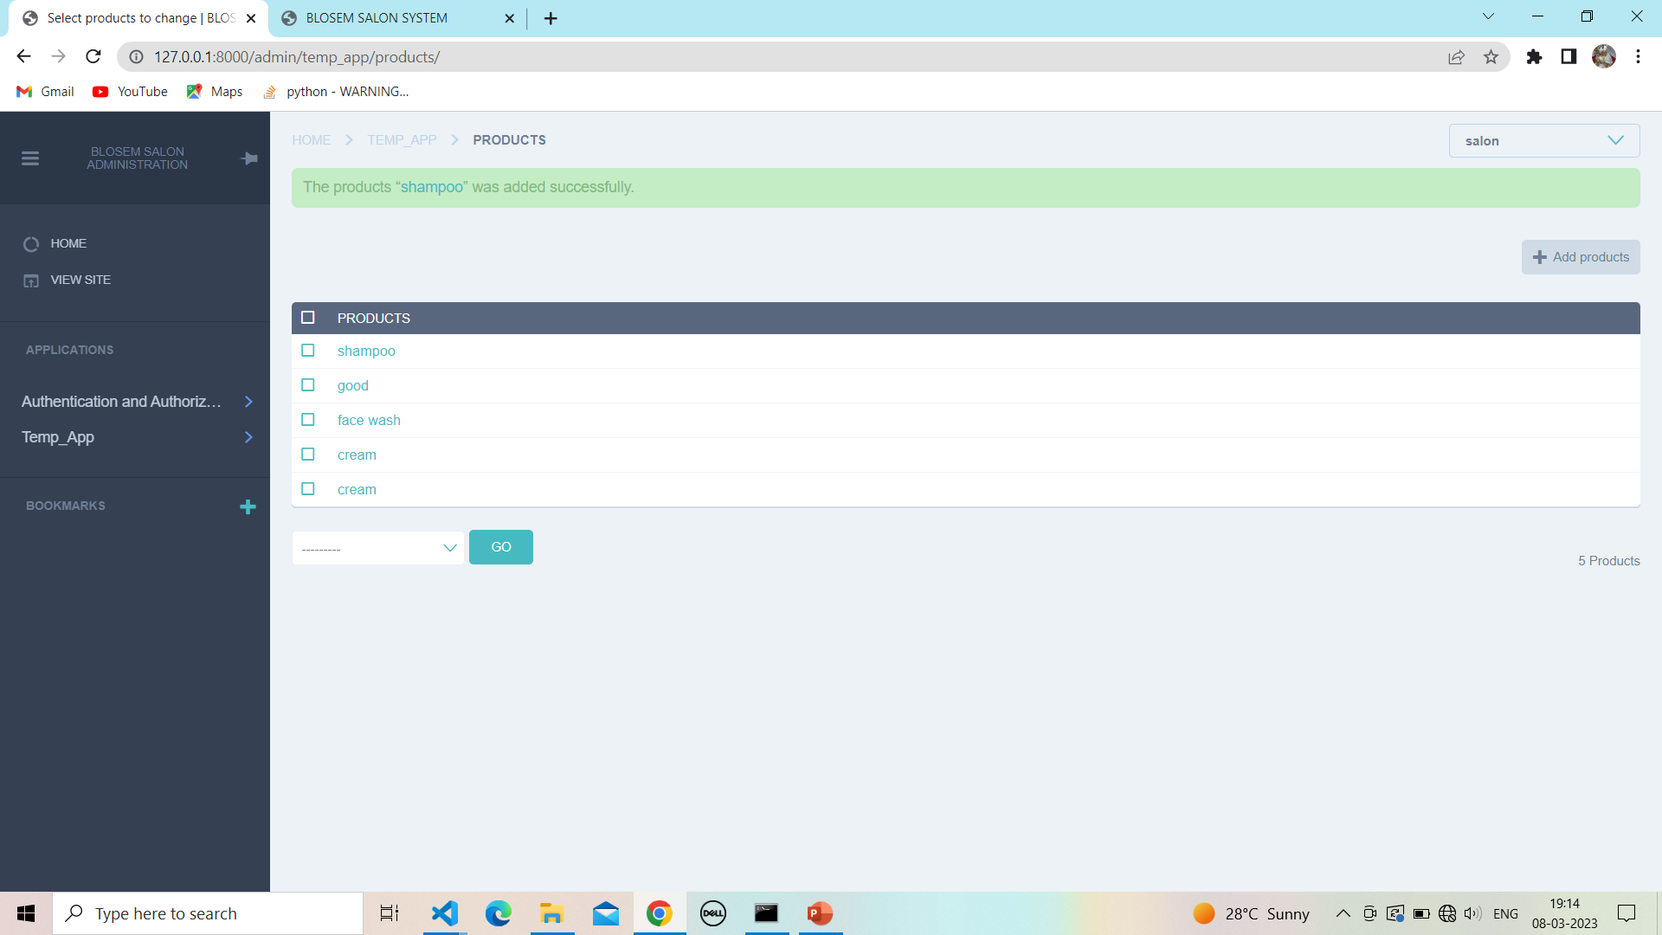

**10.5 Update product :**

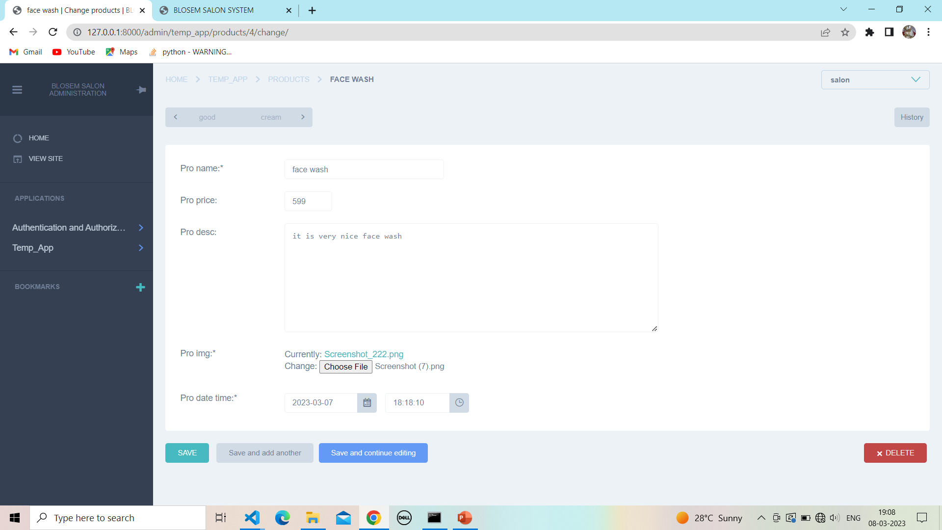

**10.6 Successfully update product :**

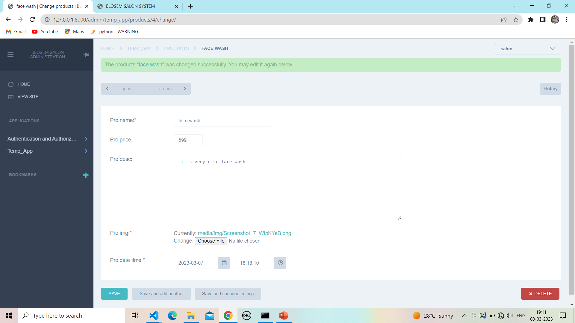

**10.7 Delete Product:**

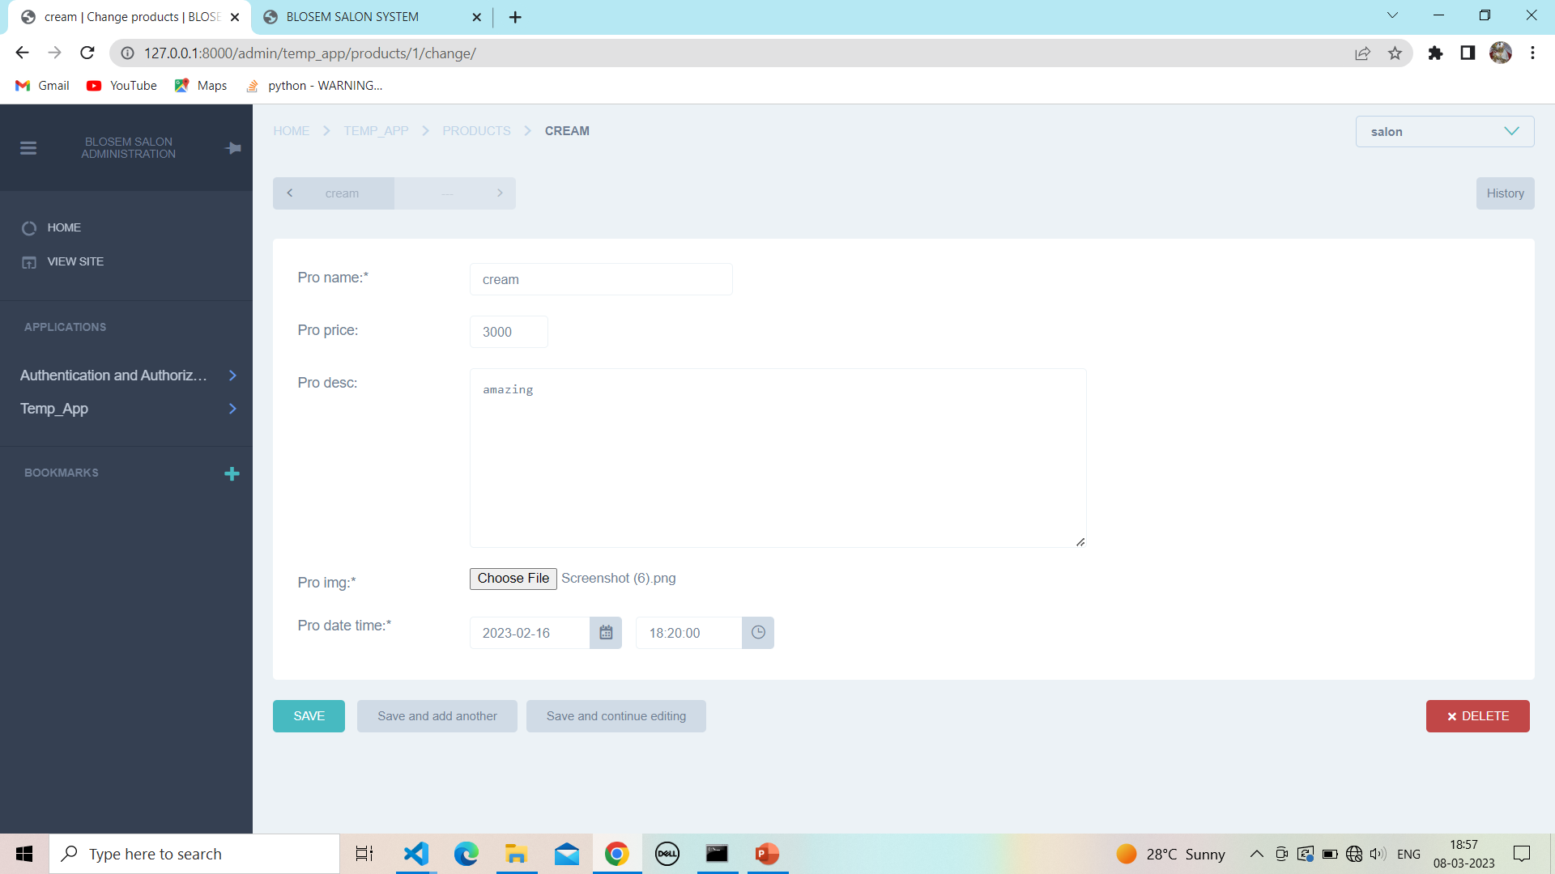

**10.8 Confirm to delete product :**

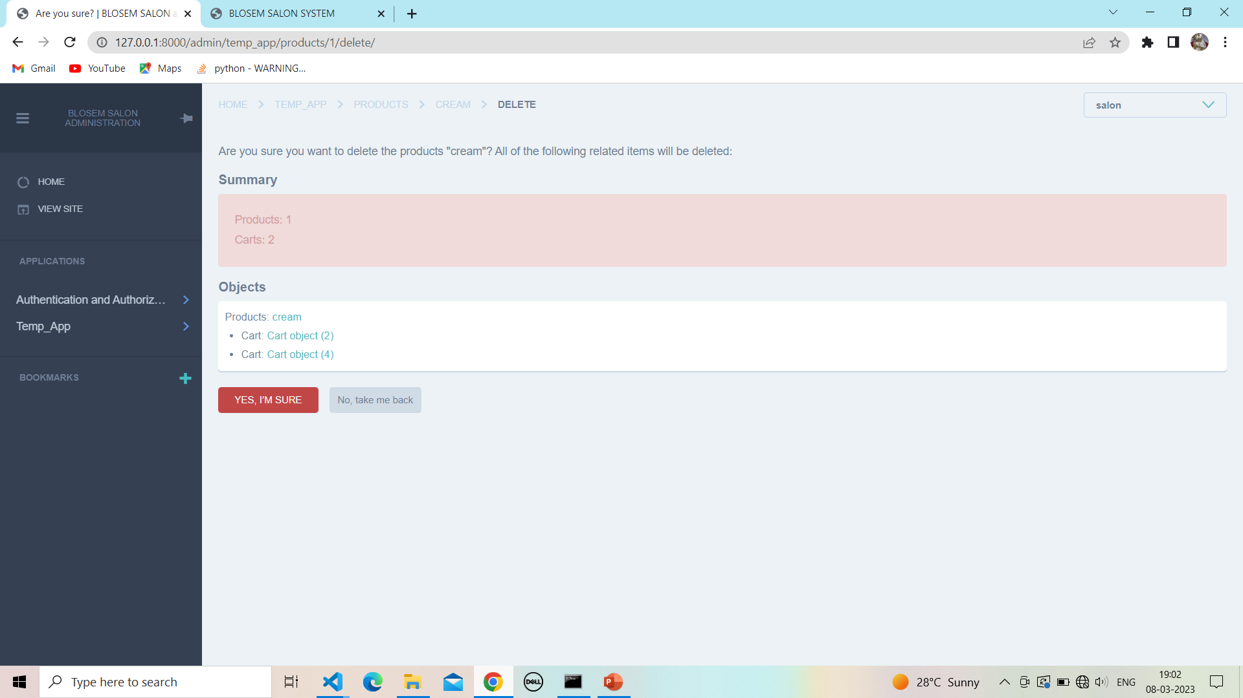

**10.9 After delete product :**

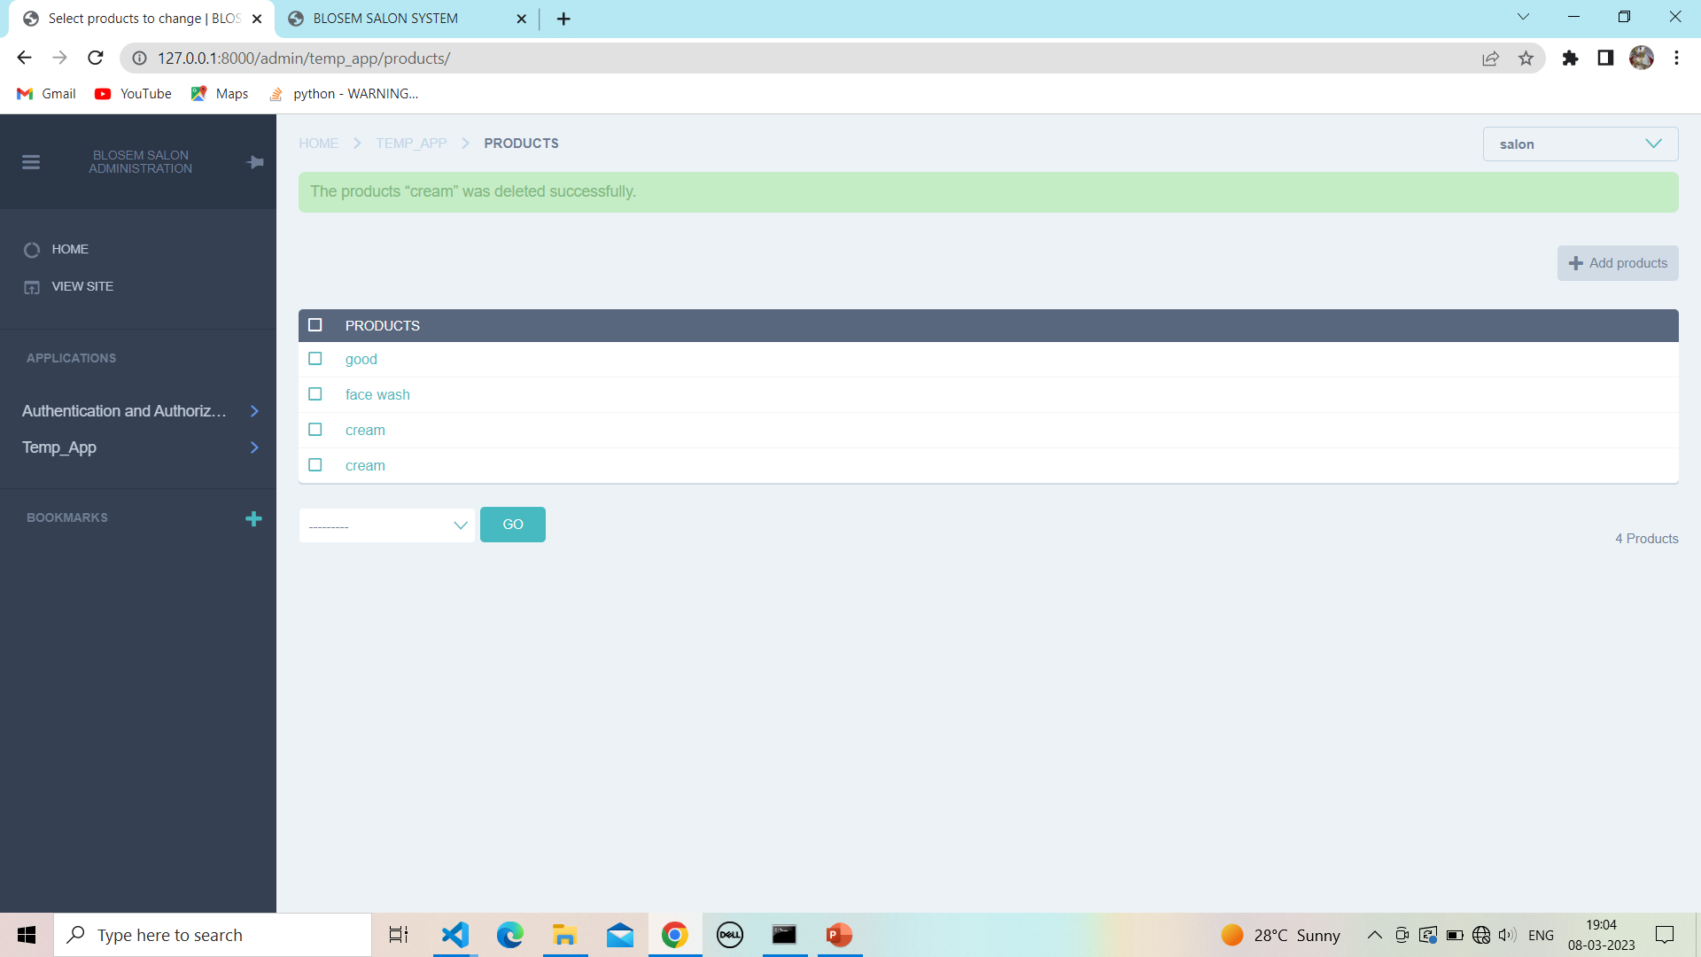

**11.Cart:**

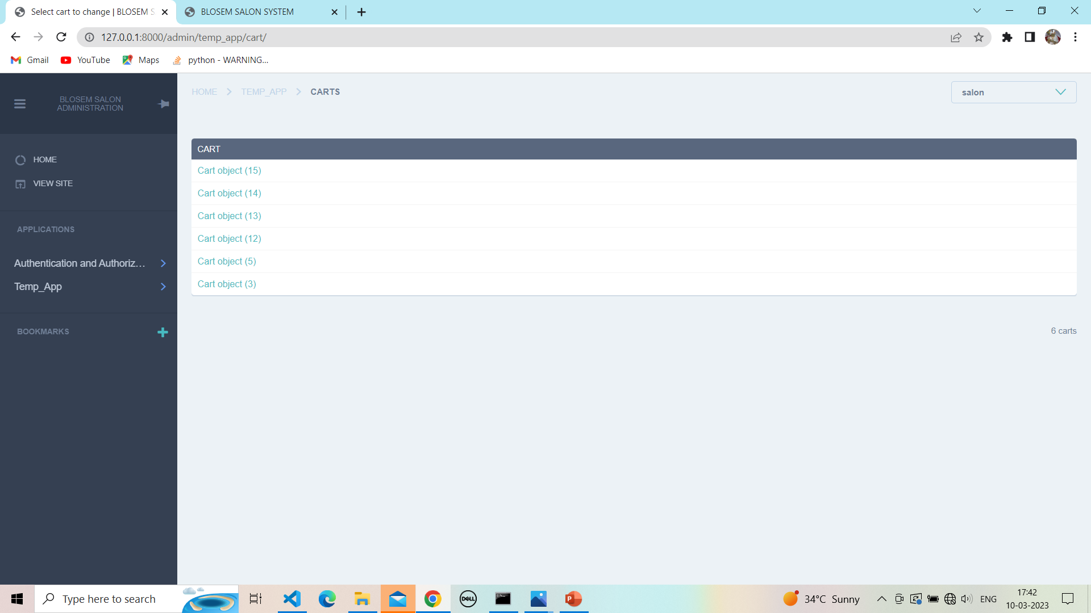

**11.1 Show cart details:**

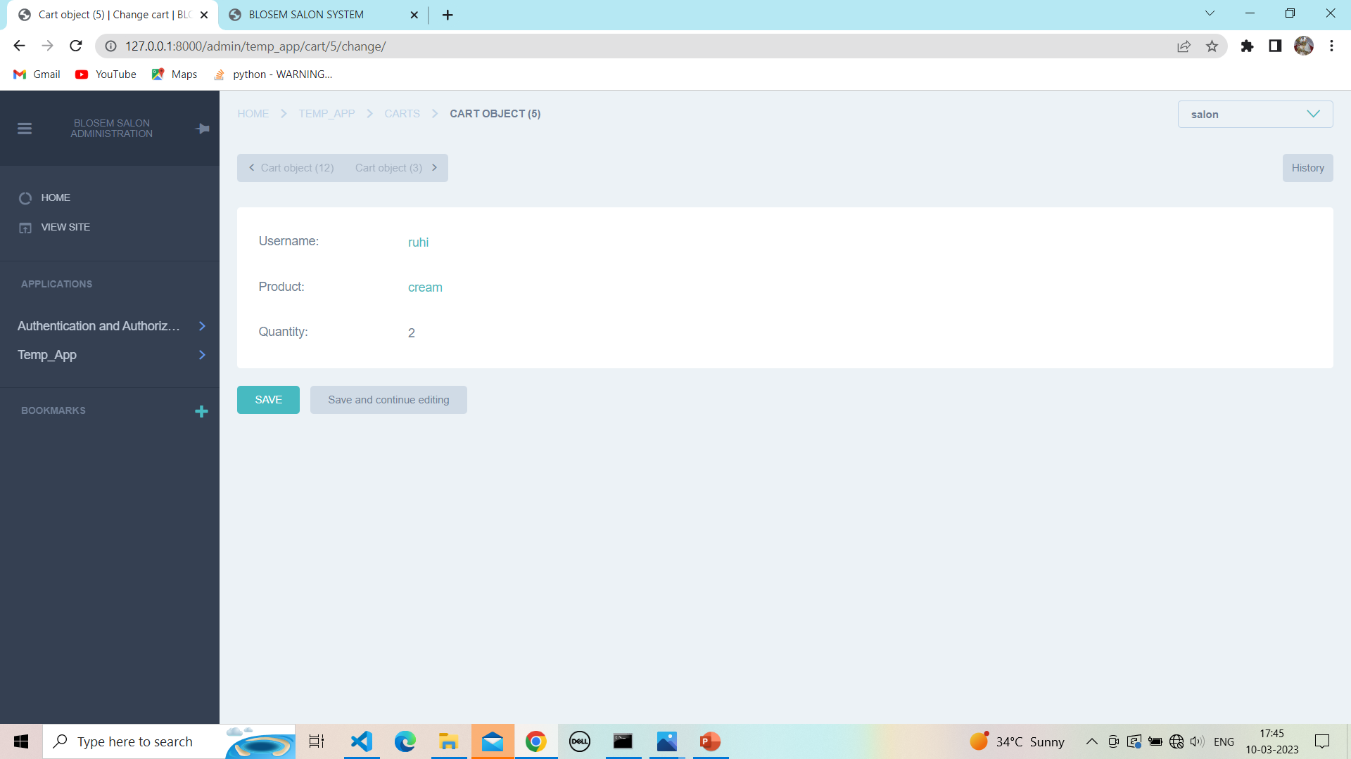

**11.2 Order :**

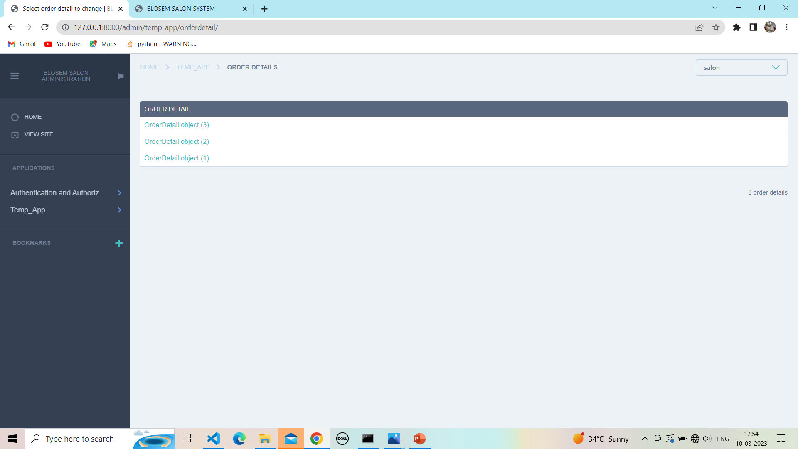

**11.3 Show order :**

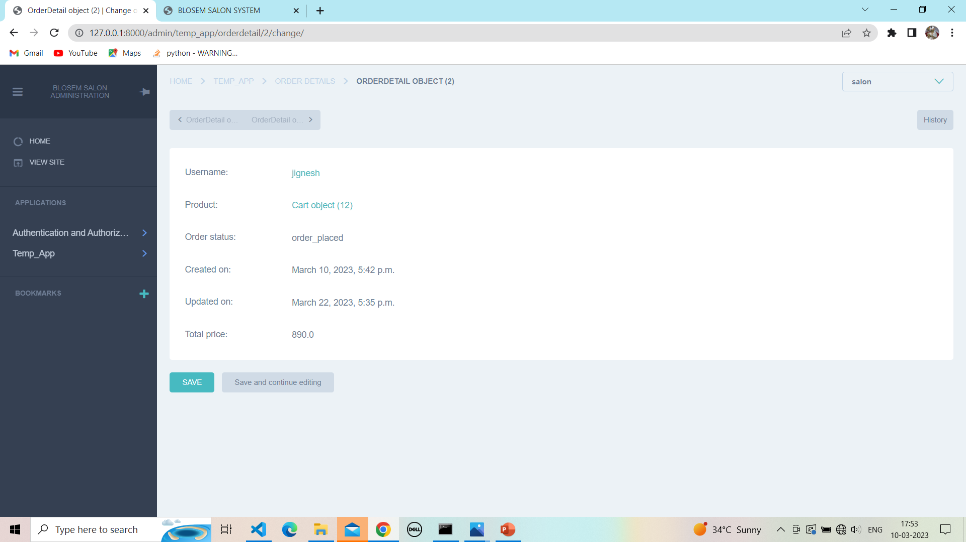

**12. Appointment :**

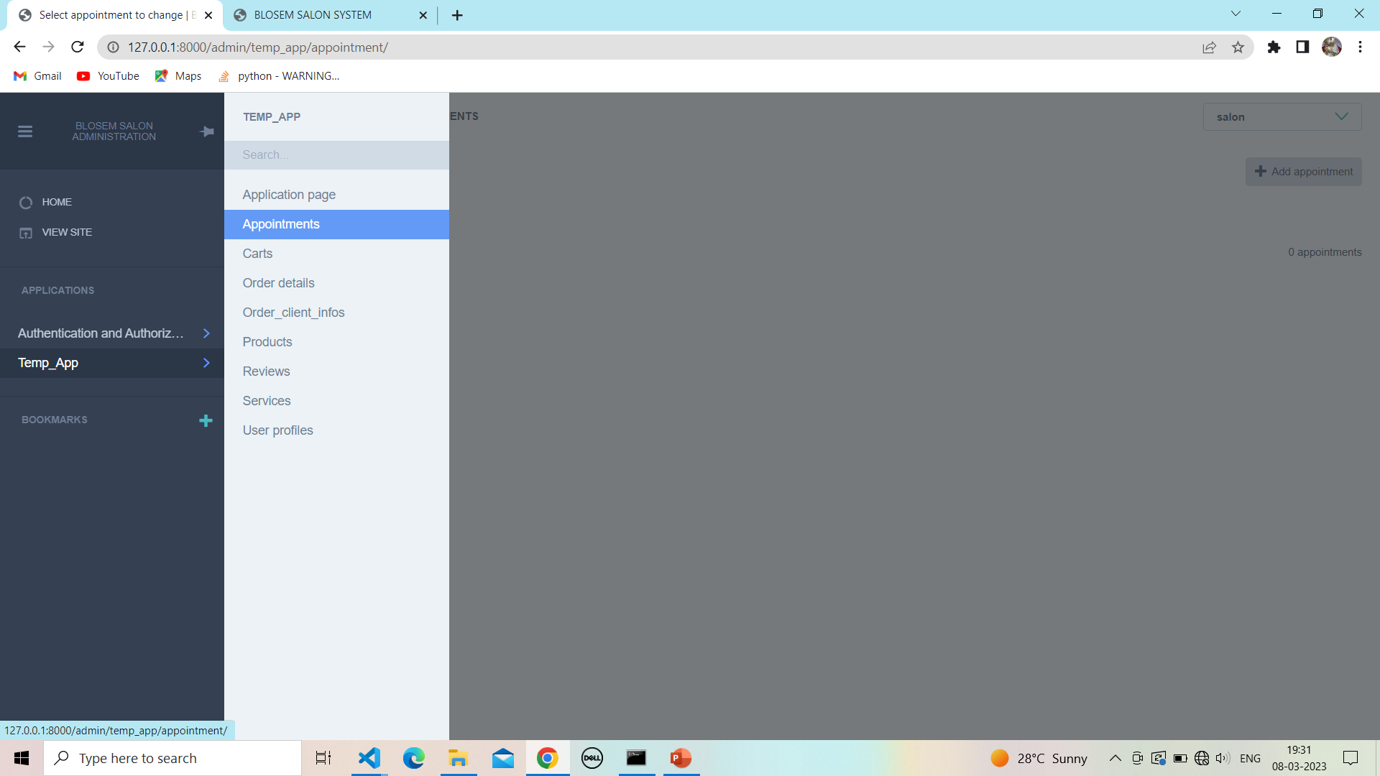

**12.1 View appointment :**

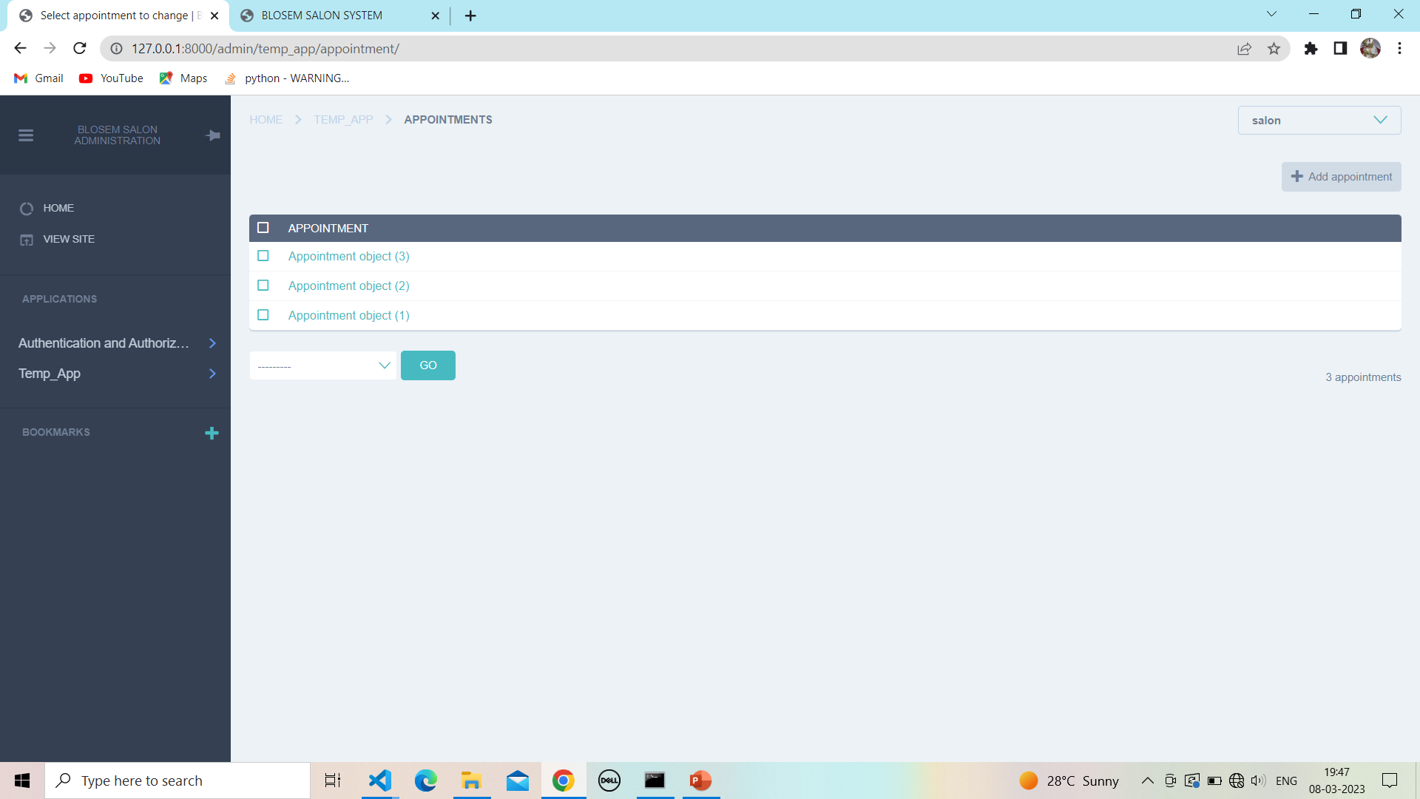

**12.2 View validation :**

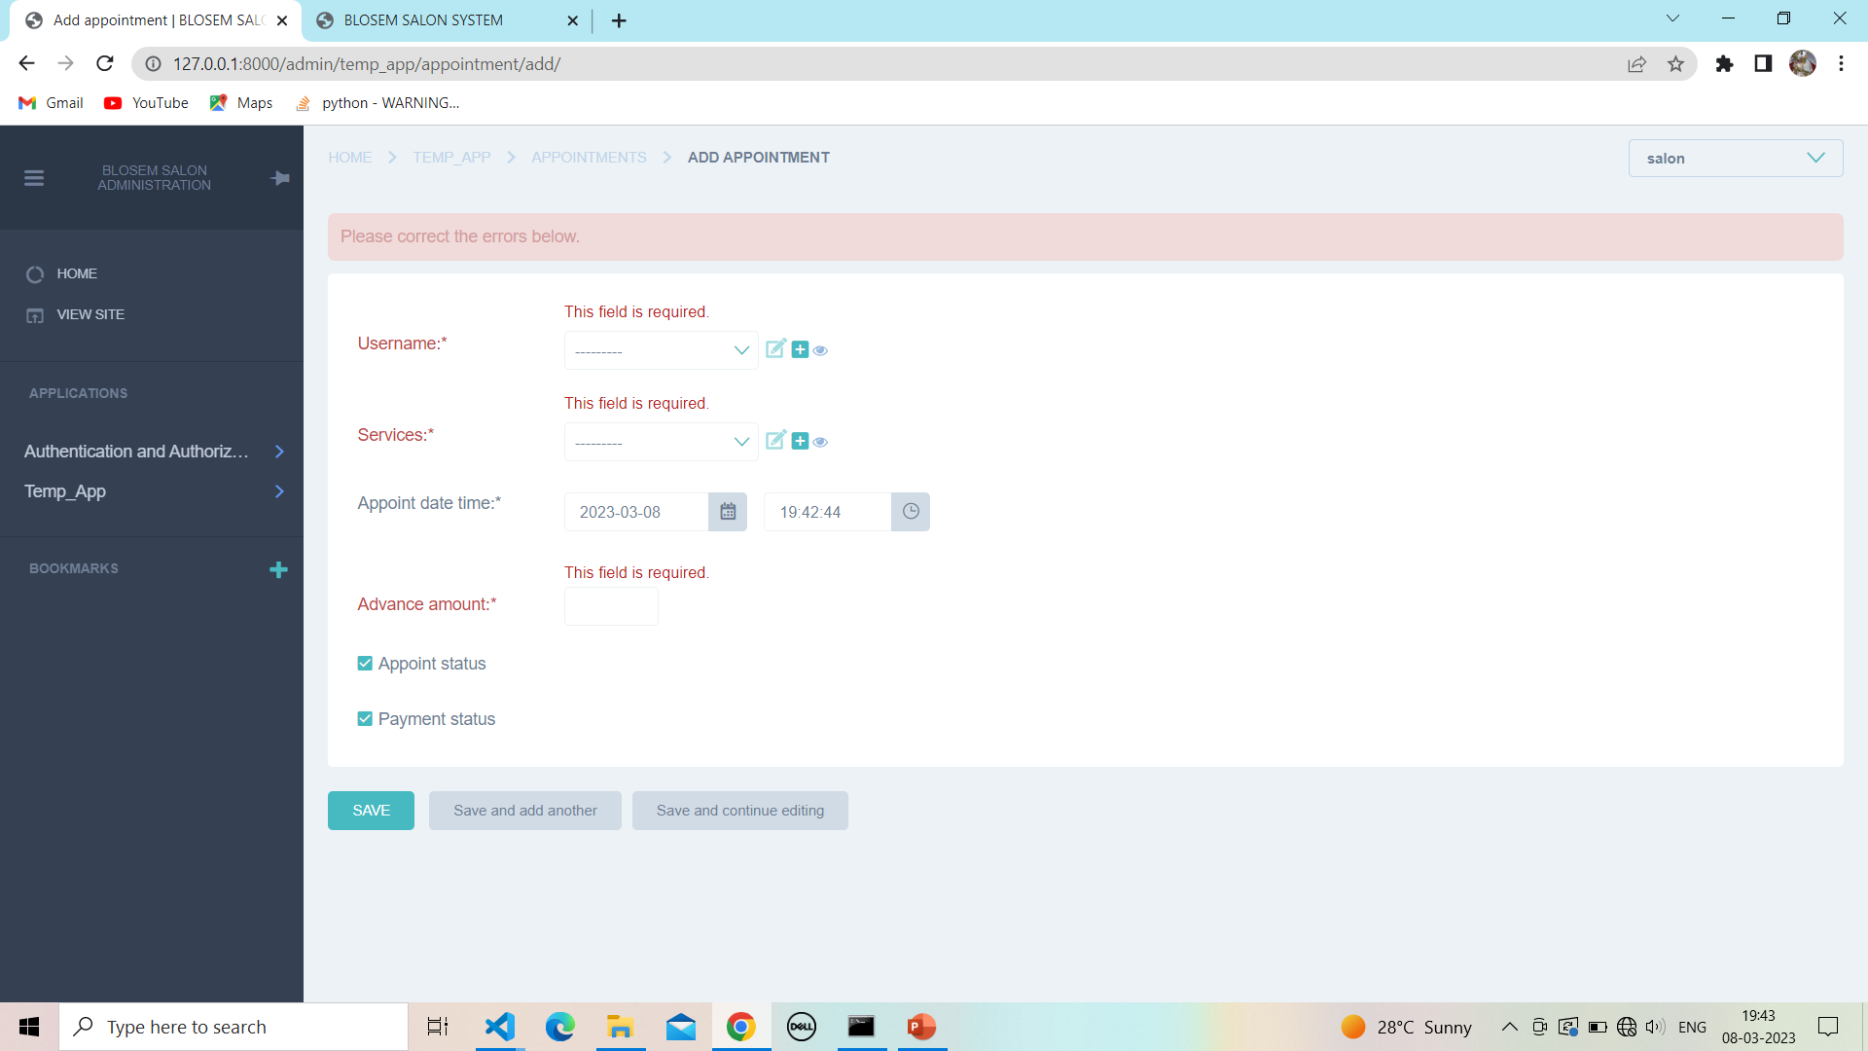

**12.3 Add appointment :**

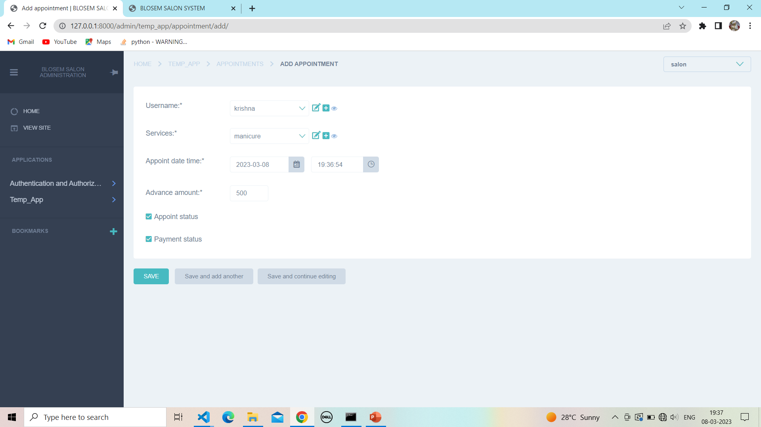

**12.4 Successfully add appointment :**

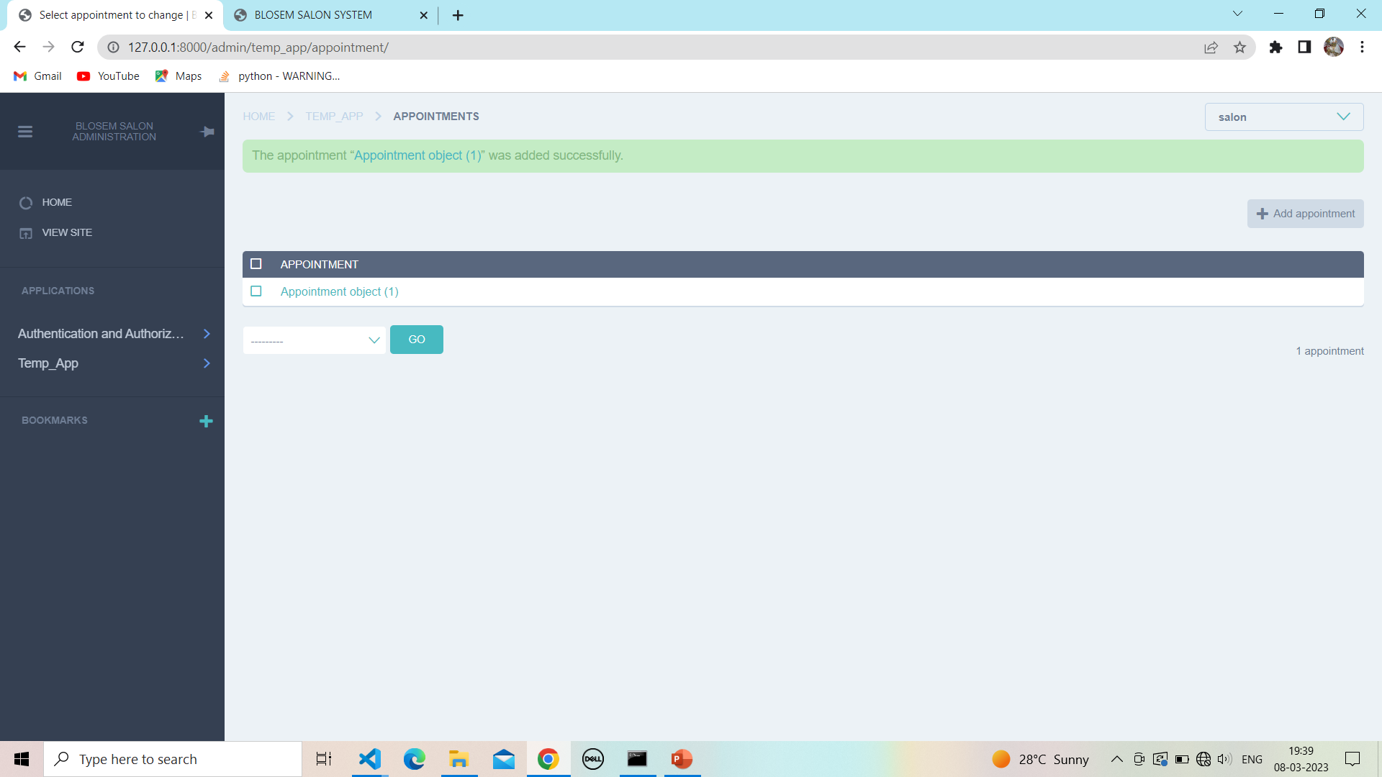

**12.5 Update appointment :**

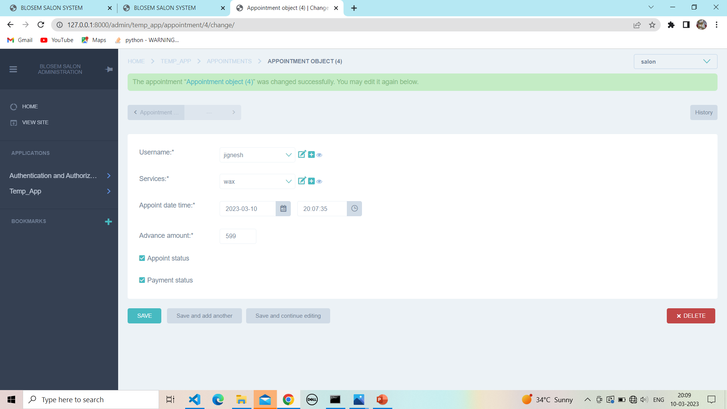

**12.6 Delete :**

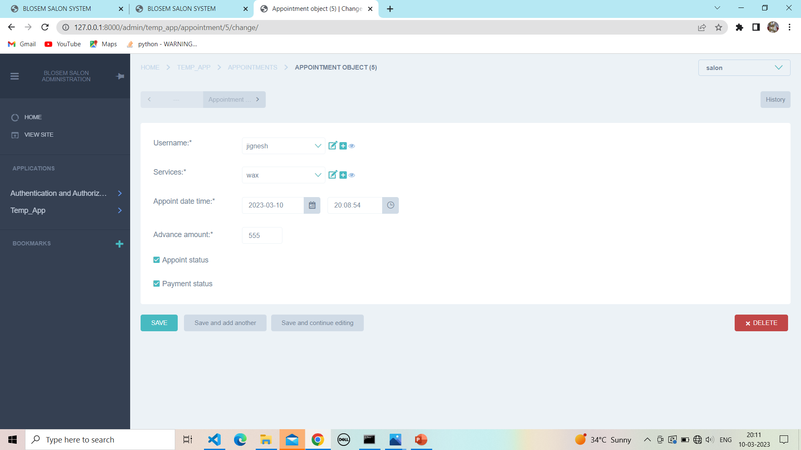

**12.7 Confirm to delete appointment :**

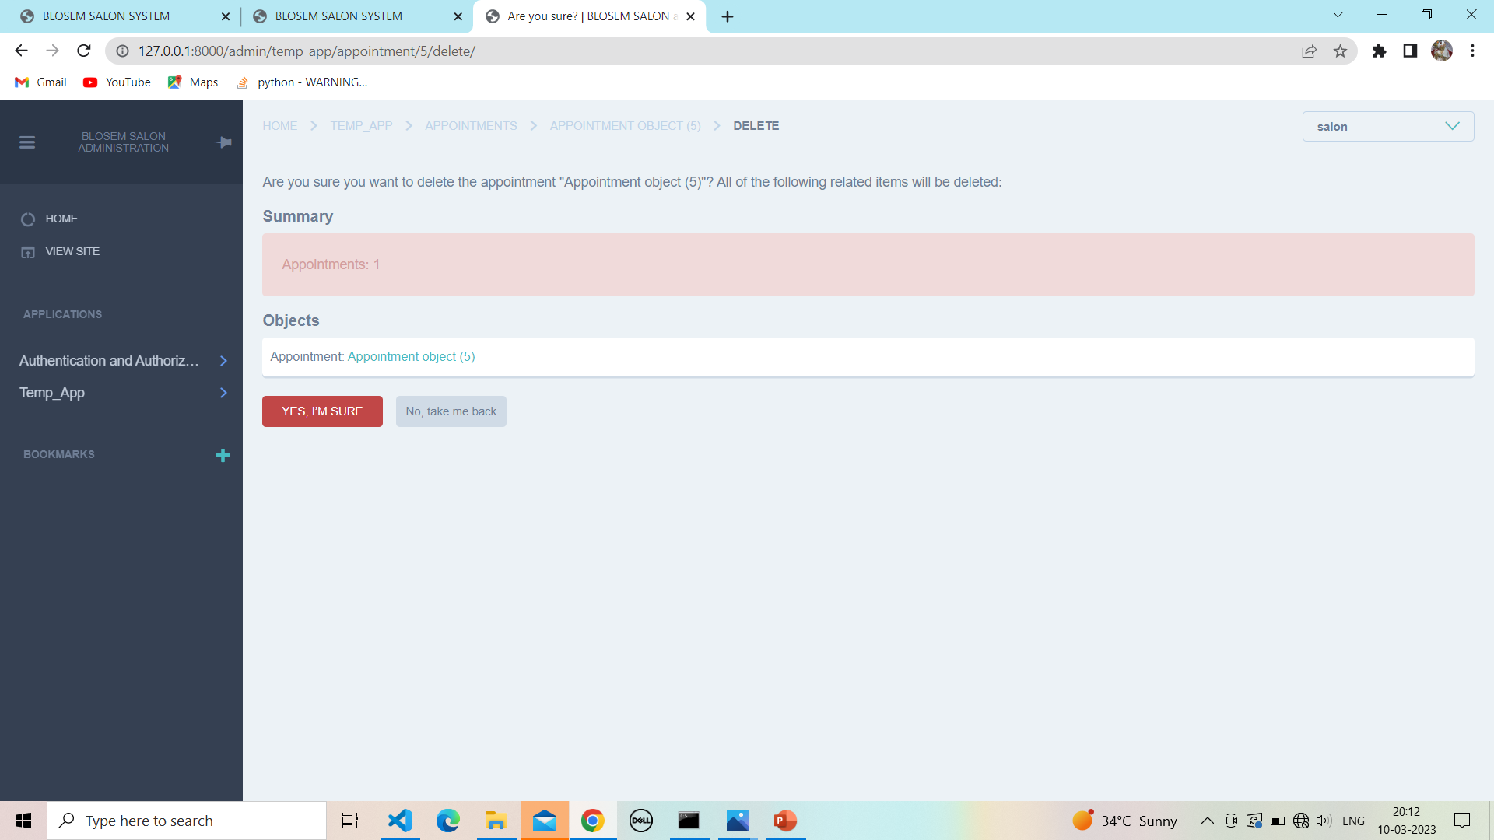

**12.8 After delete product :**

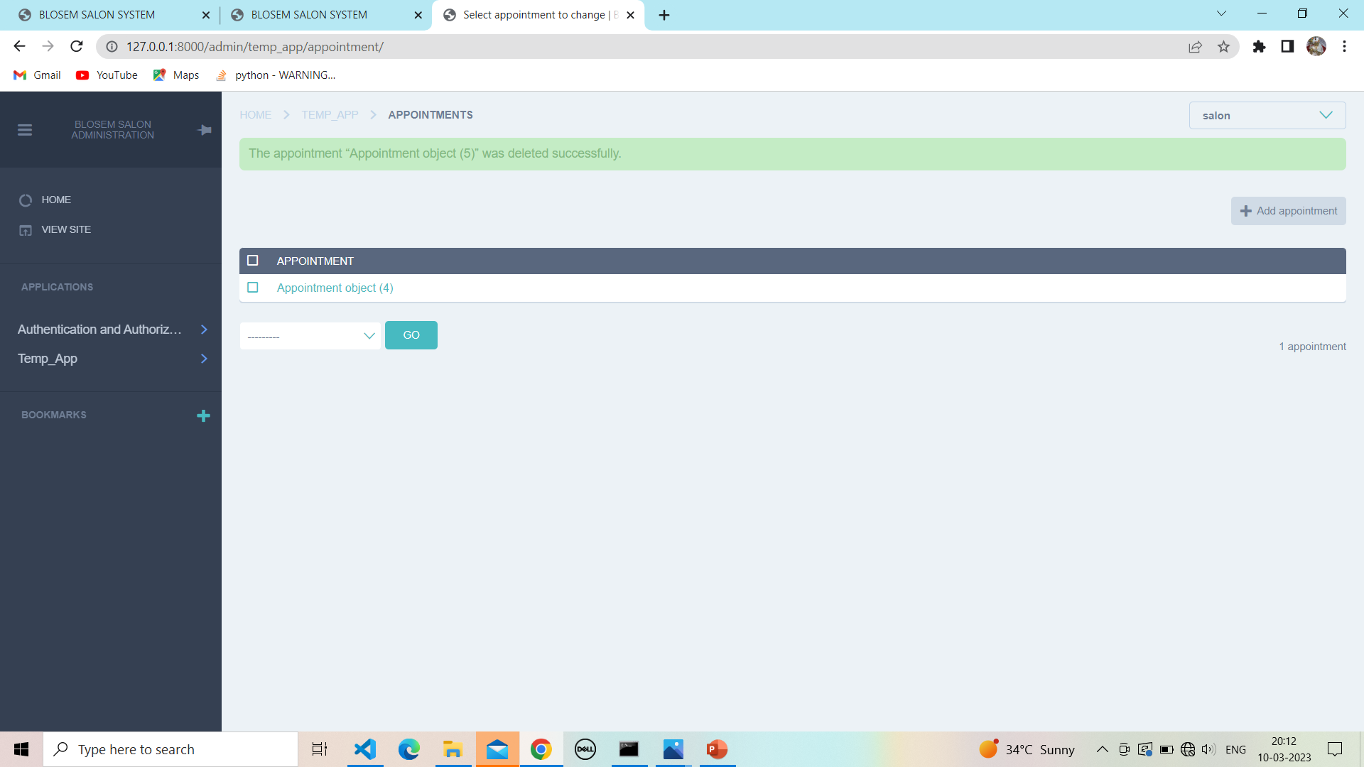

**13. Services :**

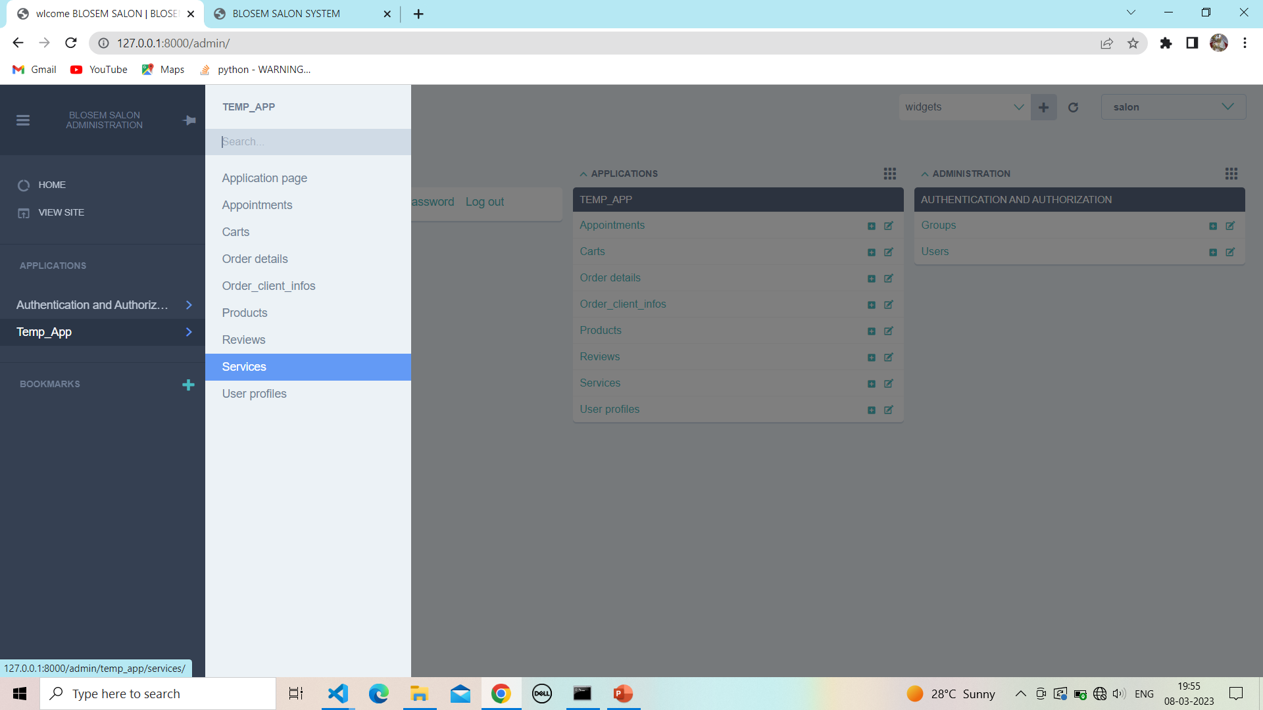

**13.1 View service :**

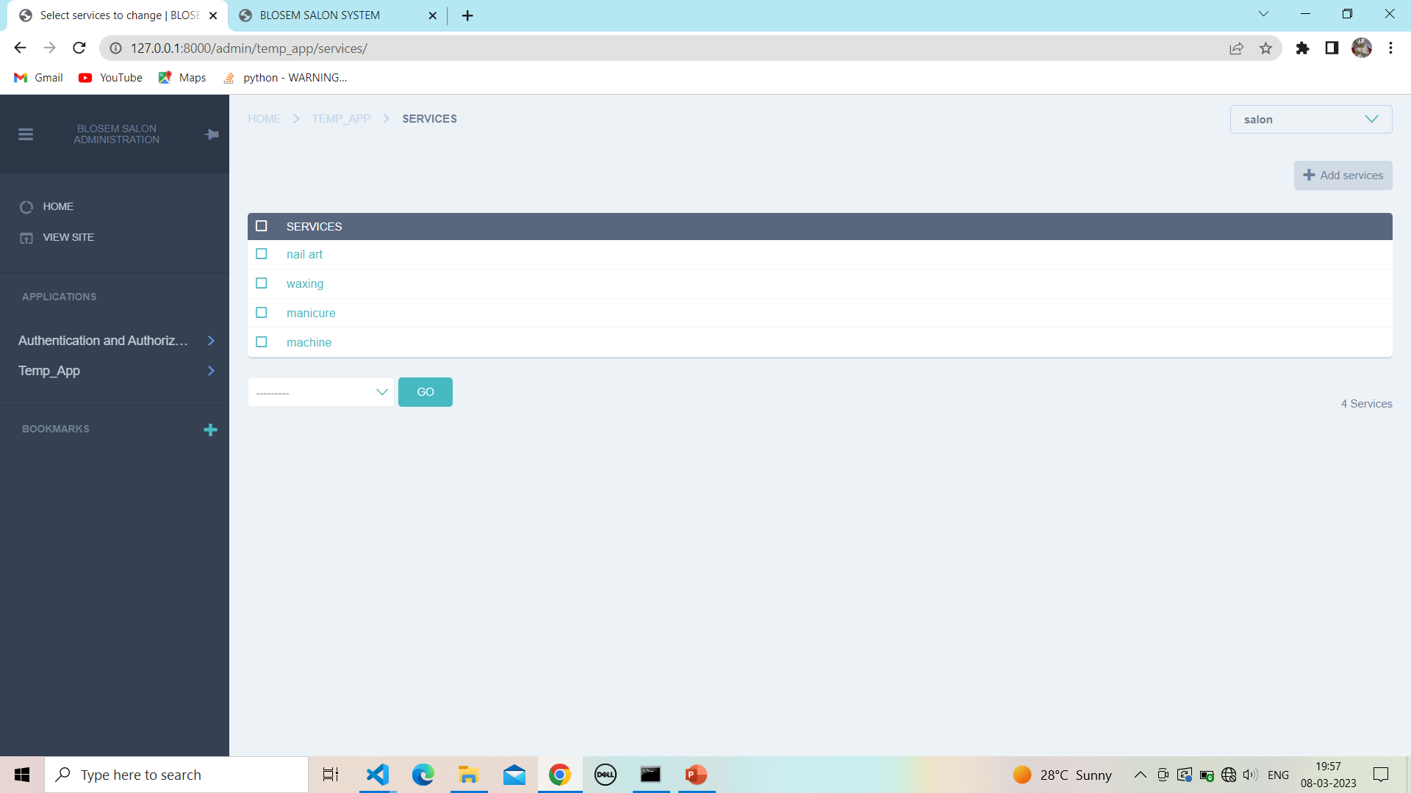

**13.2View validation :**

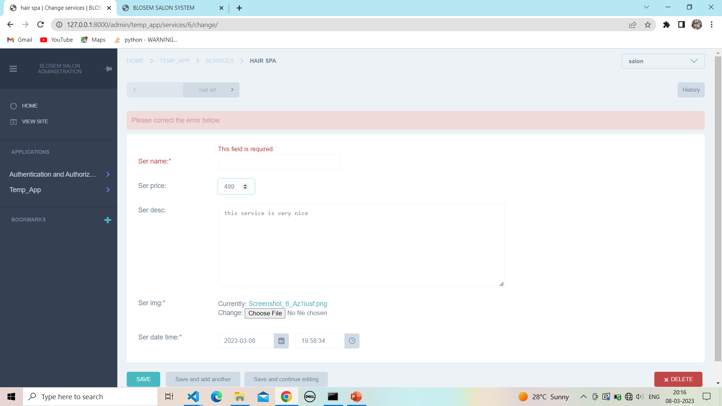

**13.3 Add service :**

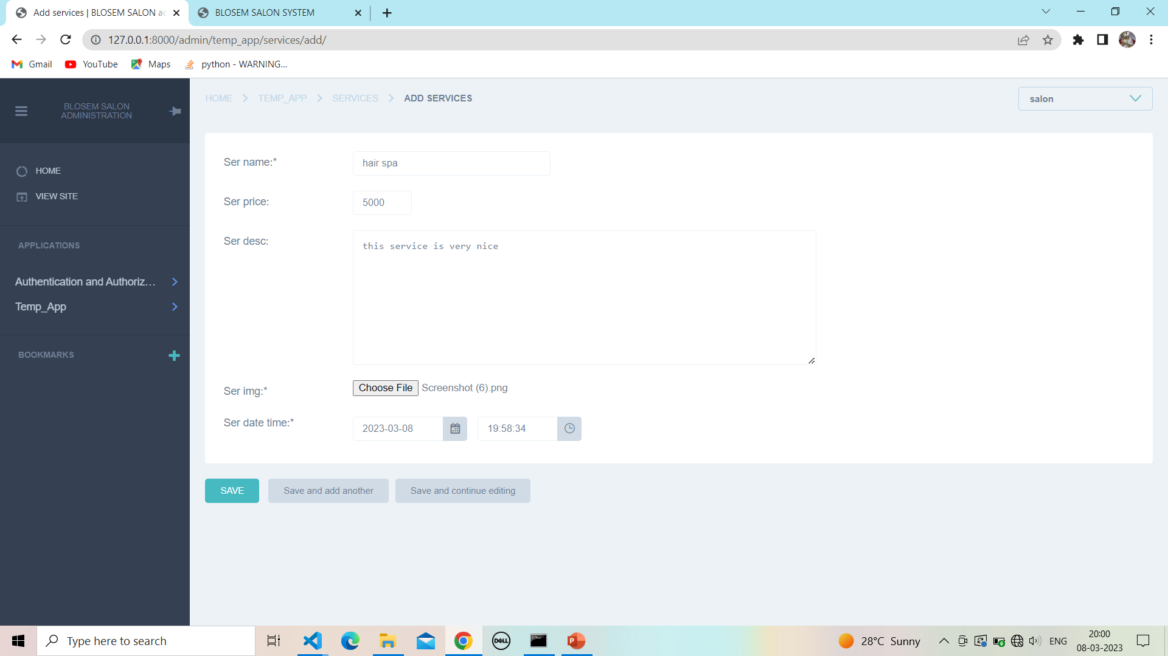

**13.4 Successfully add service :**

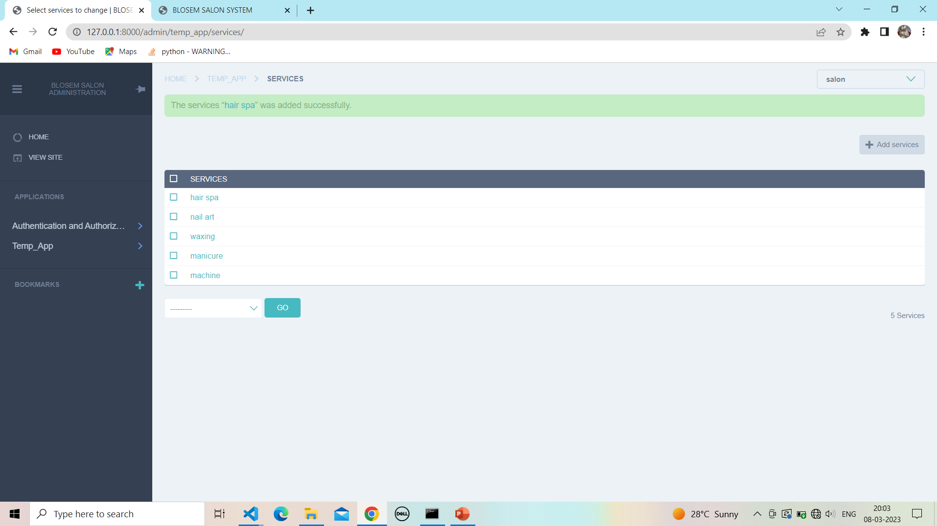

**13.5 Update service :**

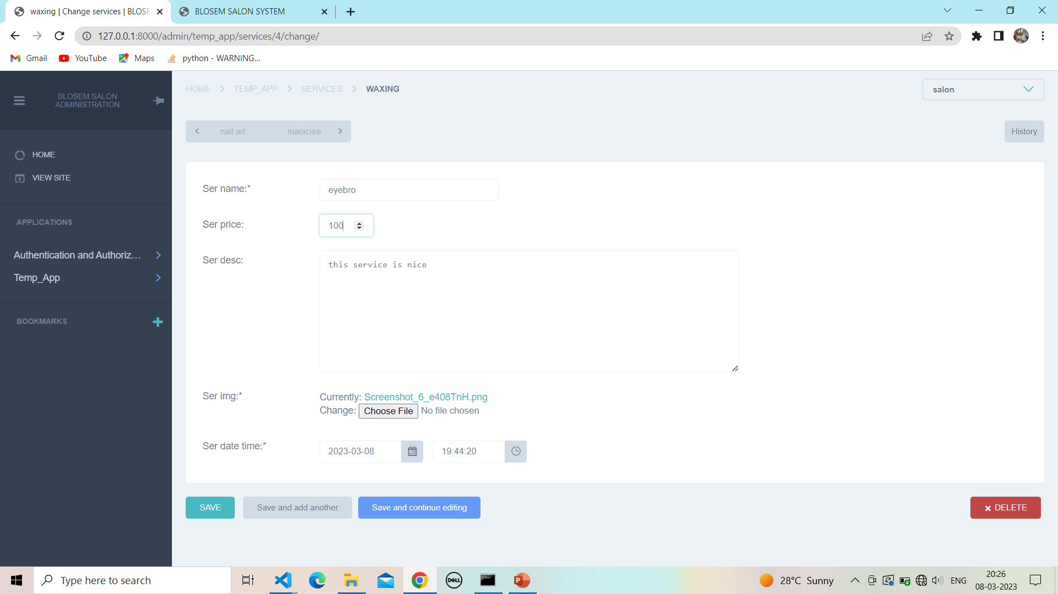

**13.6 Successfully update service :**

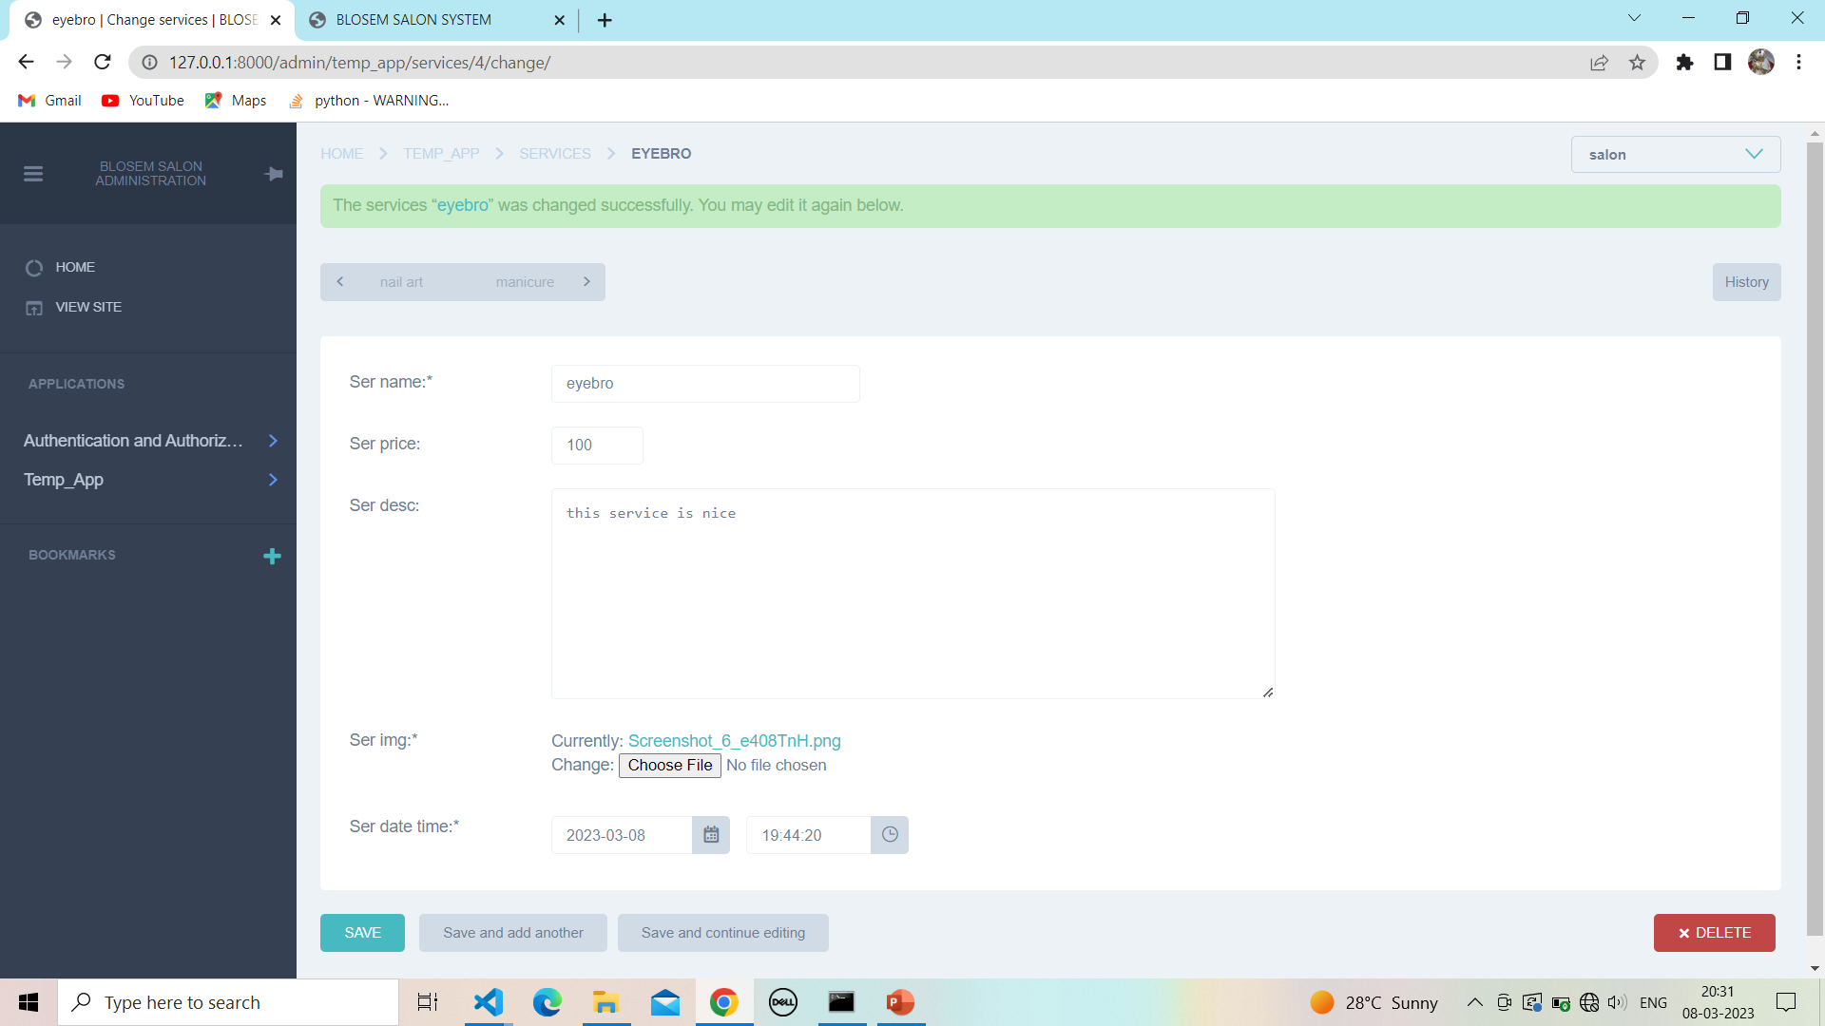

**13.7 Delete service :**

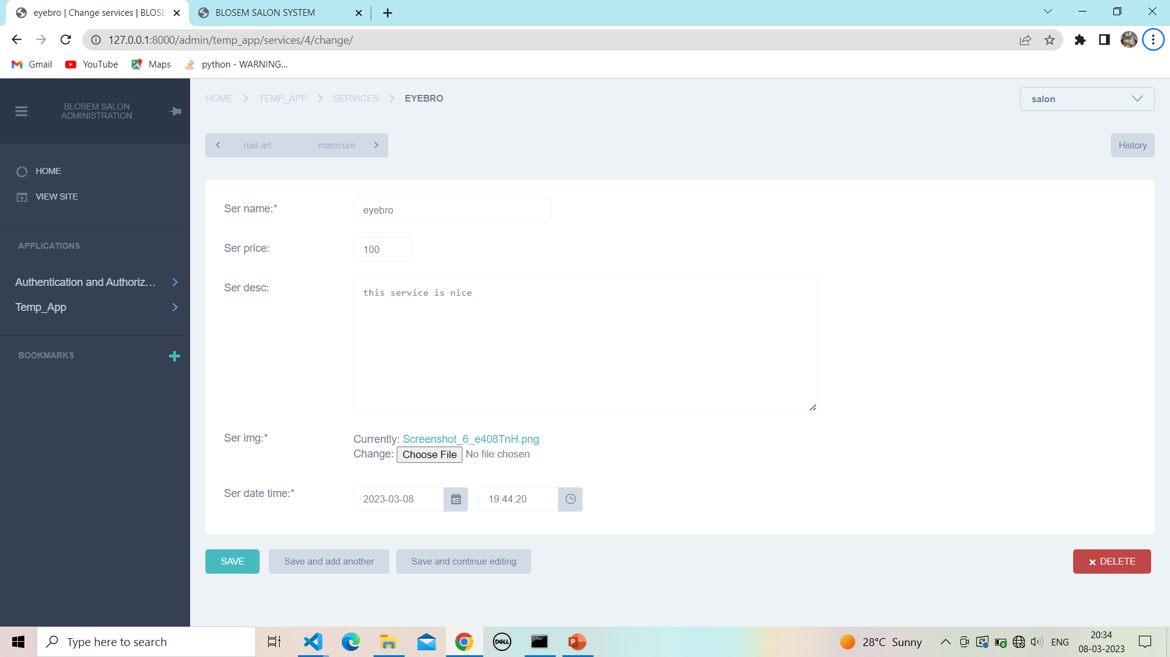

**13.8 Confirm to delete service :**

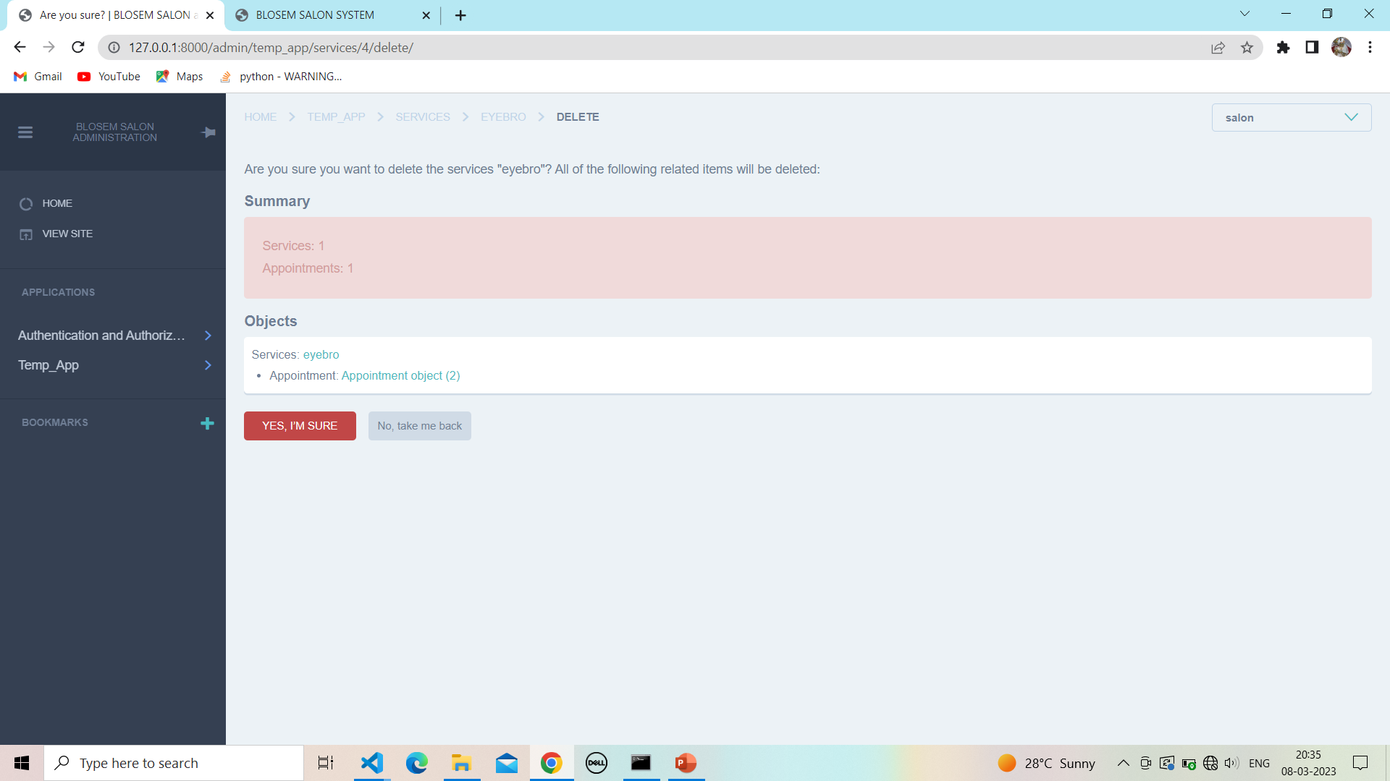

**13.9 After delete service :**

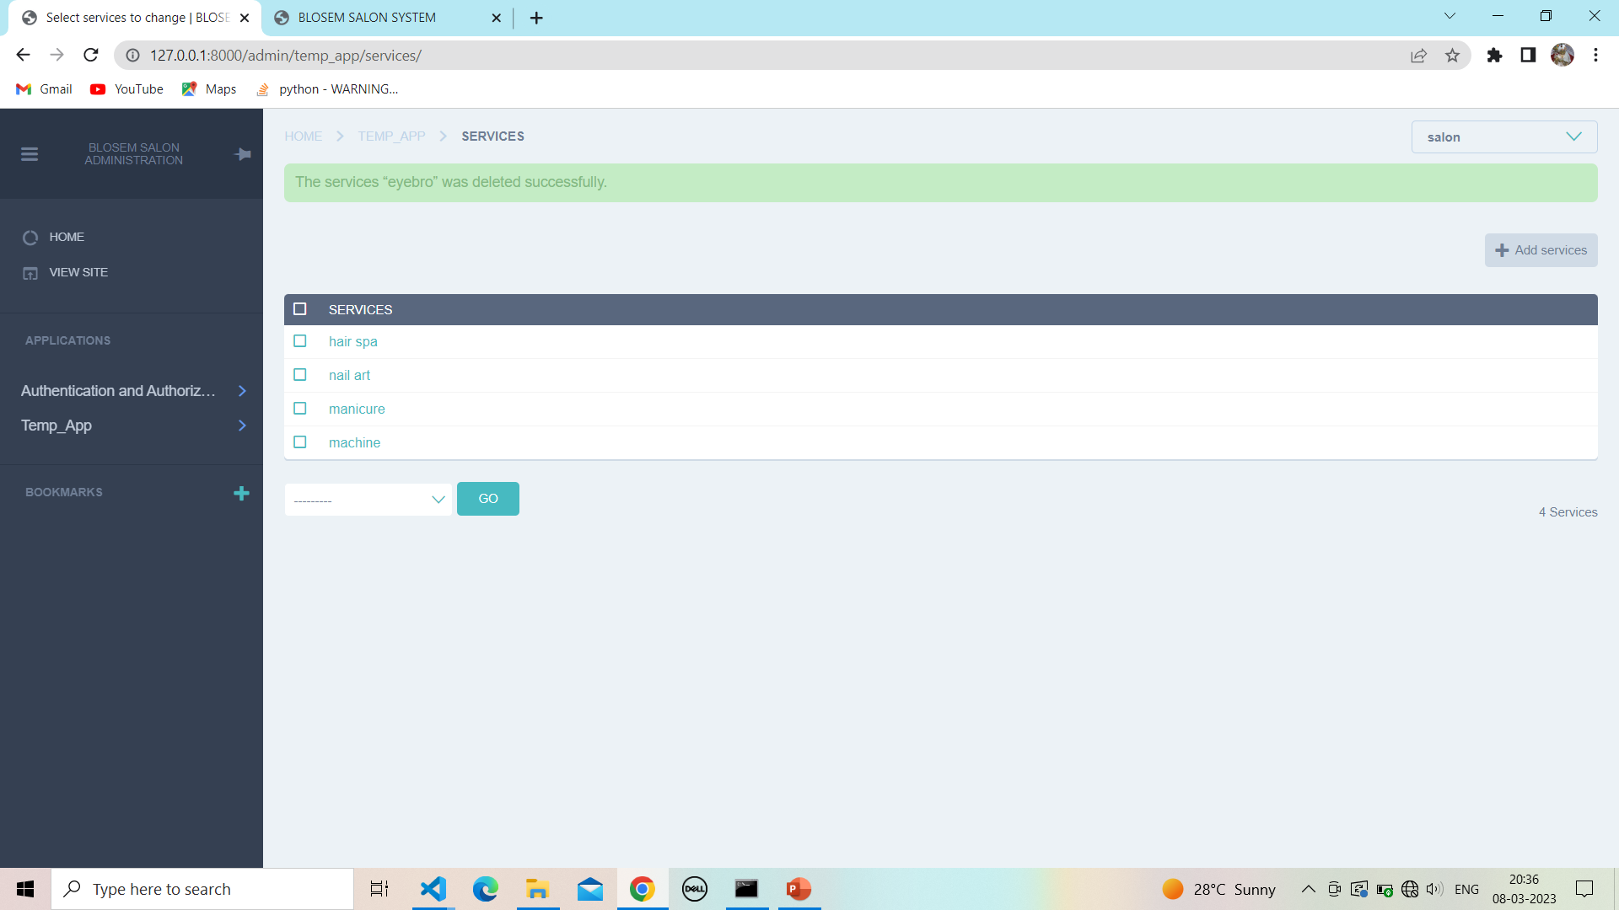

**14. client order information:**

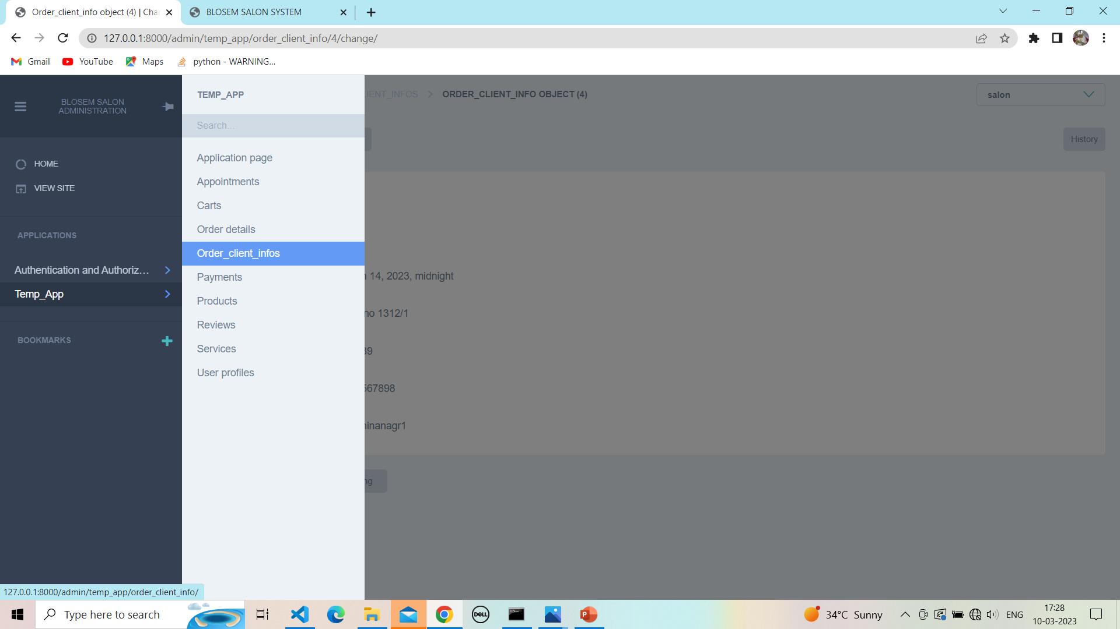

**14.1 Show client order information:**

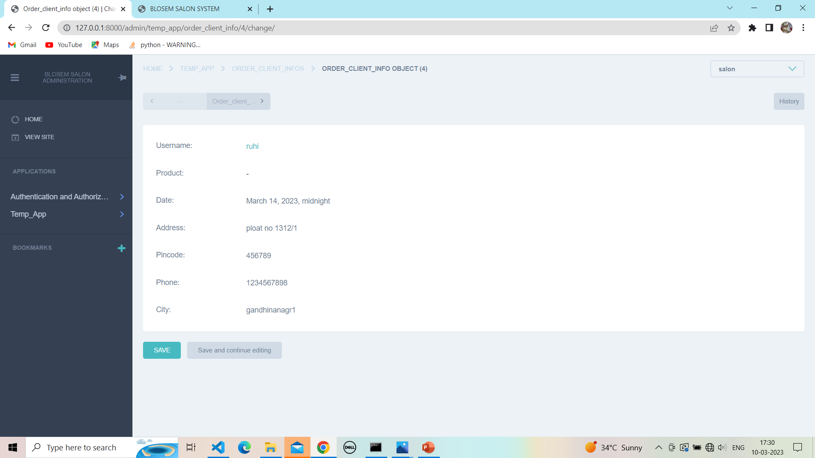

**15.Payment :**

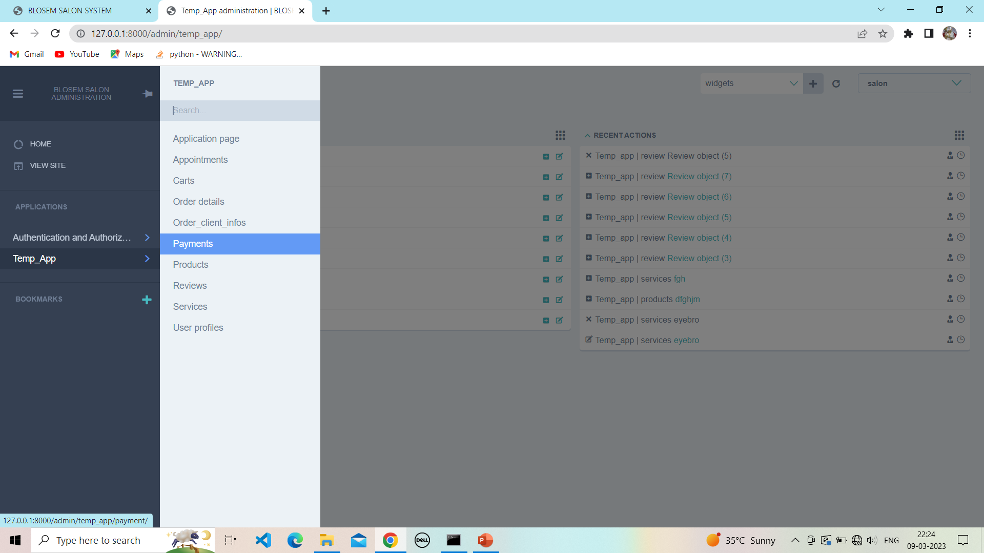

**15.1 show payment :**

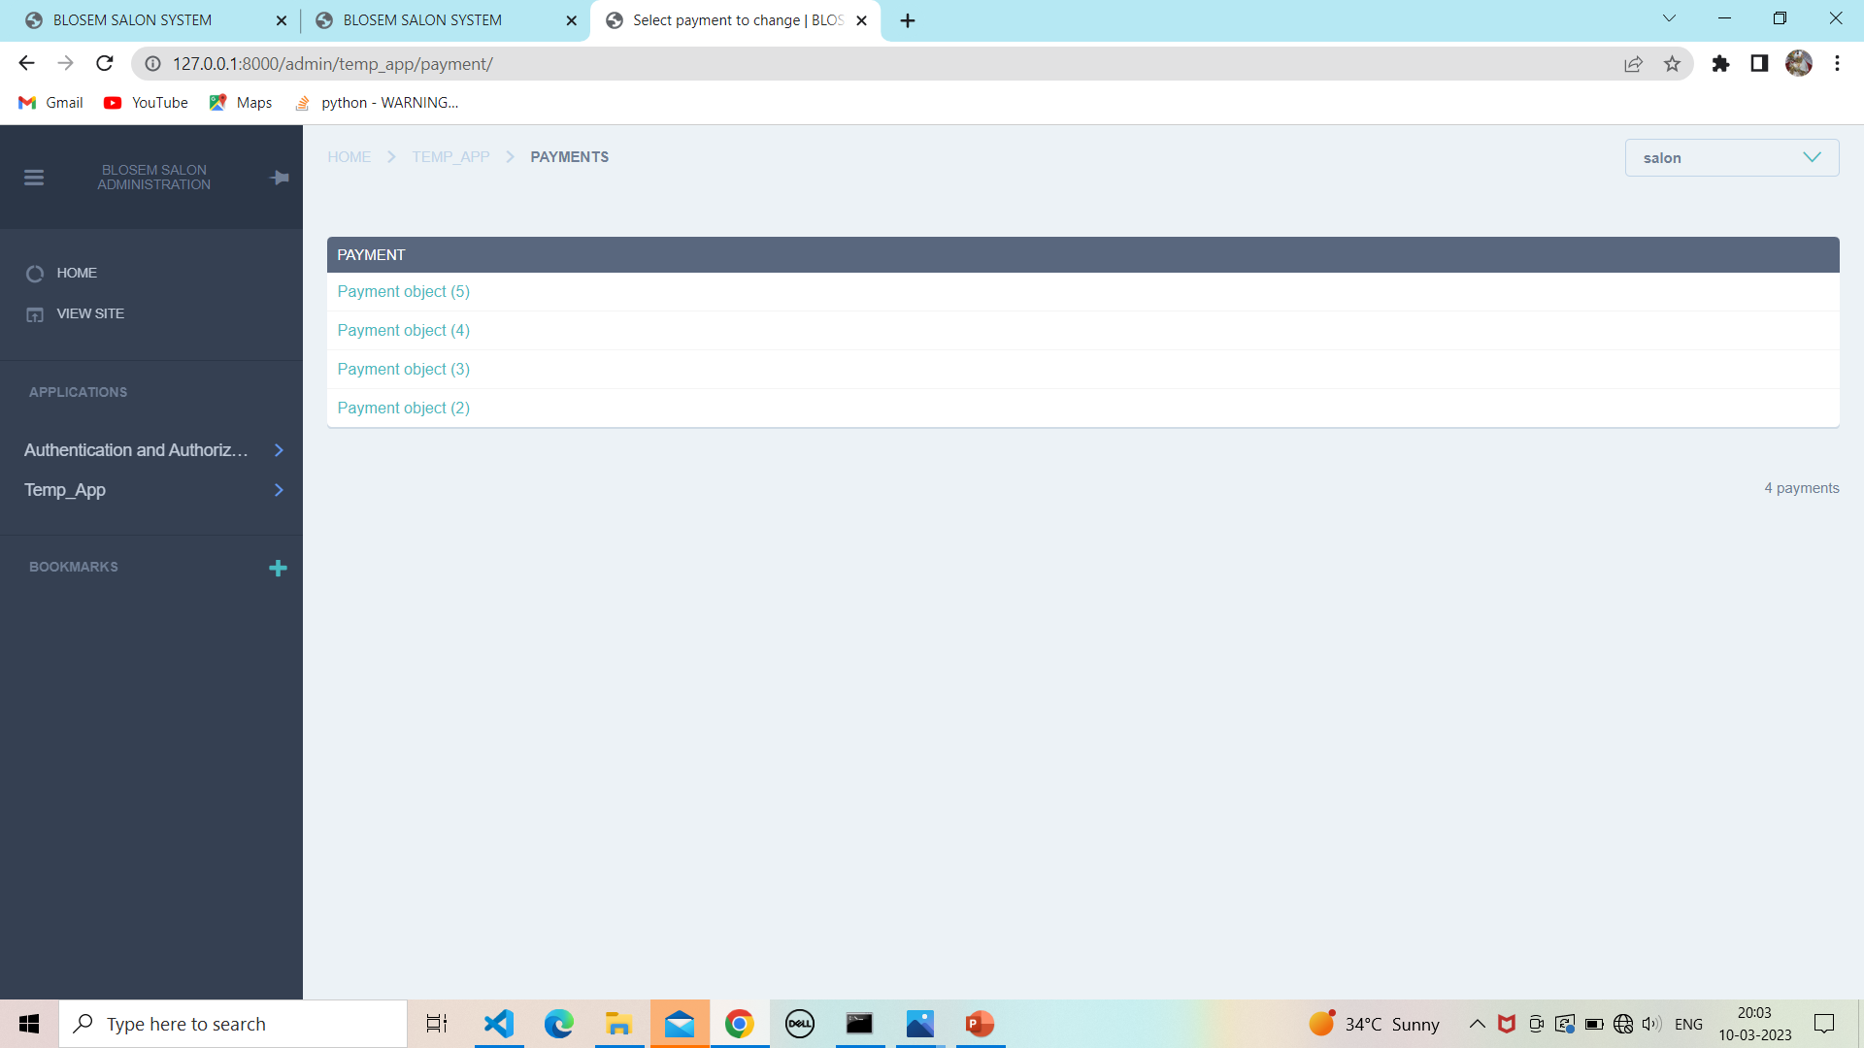

**15.2 Show payment detail:**

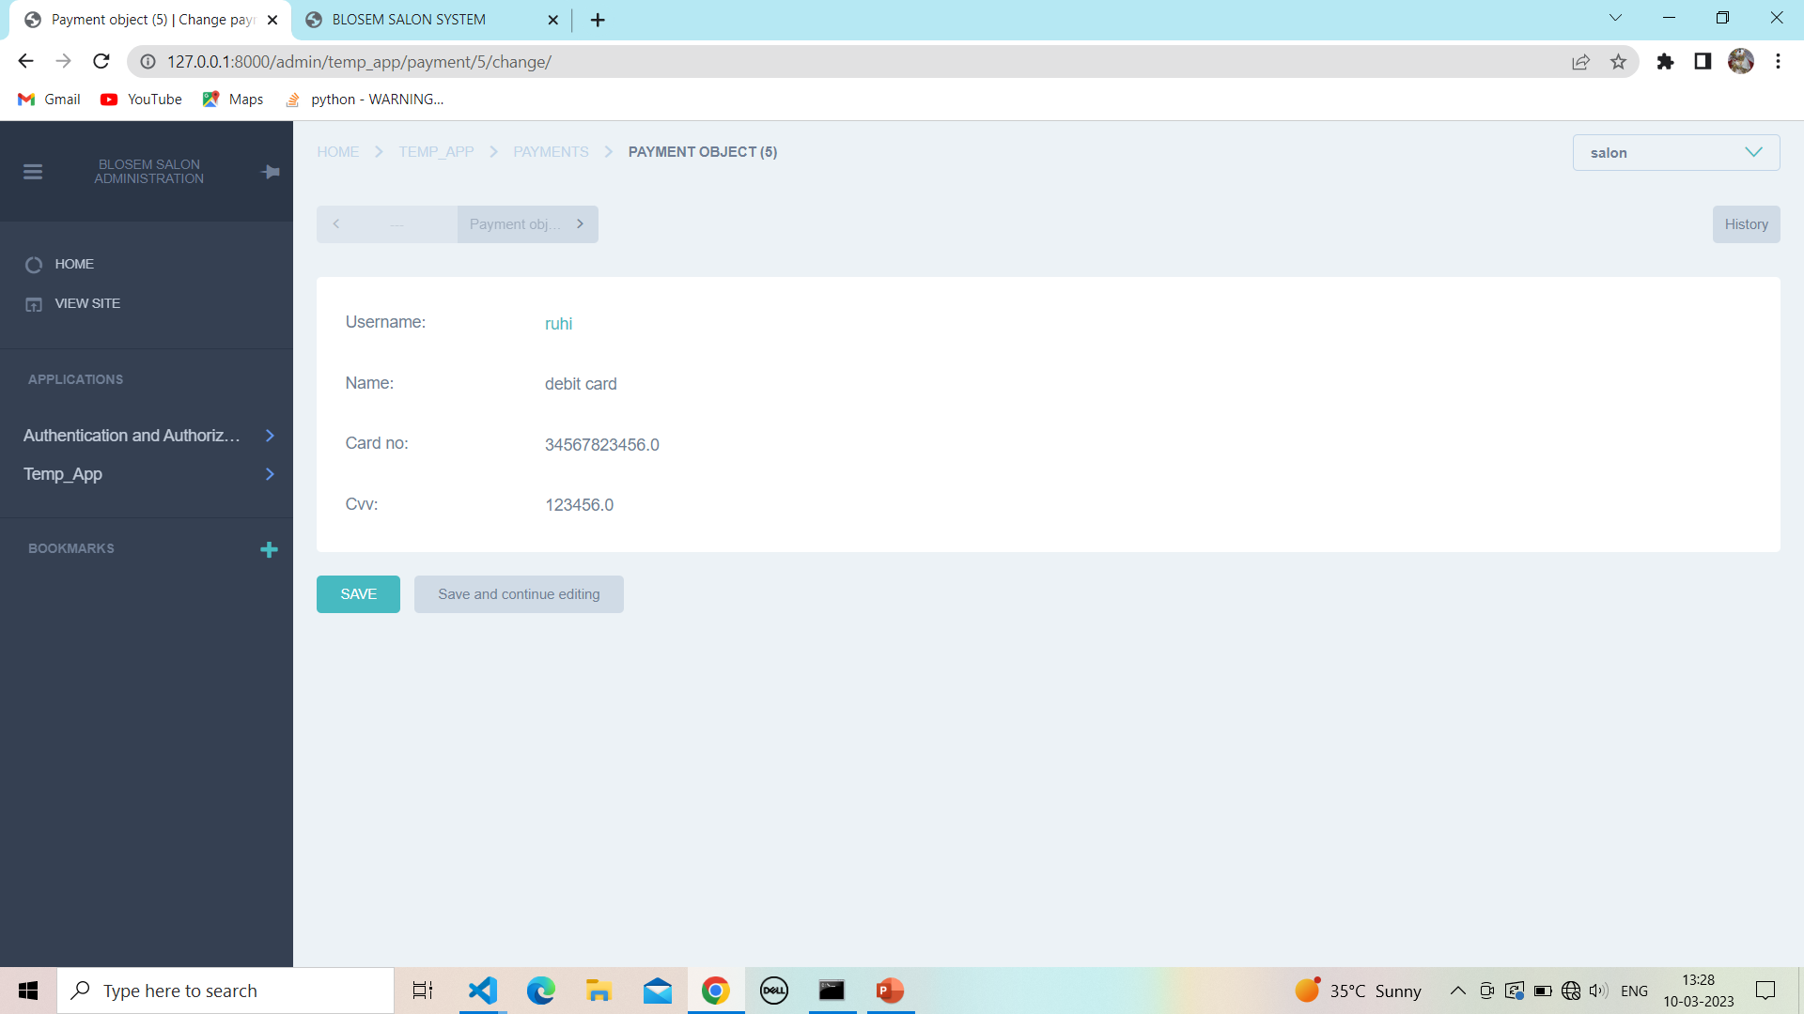

**16. Review :**

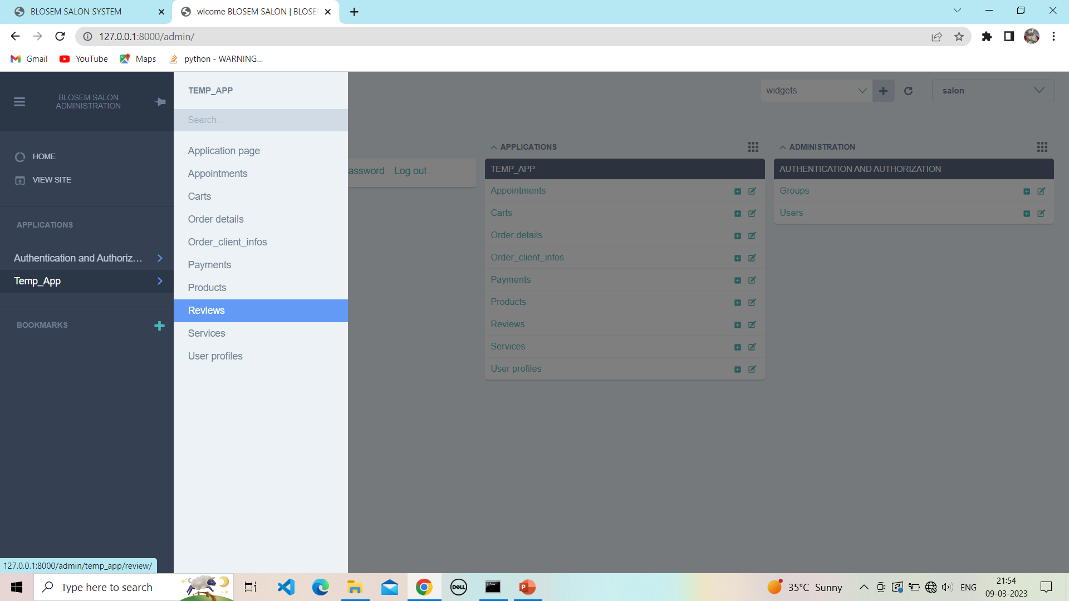

**16.1 View review :**

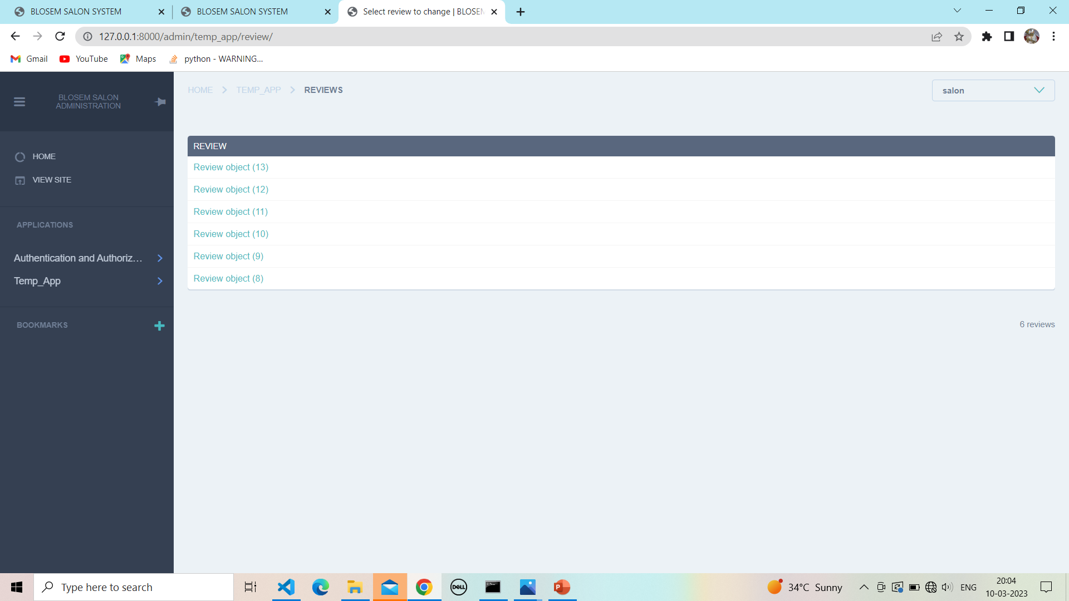

**16.2 Show review :**



**17. Select User report :**

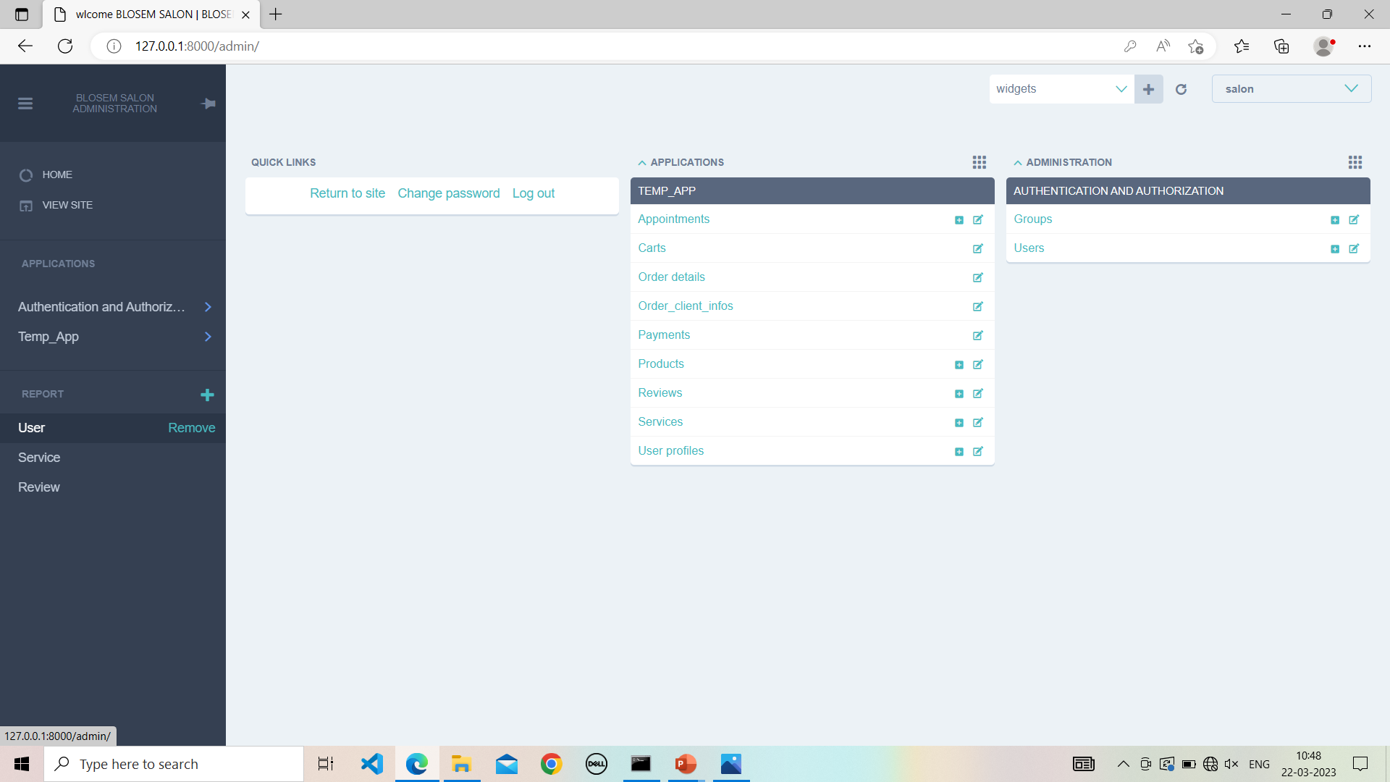

**17.1 User report :**

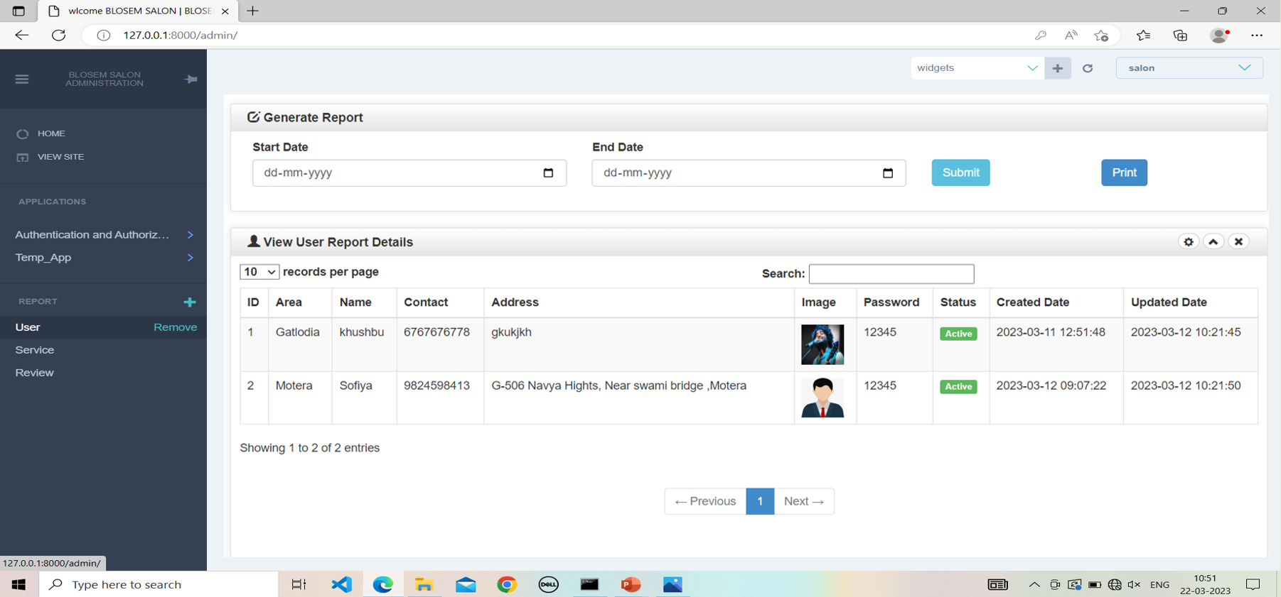

**17.2 select service report :**

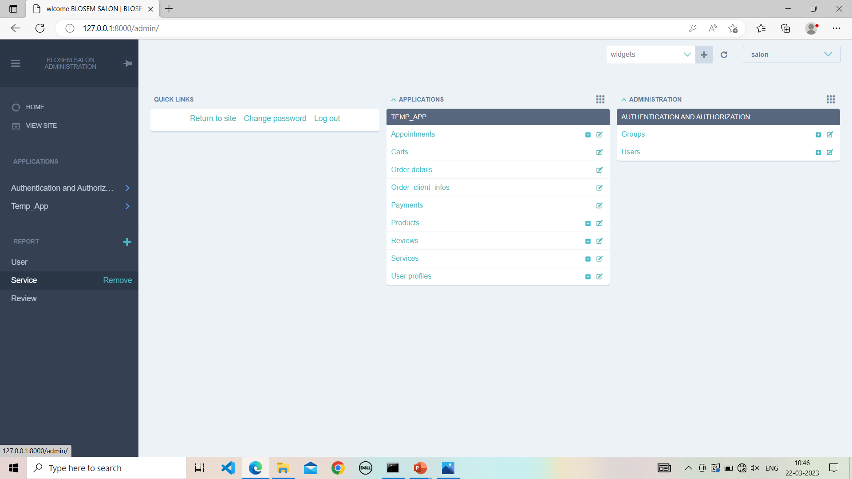

**17.3 Service report :**

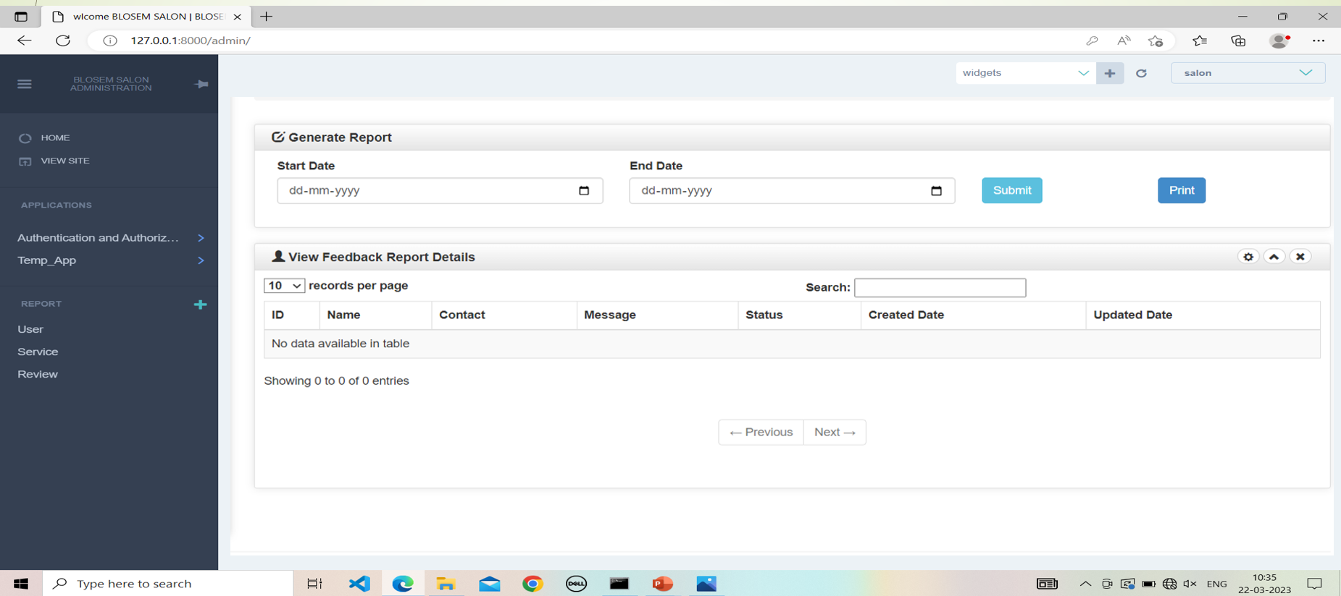

**17.4 Select review report:**

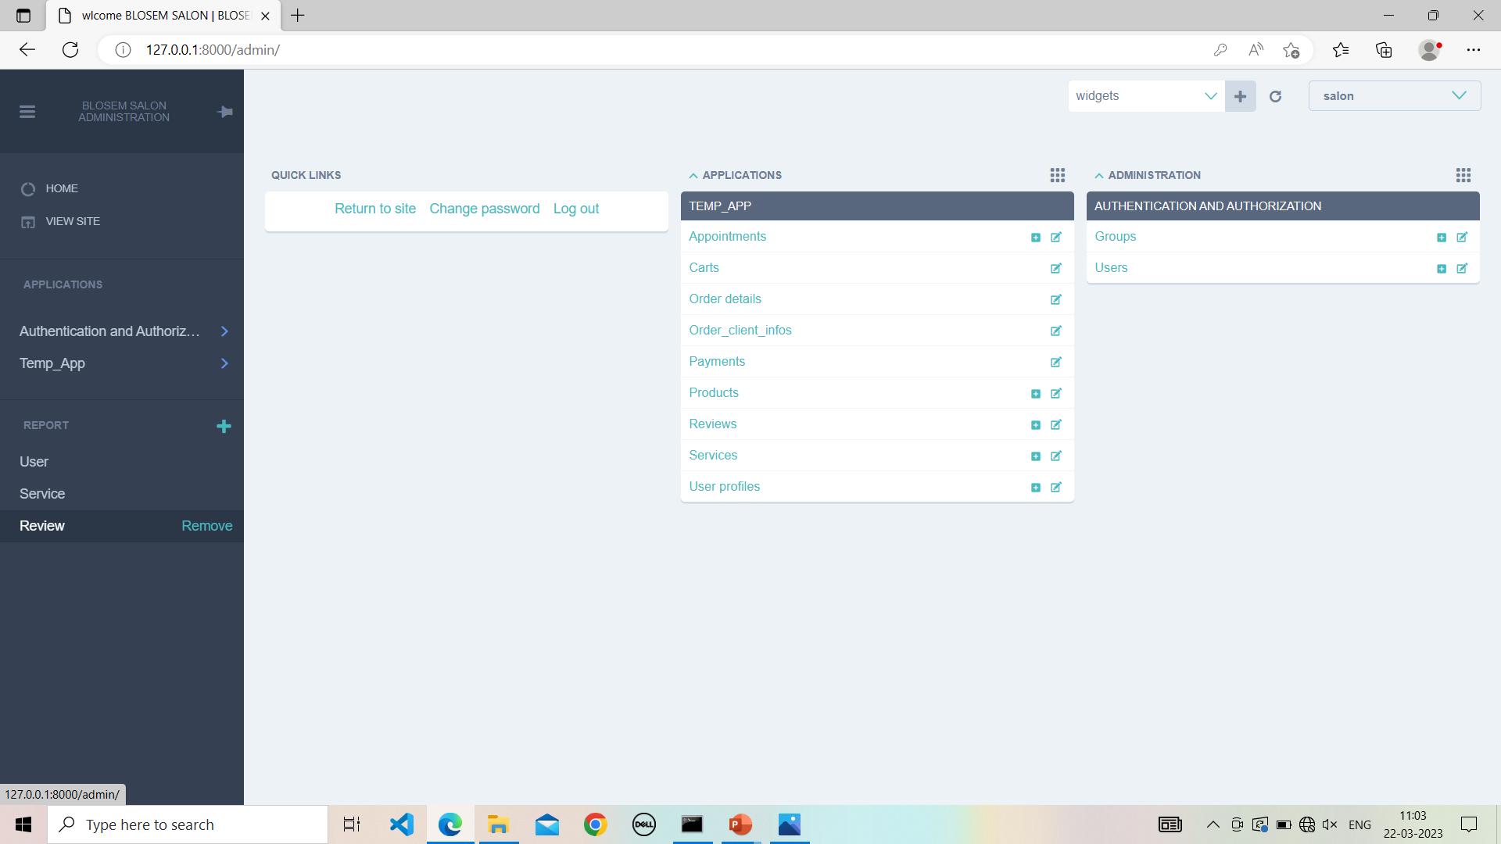

**17.5 Rweview report:**

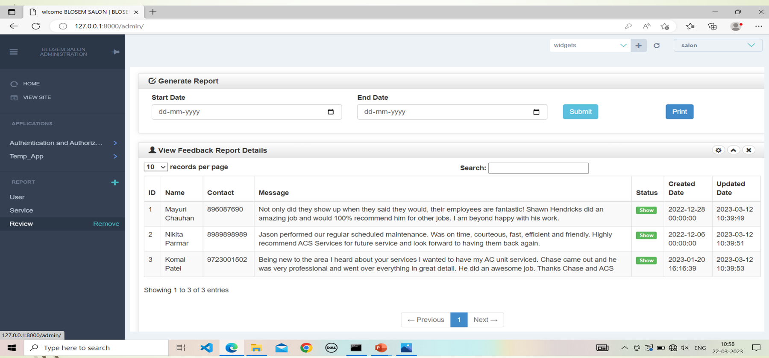

**18. Logout :**

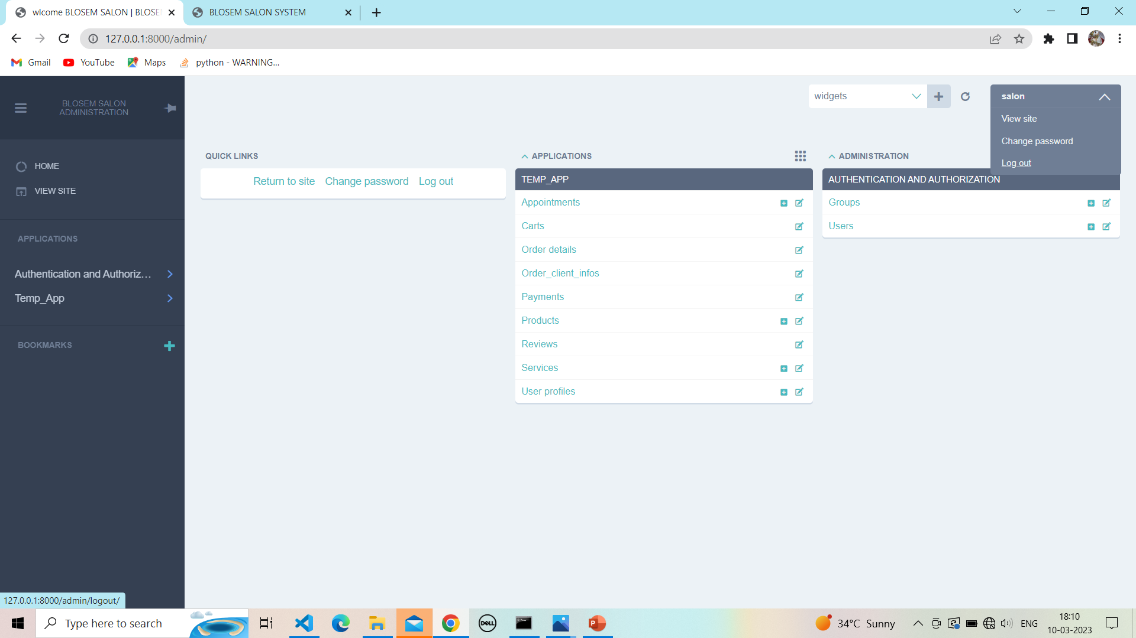

**18.1 Successfully logout :**

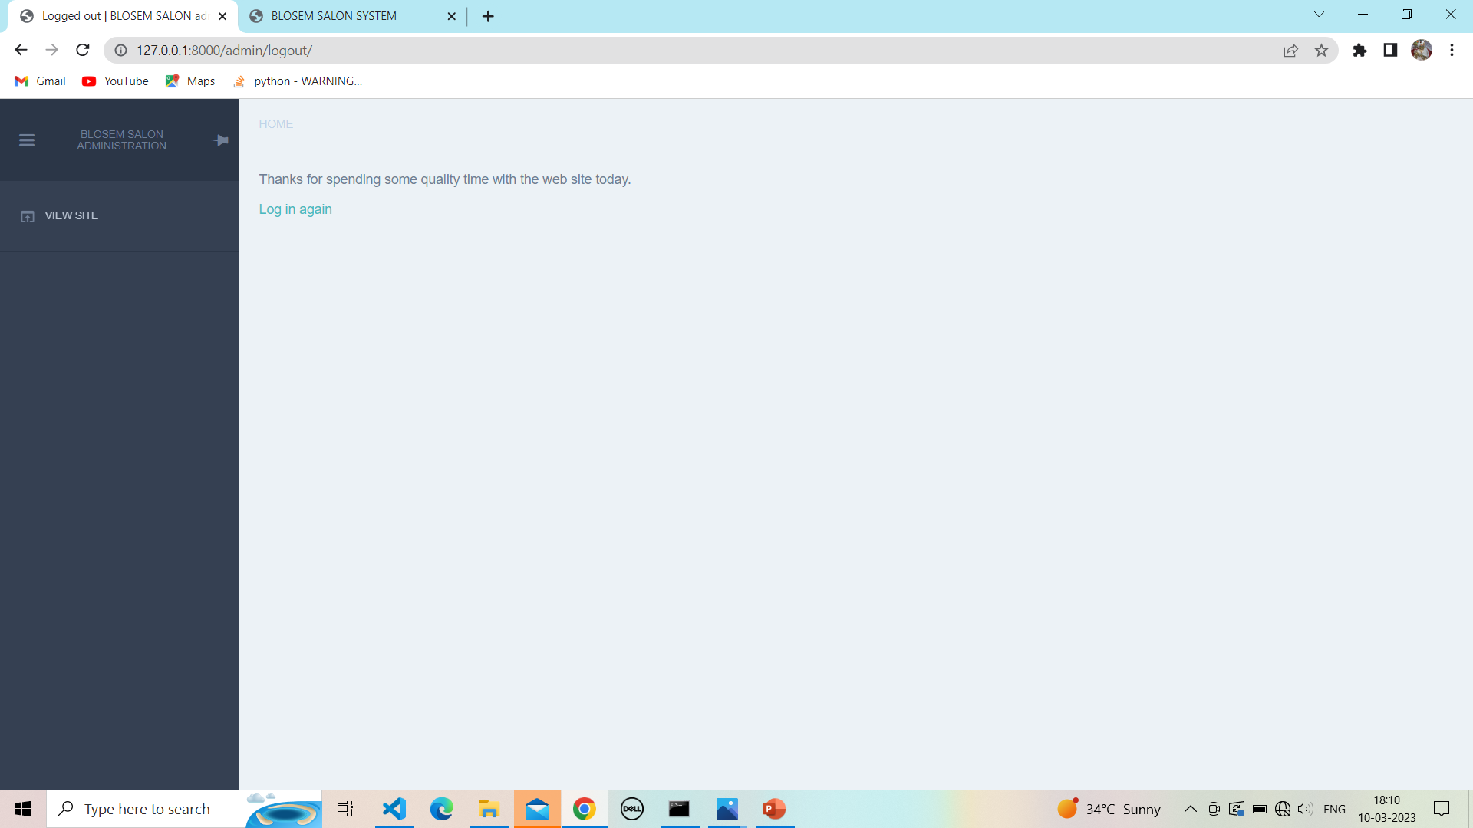

**CLIENT PANEL**

**19.1 Home page :**

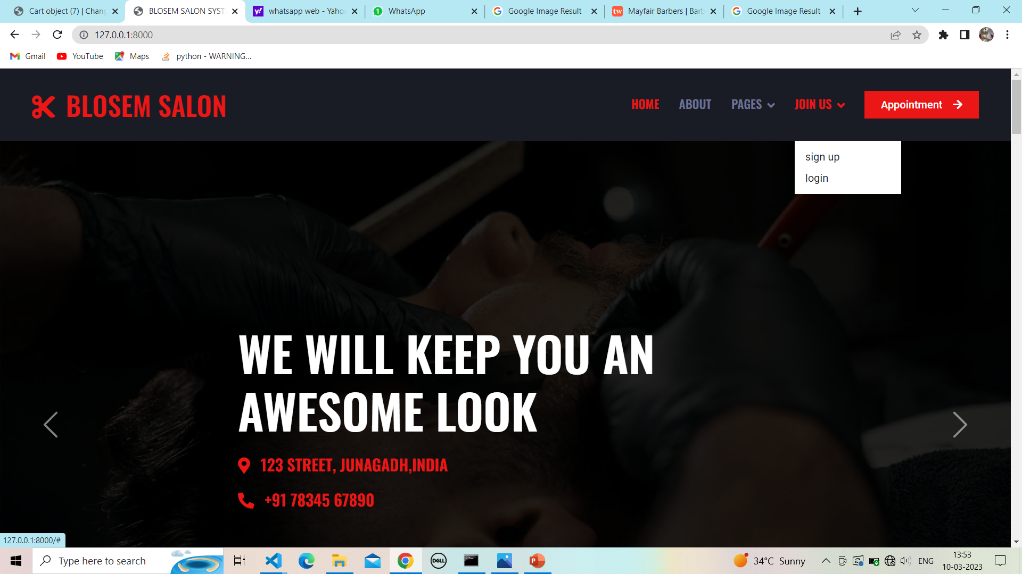

**19.2 Client signup page :**

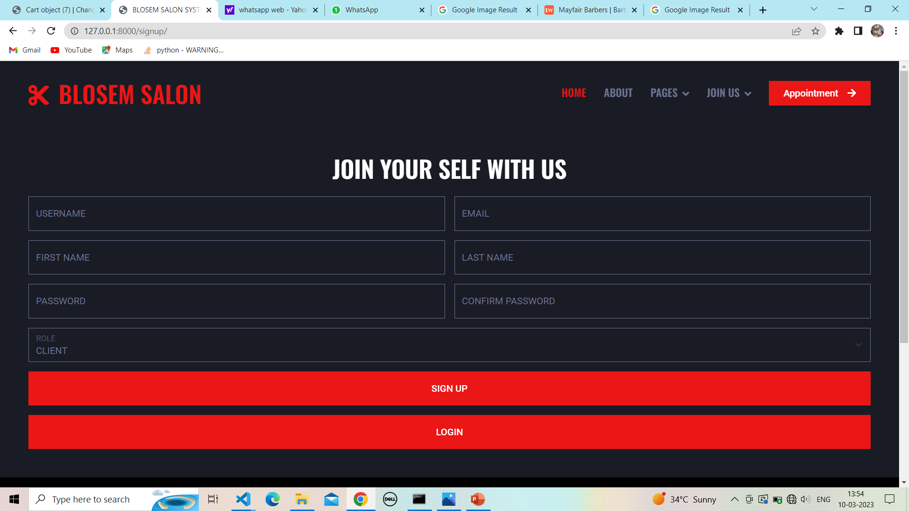

**19.3 Client signup with username validation:**

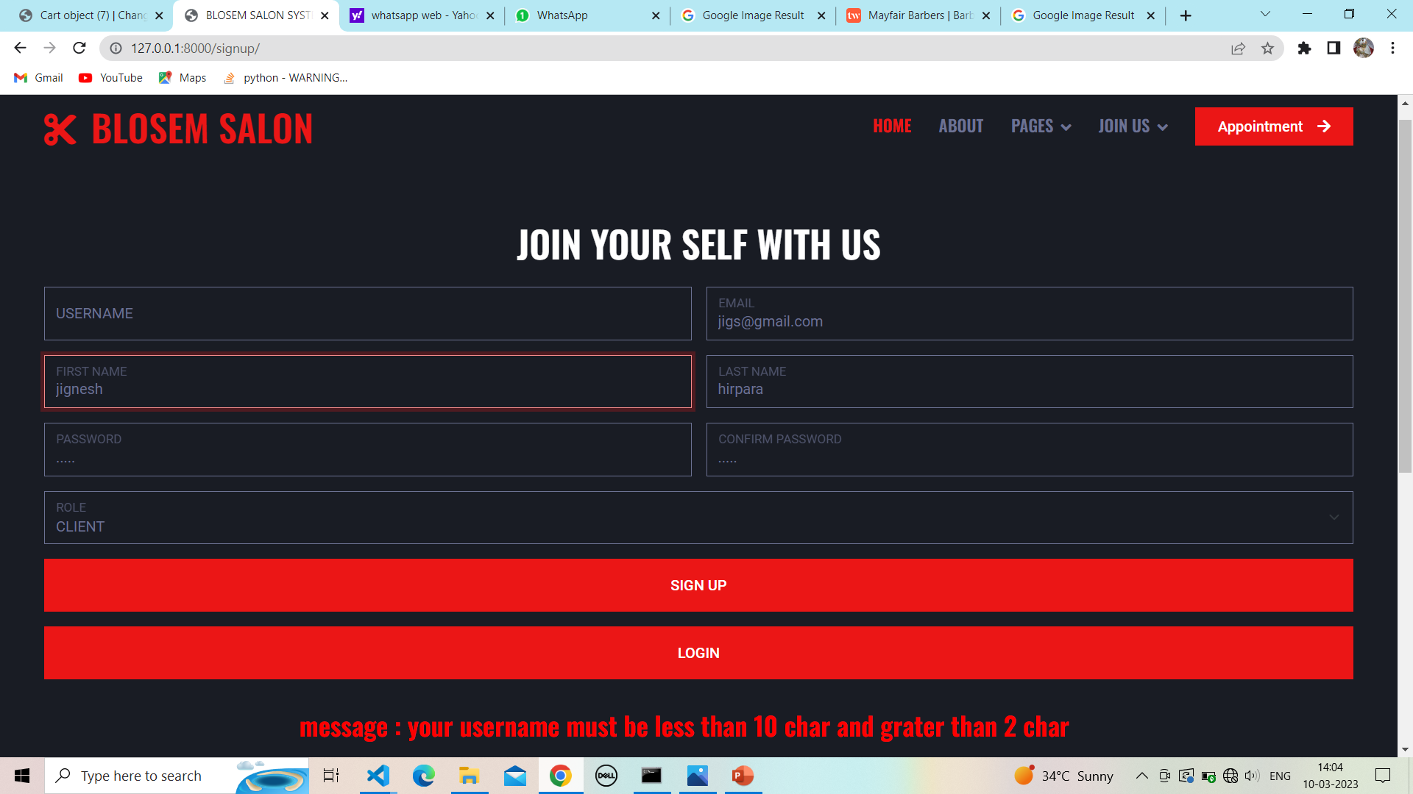

**19.4 Client signup with email validation:**

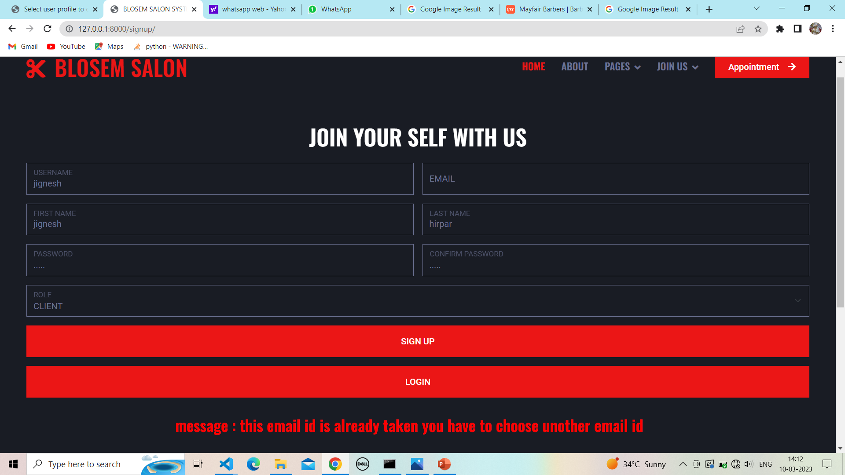

**19.5 Client signup with password validation:**

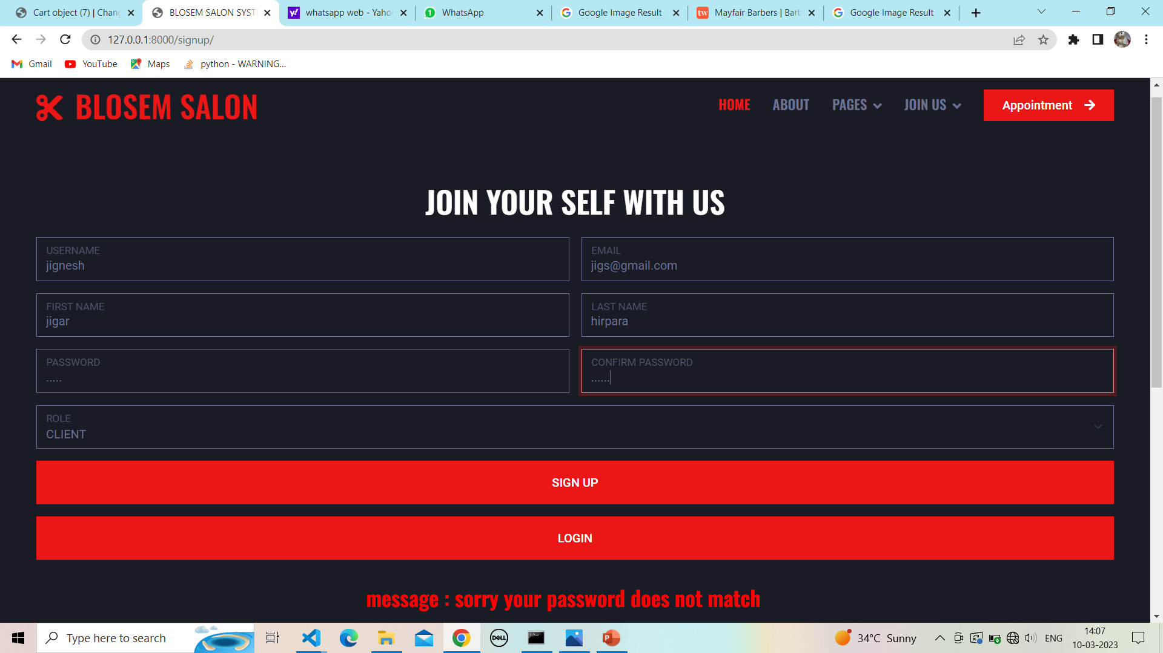

**19.6 Client signup page with detail:-**

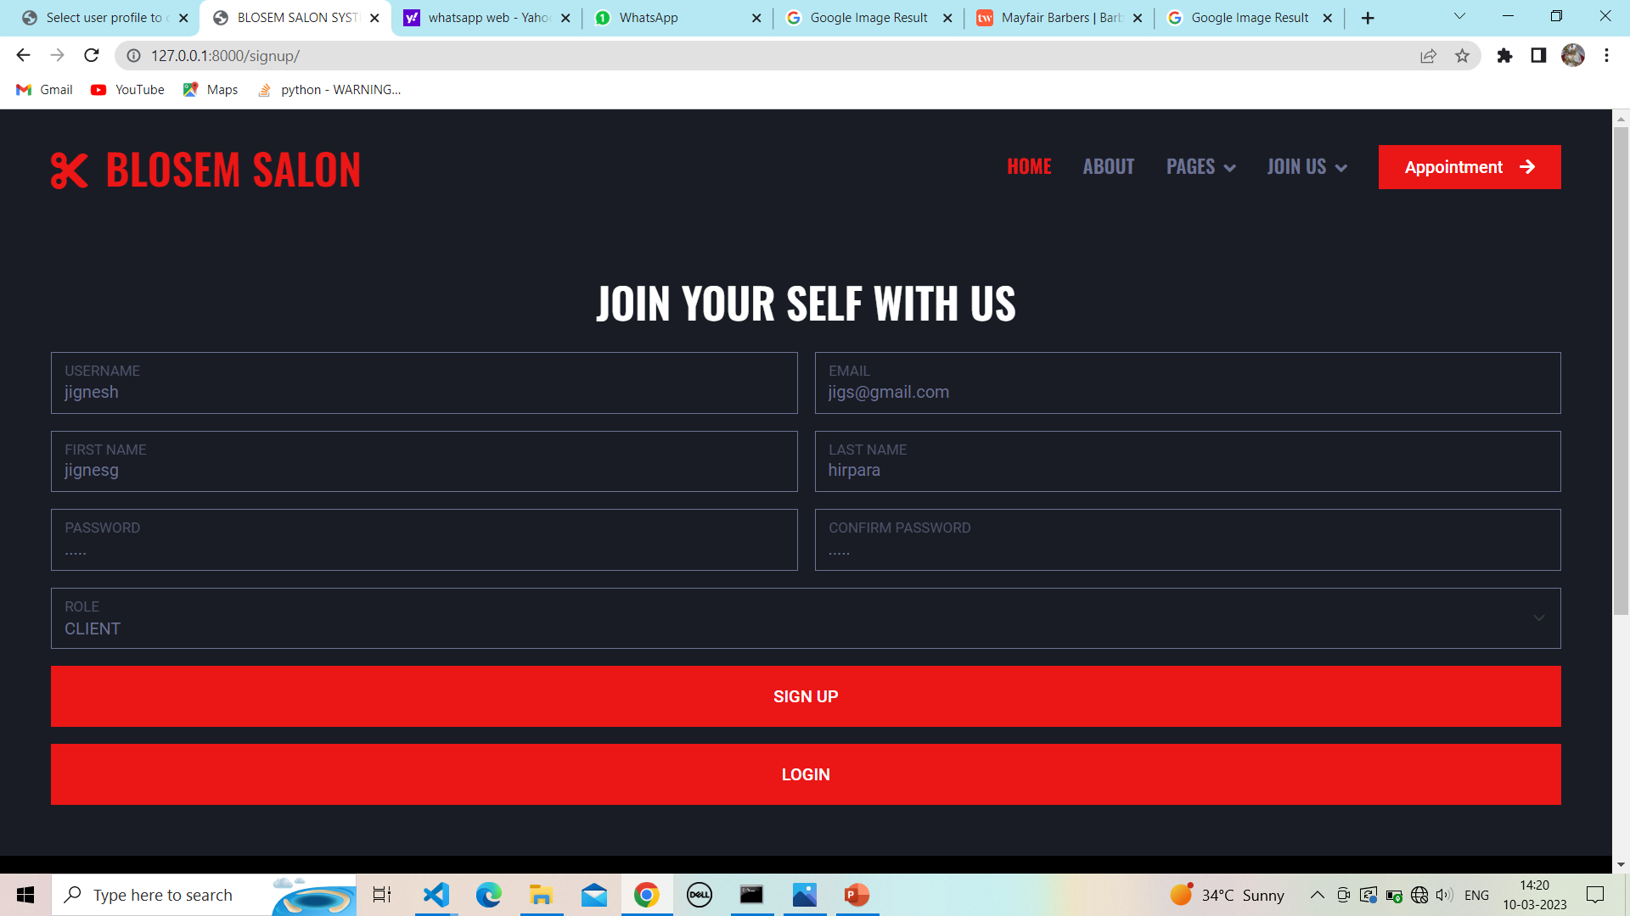

**19.7 Successfully signup:**

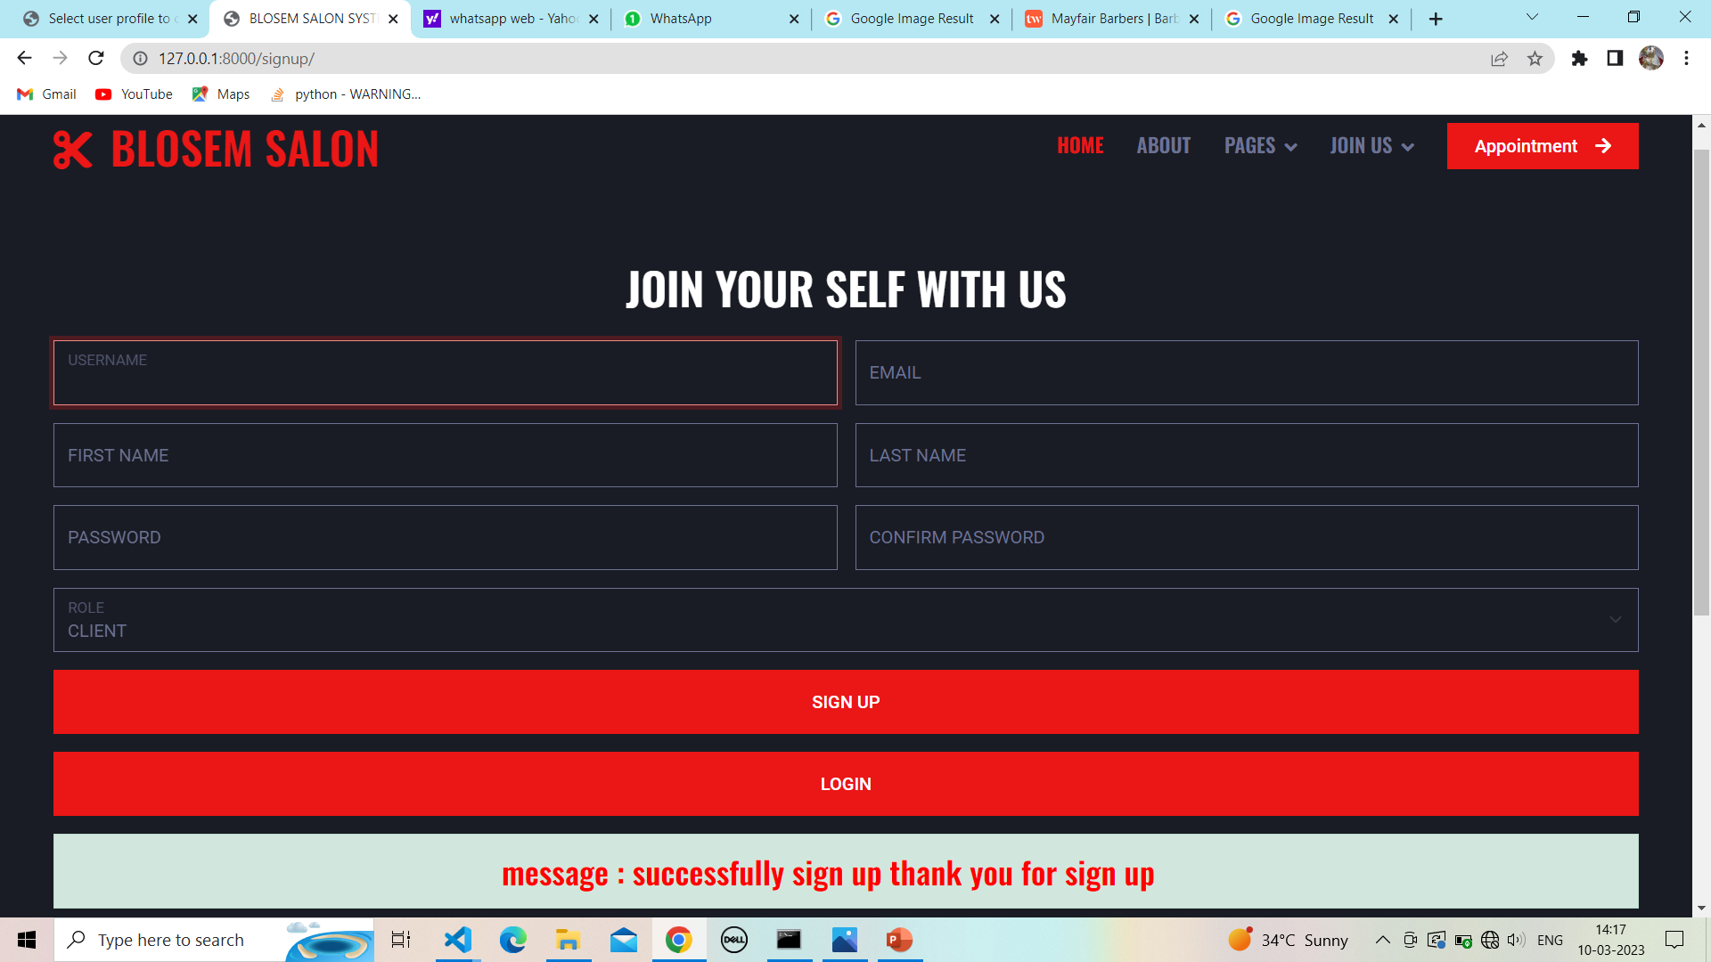

**19.8 Client login page:**

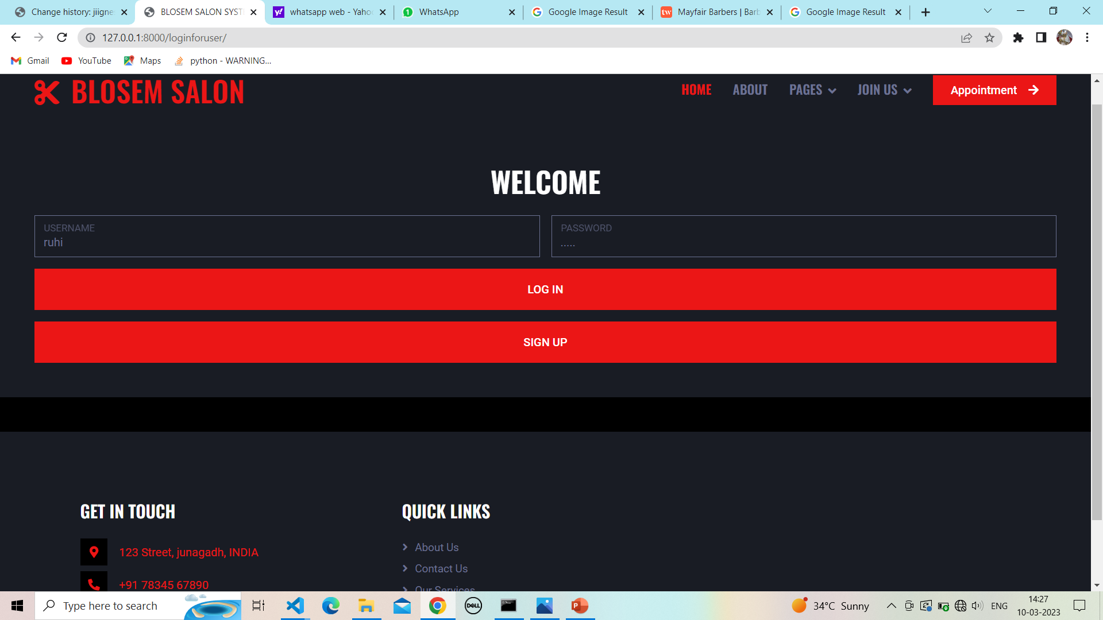

**19.9 Login successfully :**

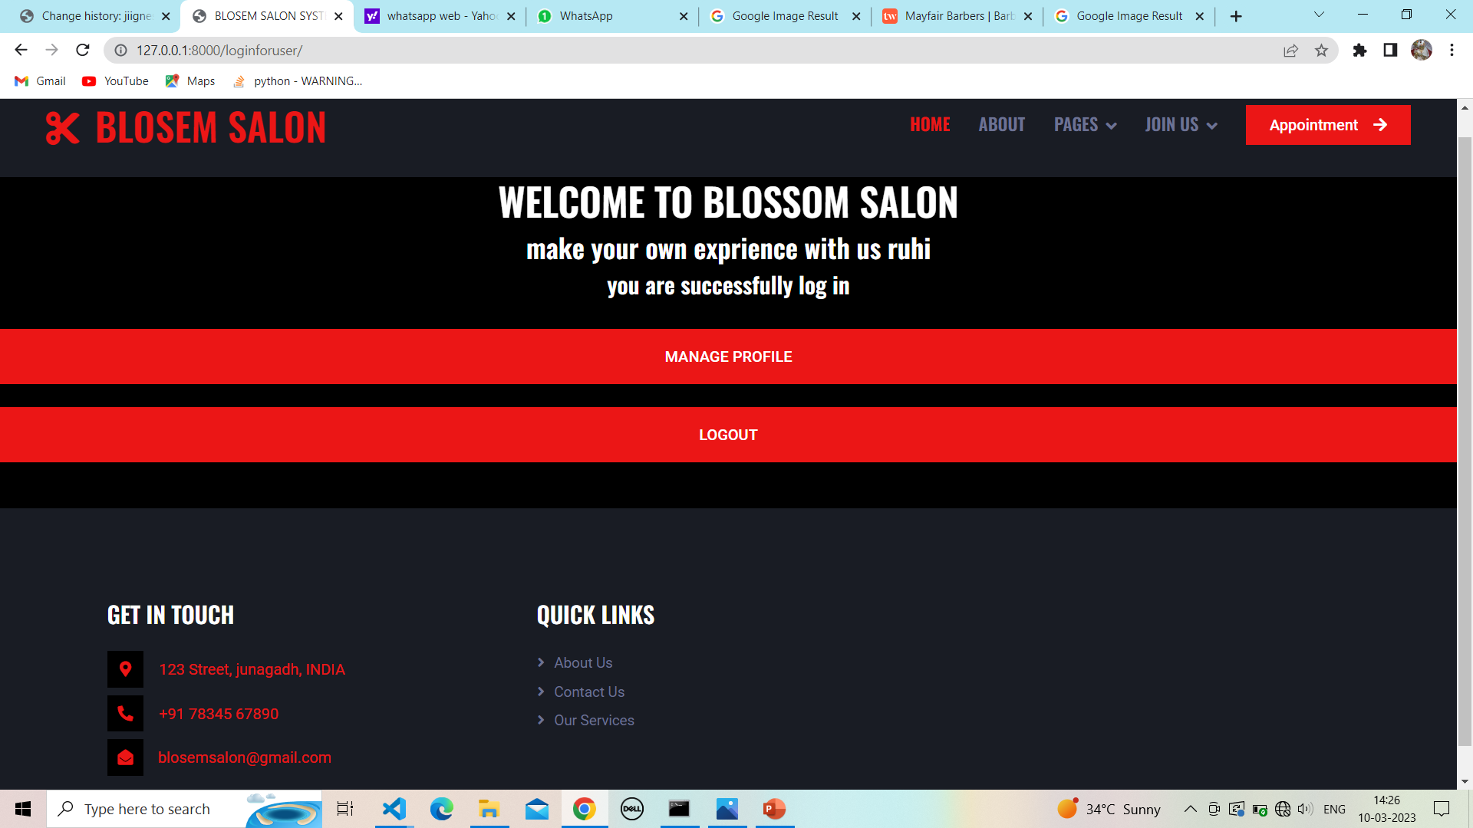

**20.Client detail :**

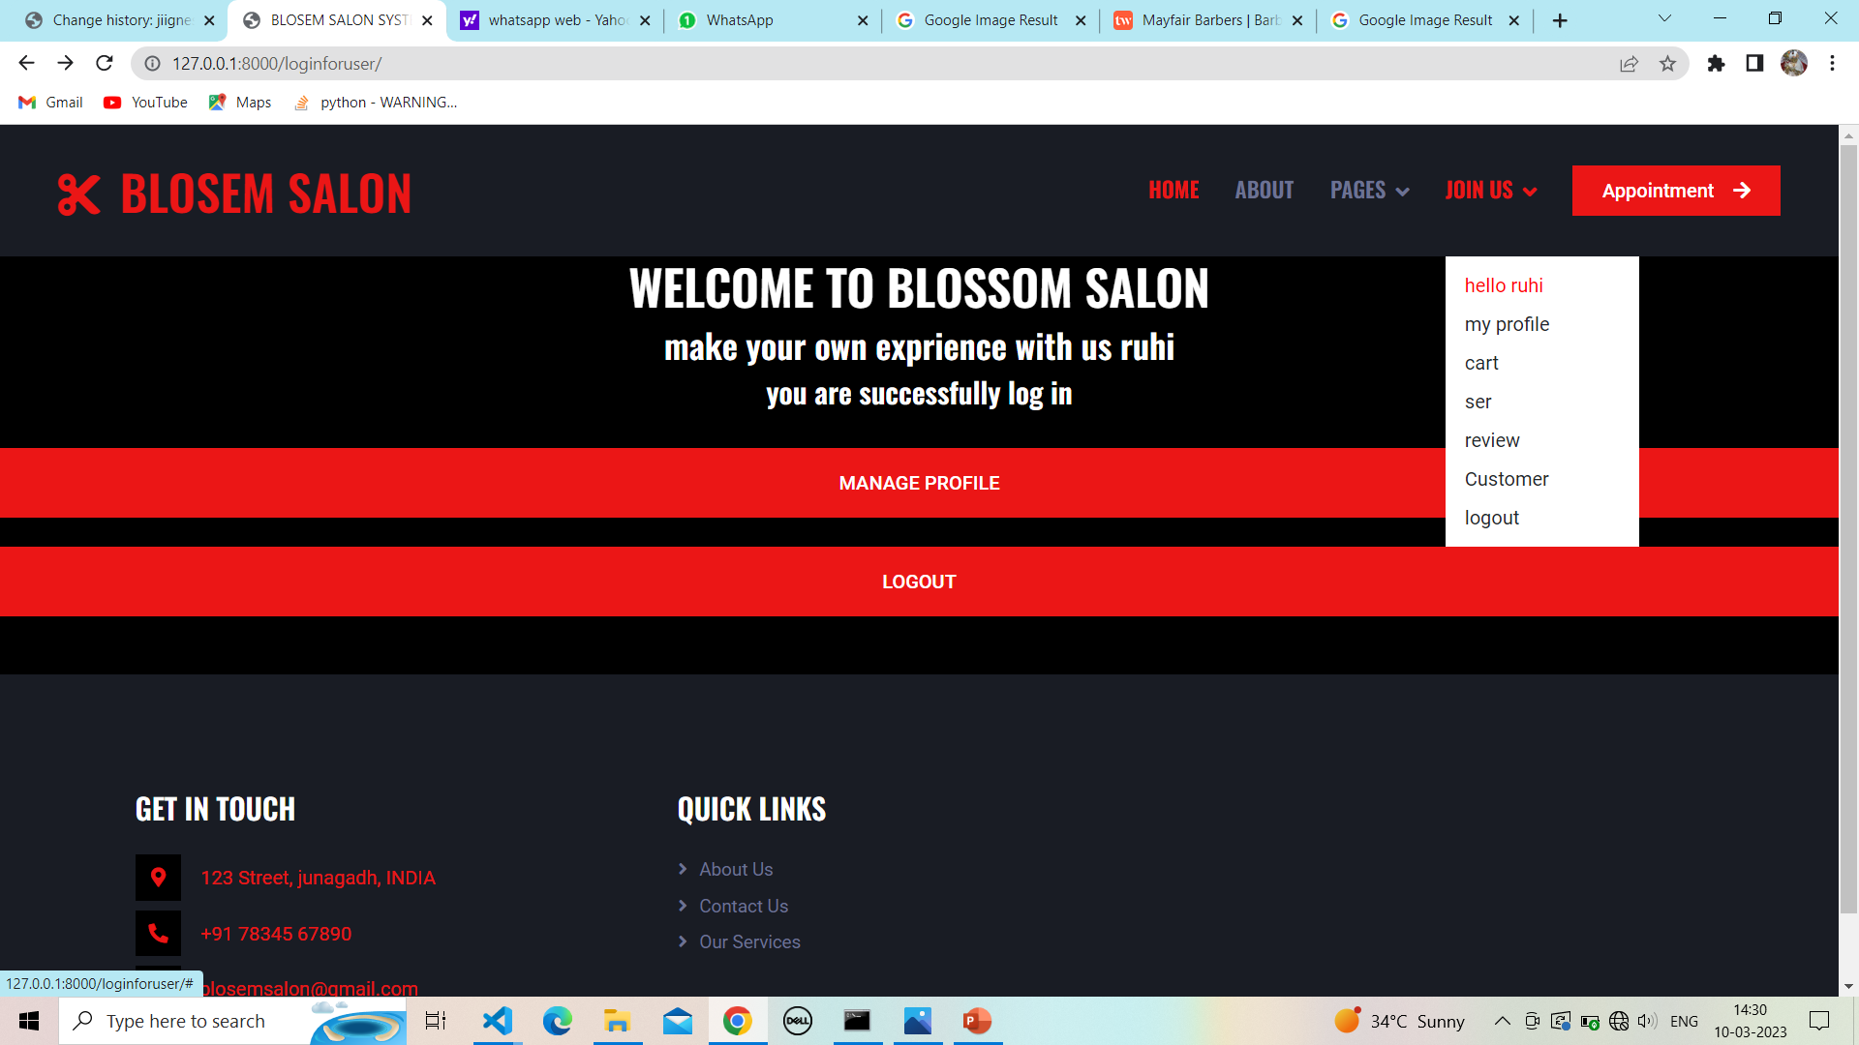

**20.1 Client profile :**

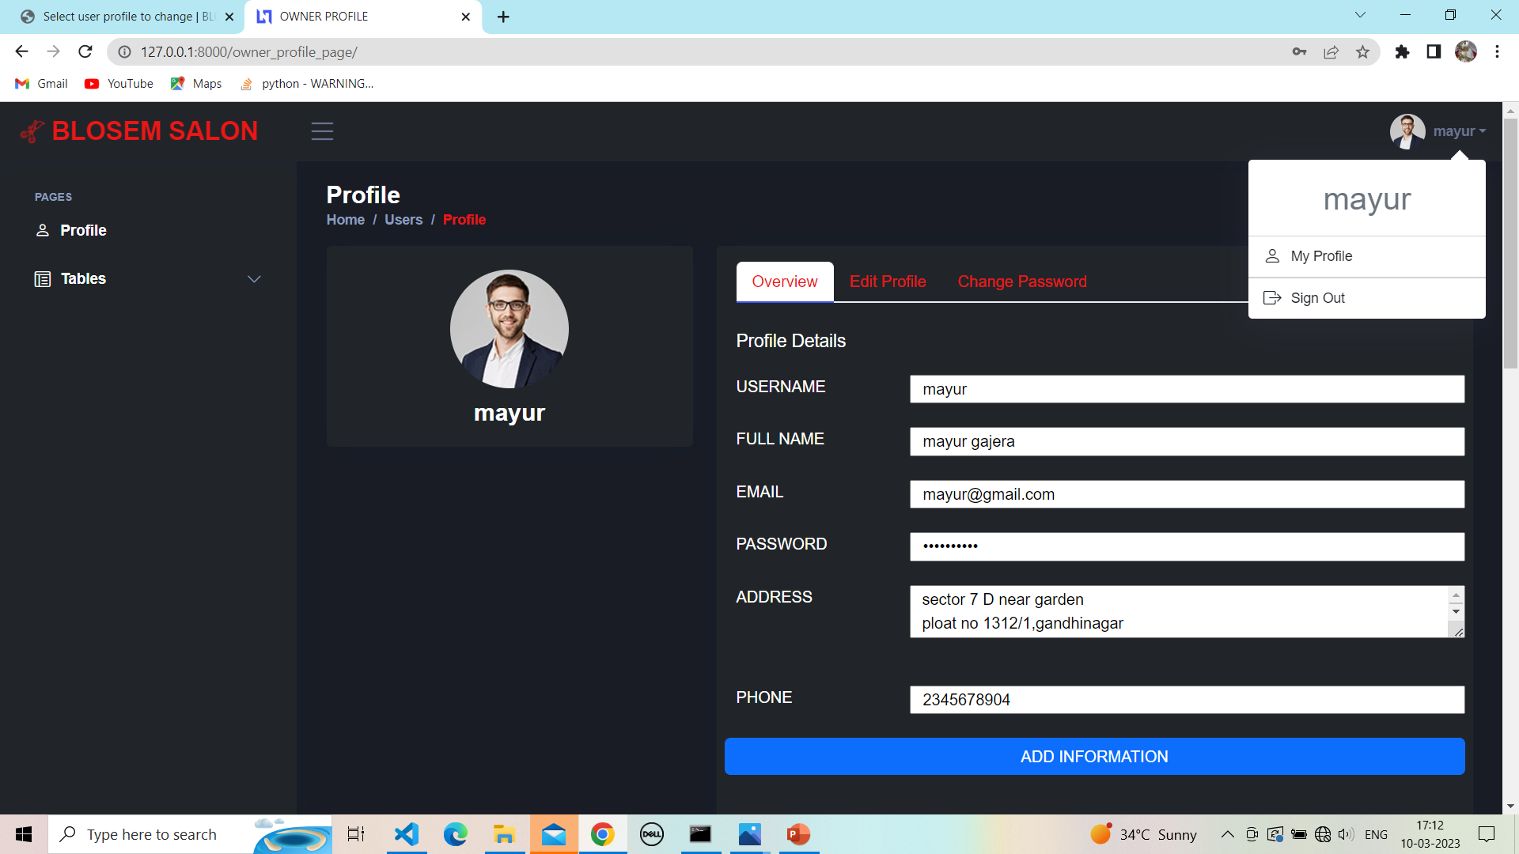

**20.2 Client order detail:**

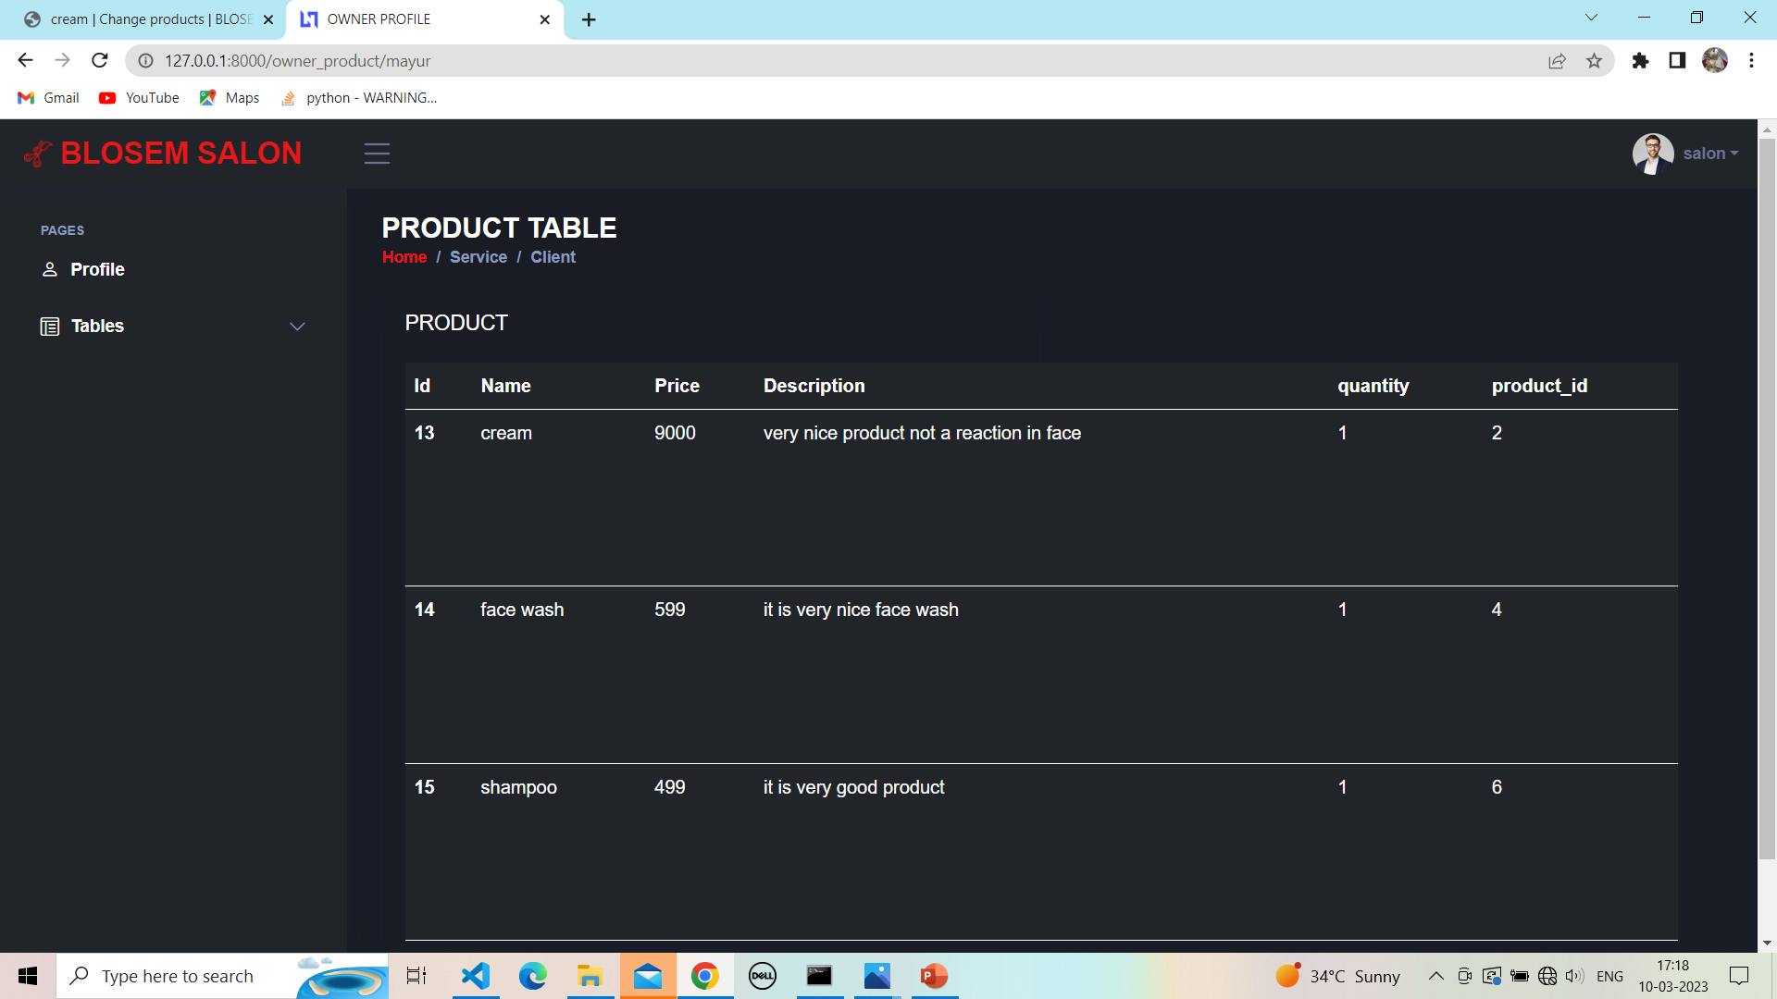

**21.Client home page :**

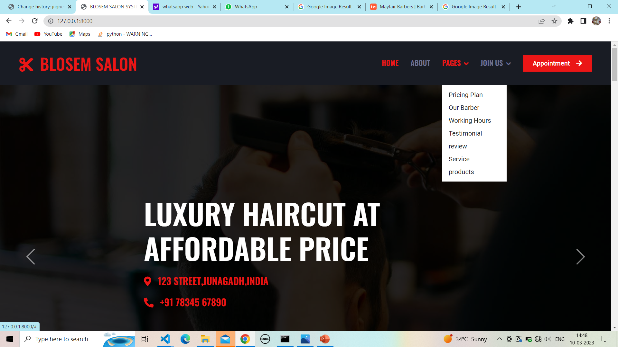

**21.1 Client home page :**

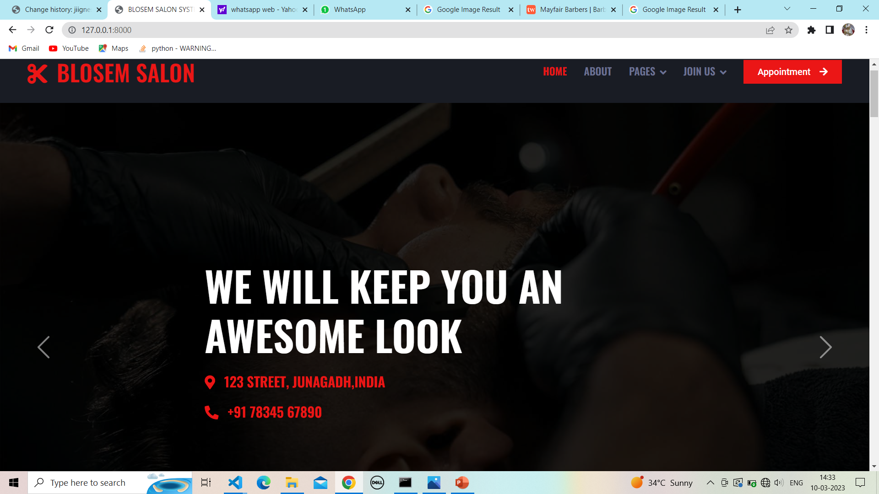

**22.Client Appointment form :**

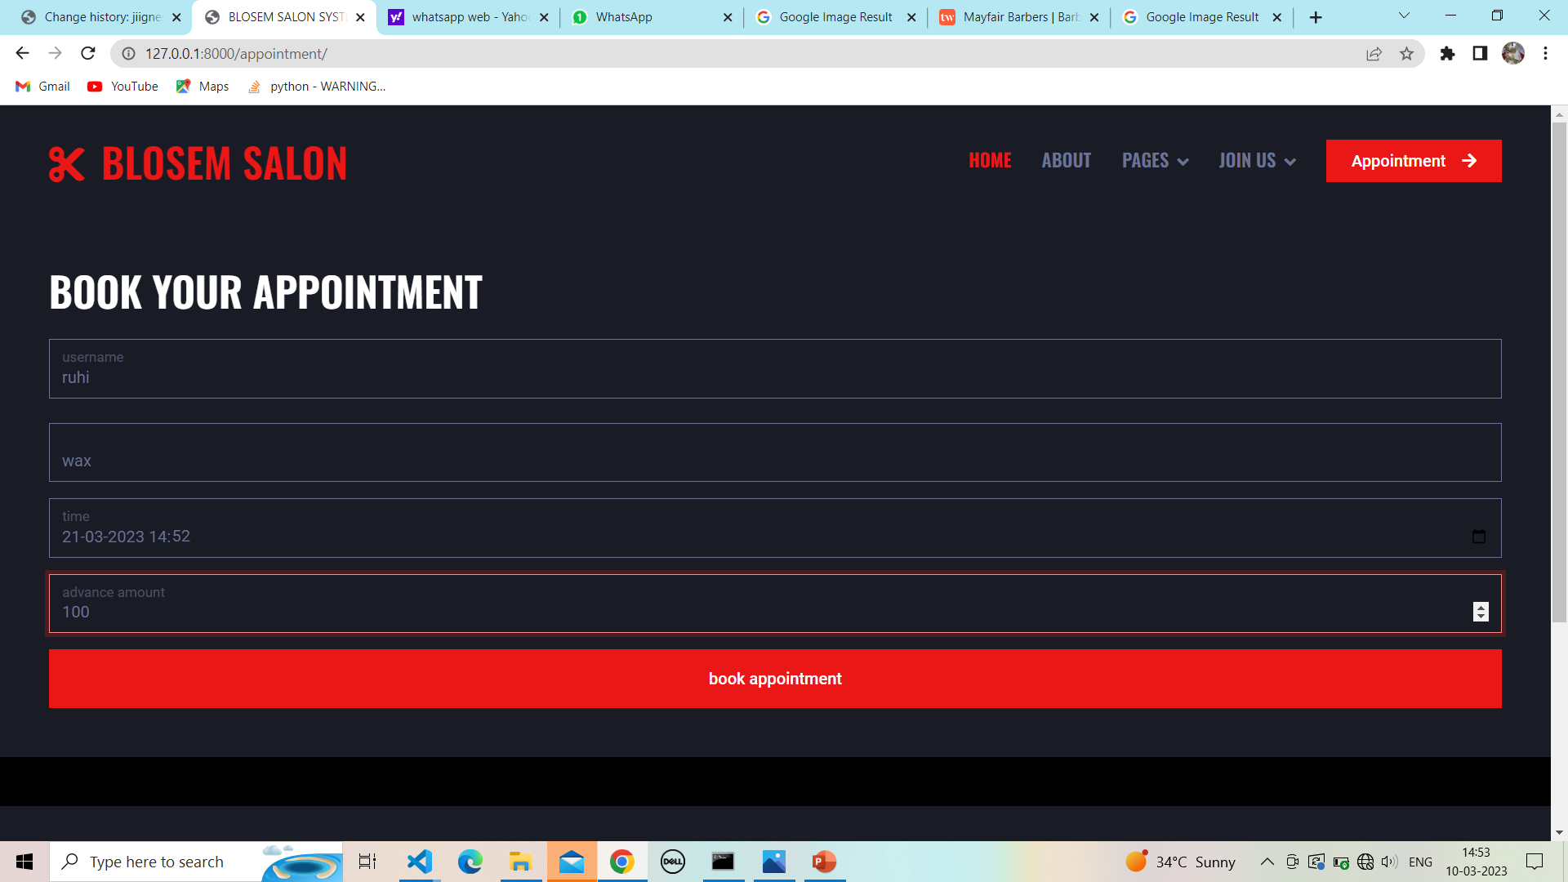

**22.1 Suuccessfully book appointment :**

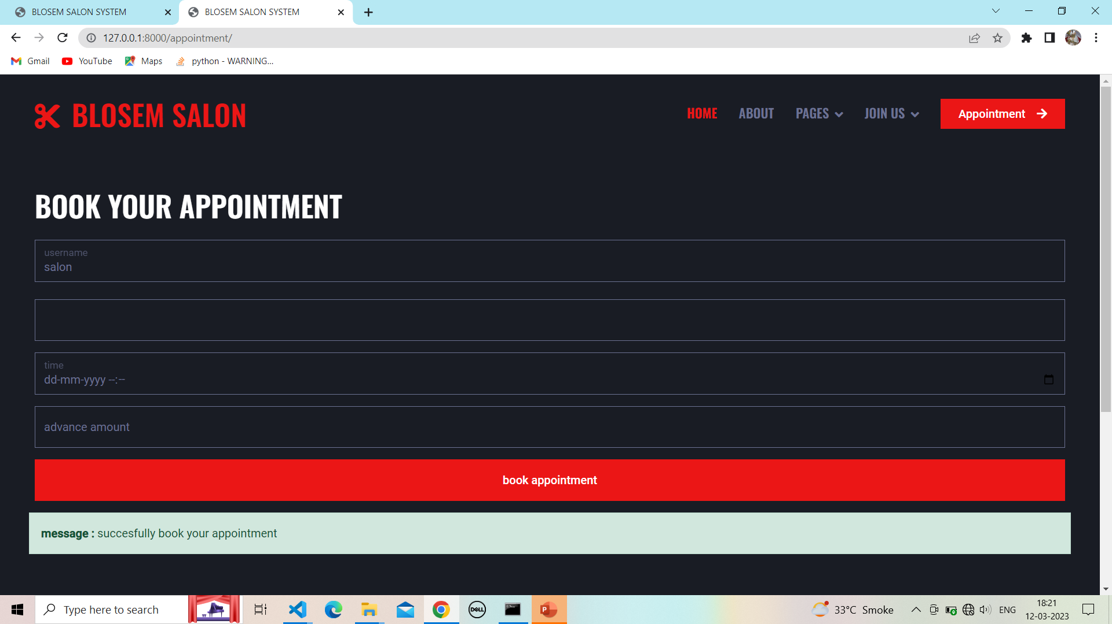

**23.Client home page :**

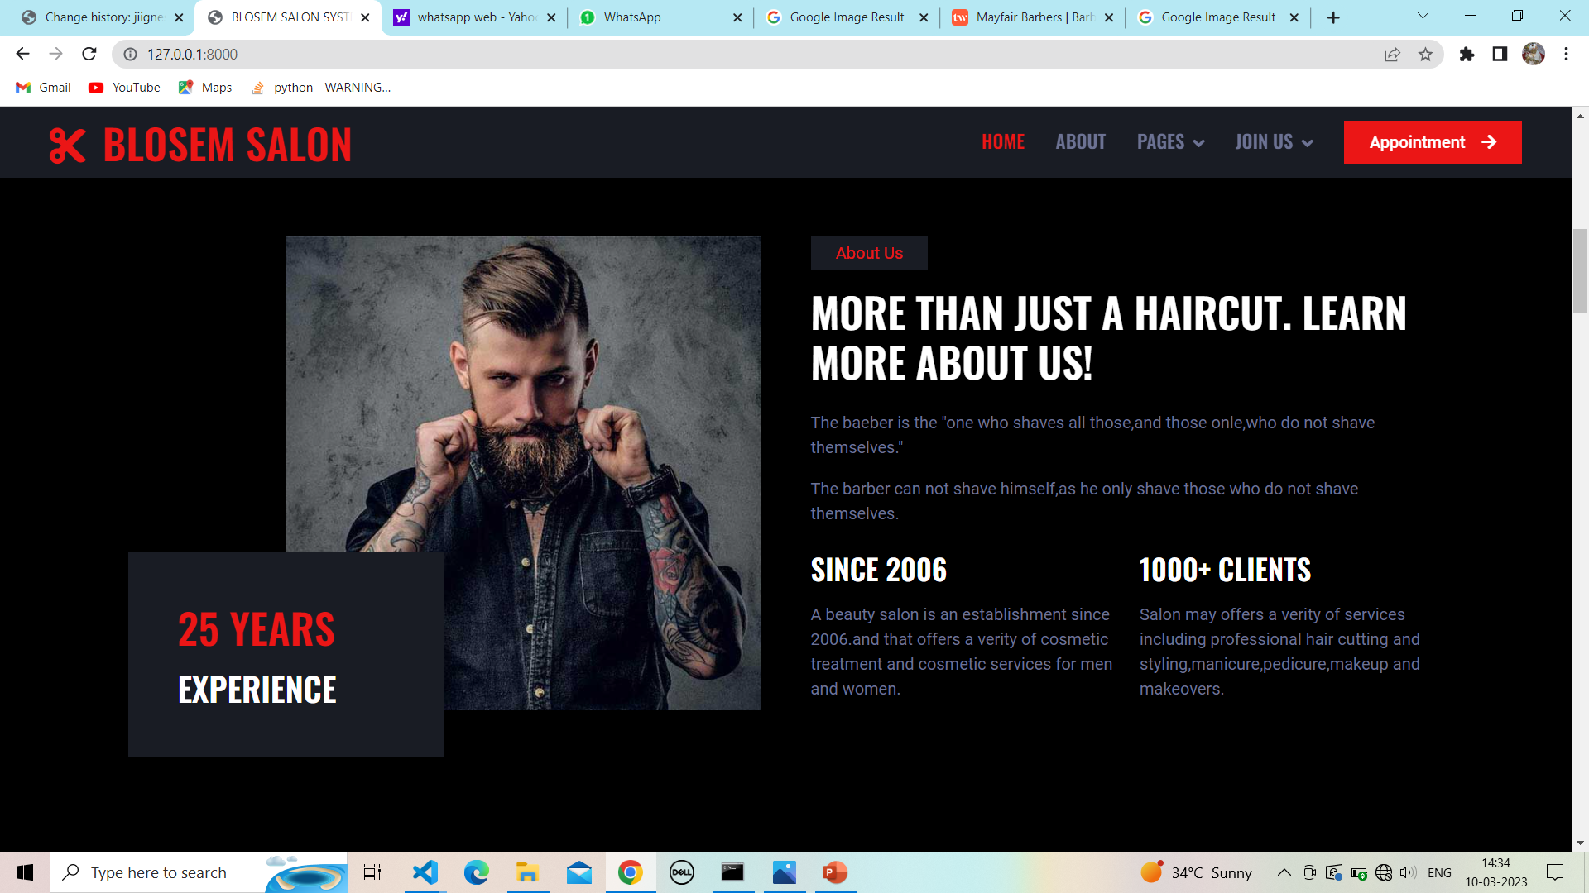

**23.1Client home page service:**

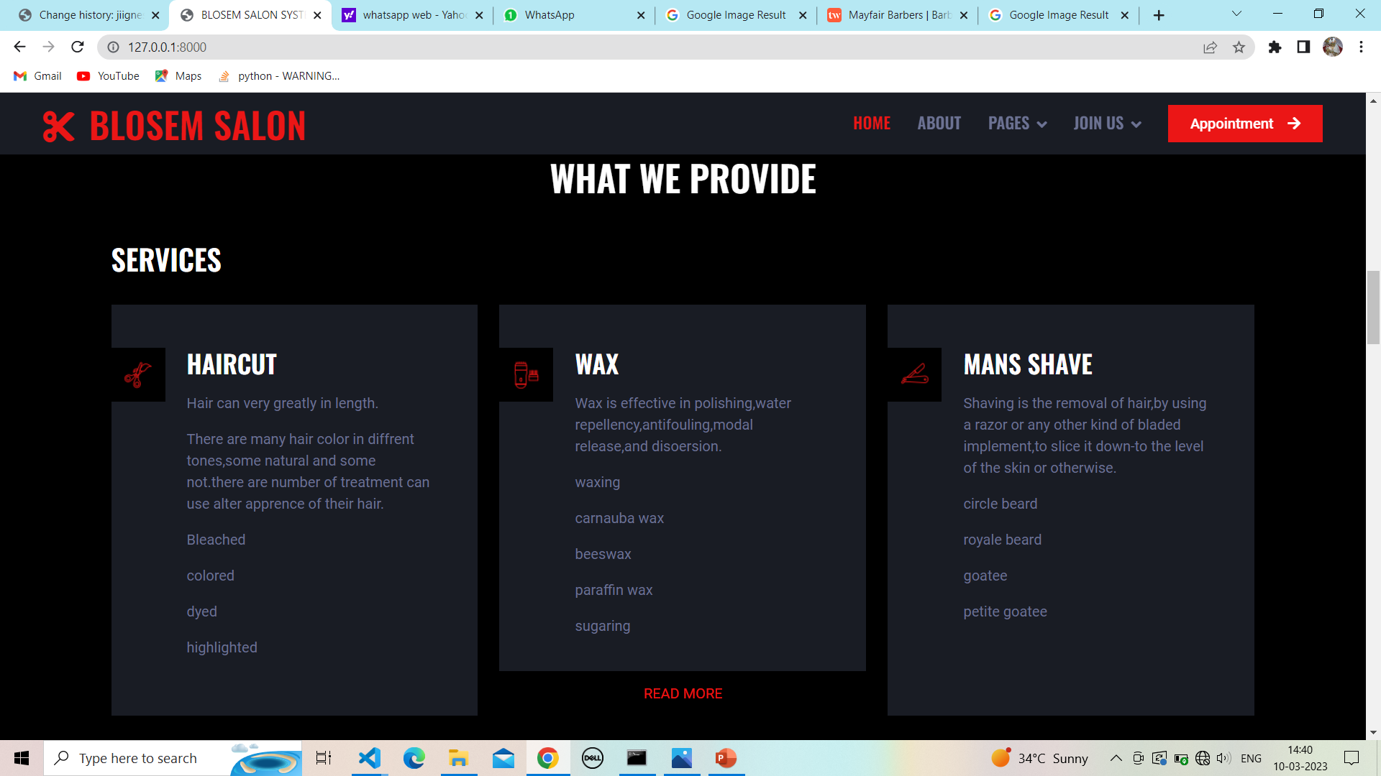

**23.2 Show service page:**

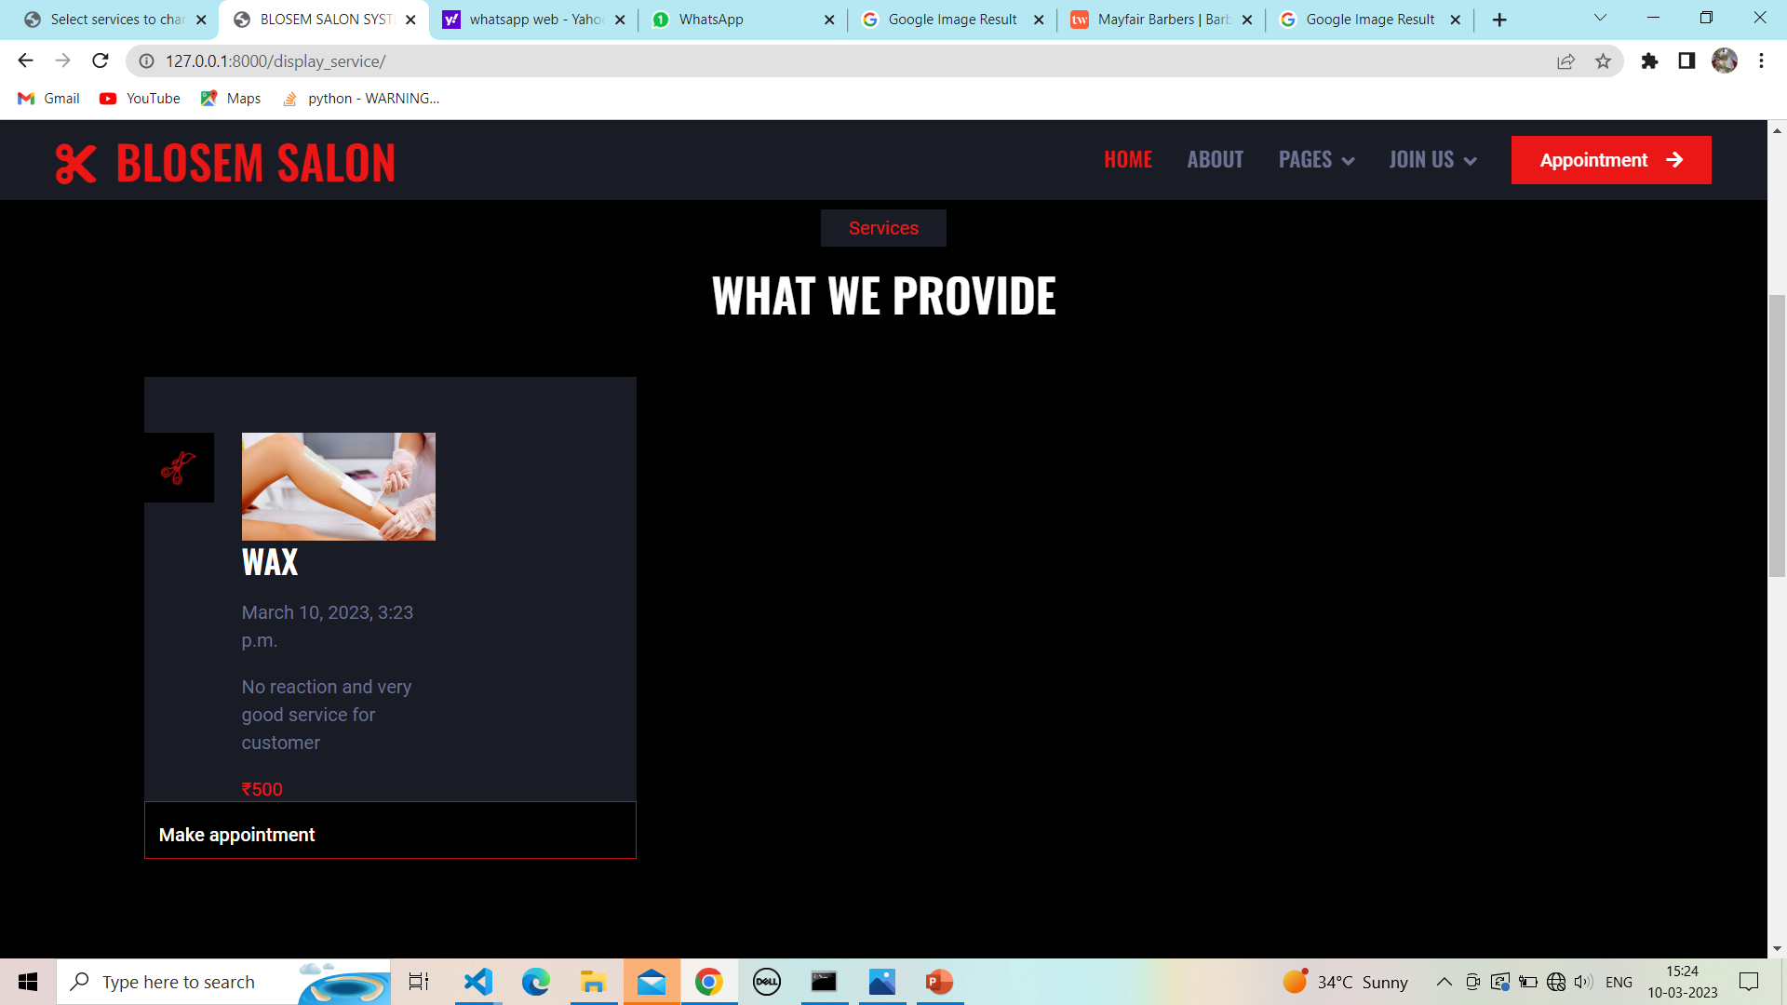

**23.3 Service to appointment:**

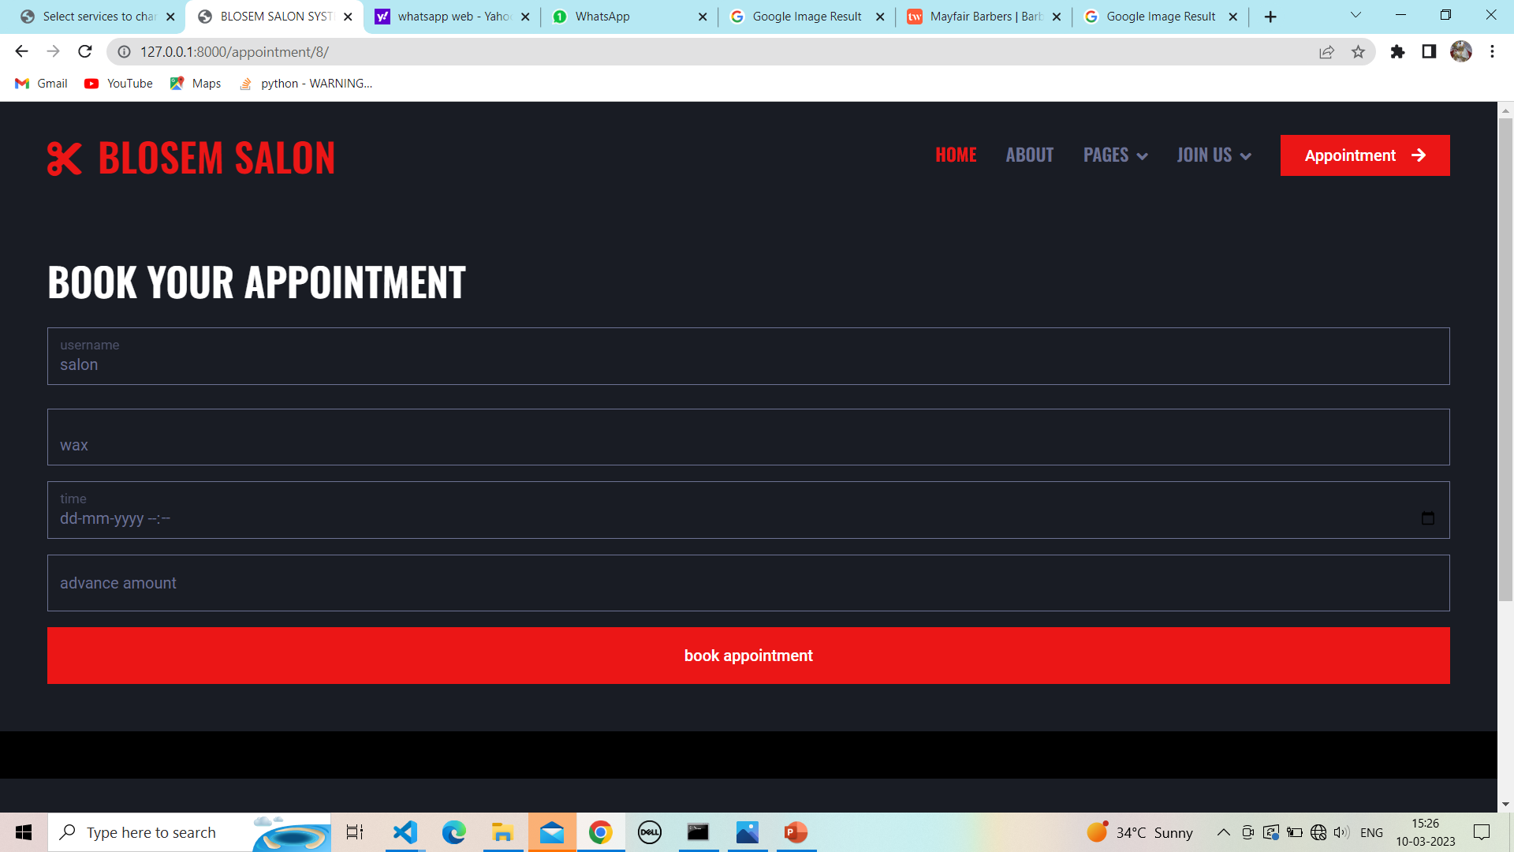

**23.4 Successfully book your appointment:**



**24. Client home page products :**

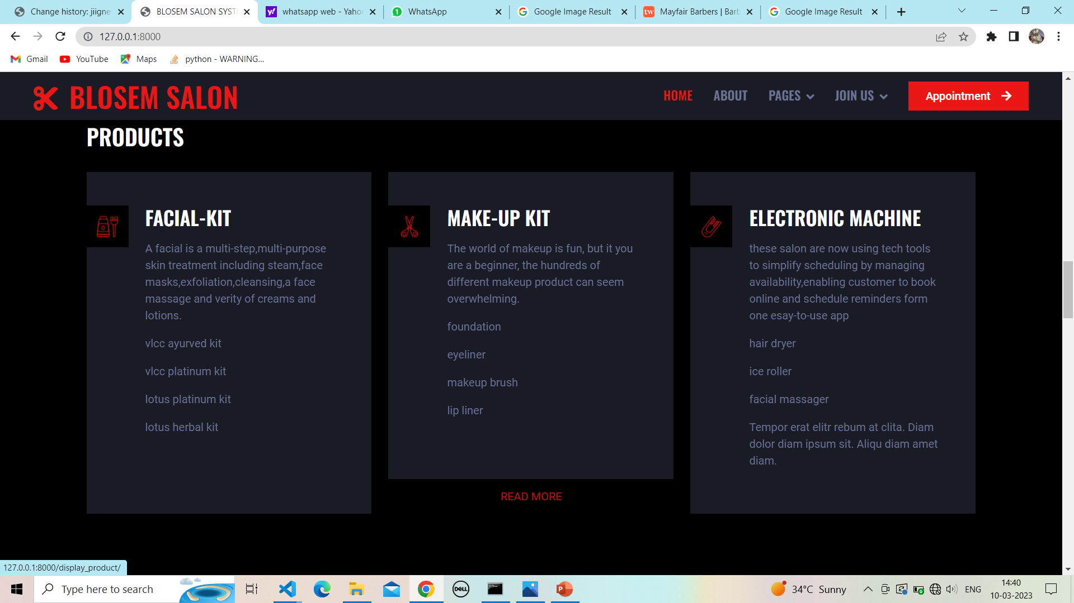

**24.1Show Product page:**

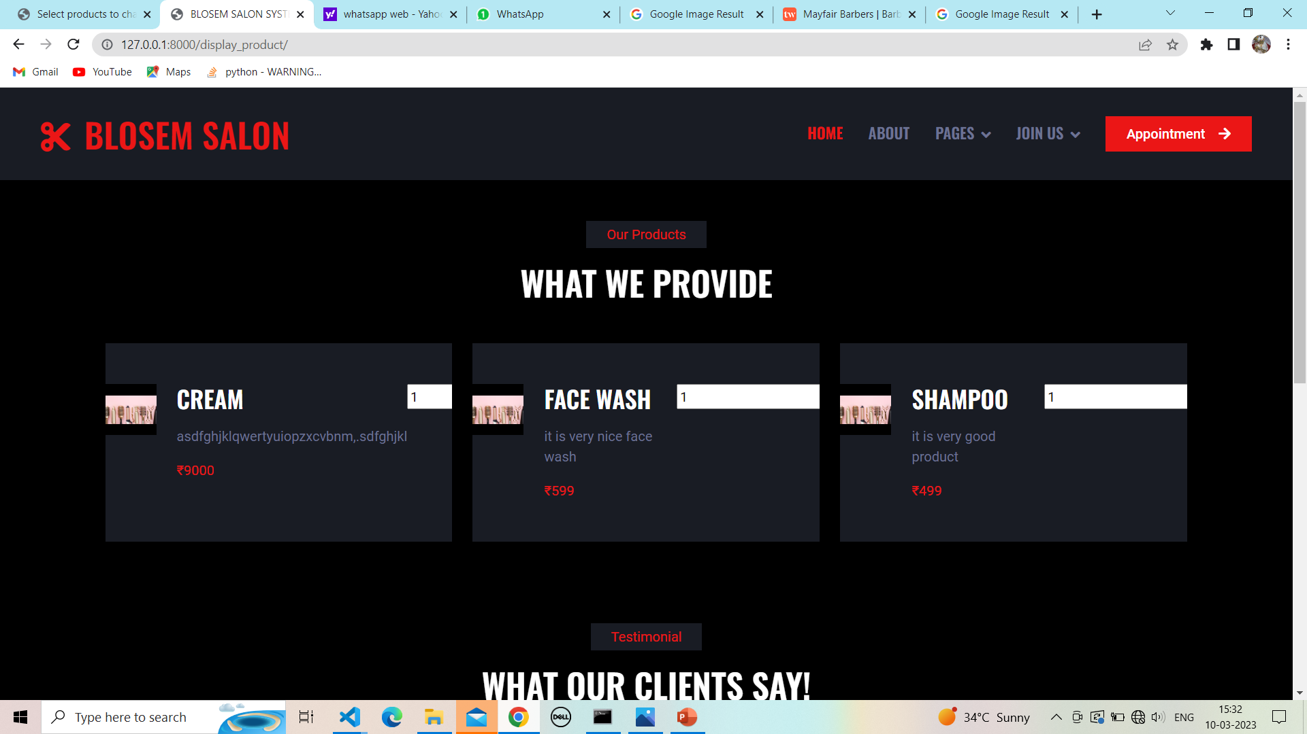

**25.Client home page pricing and plan :**

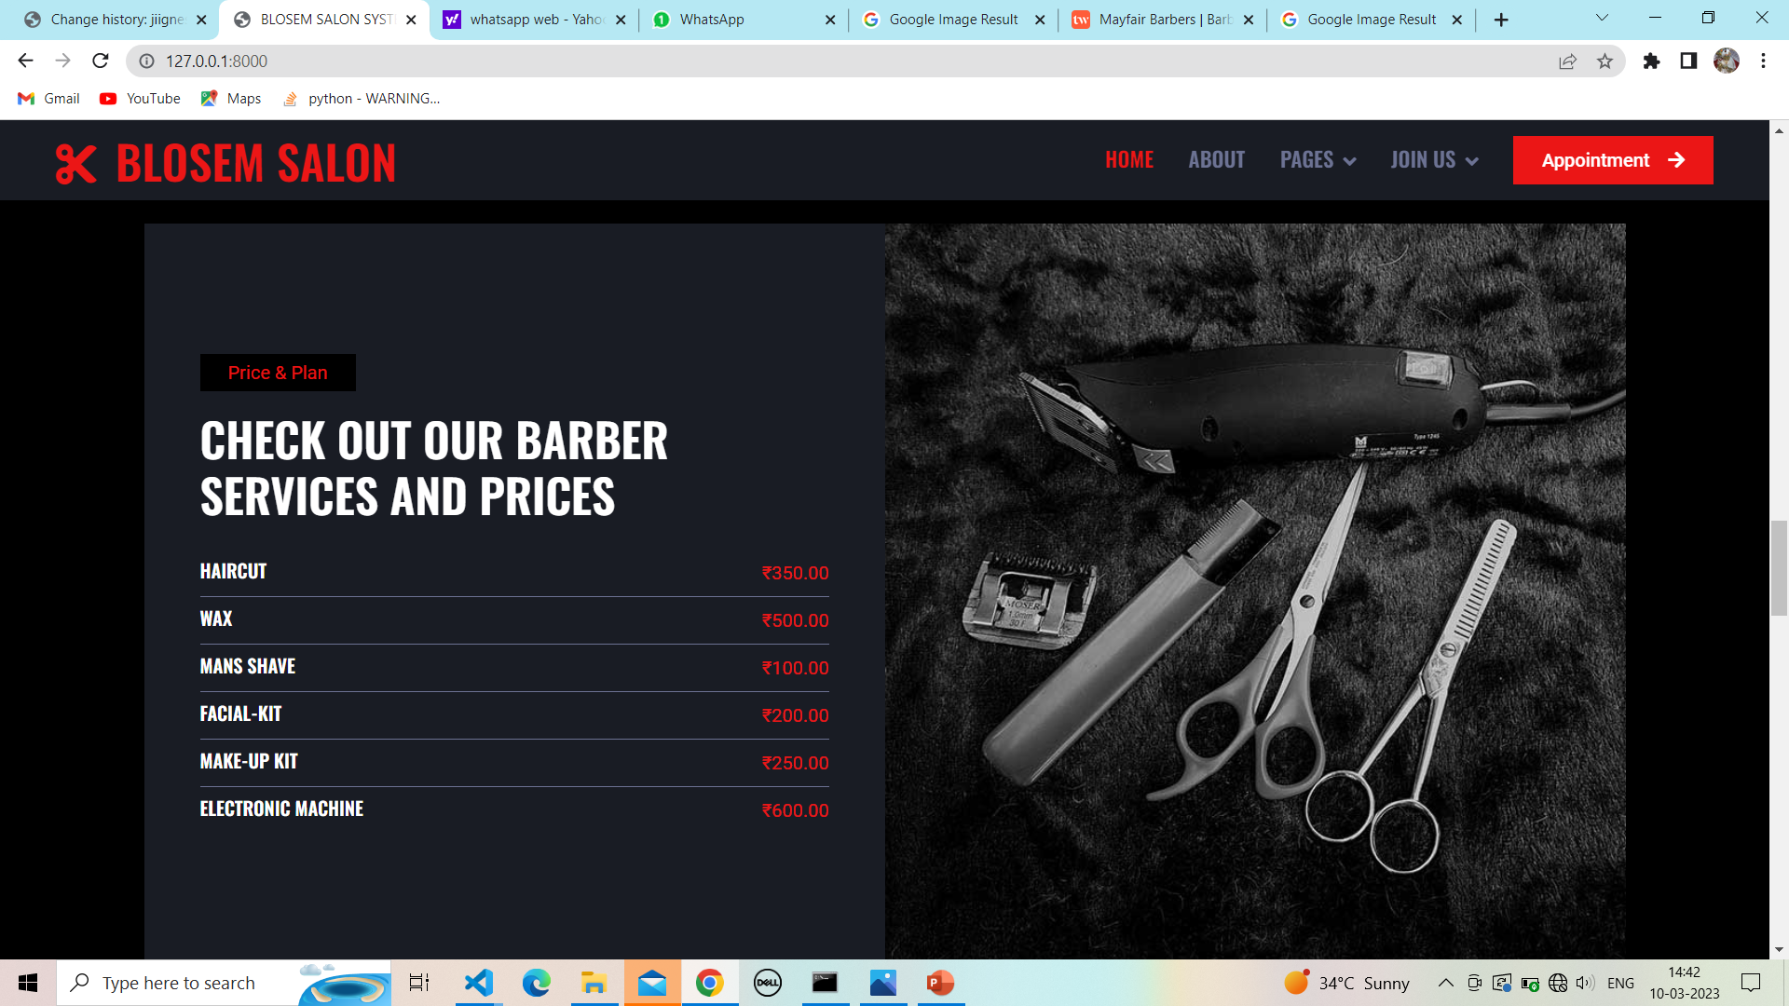

**25.1 Client home page and barber:**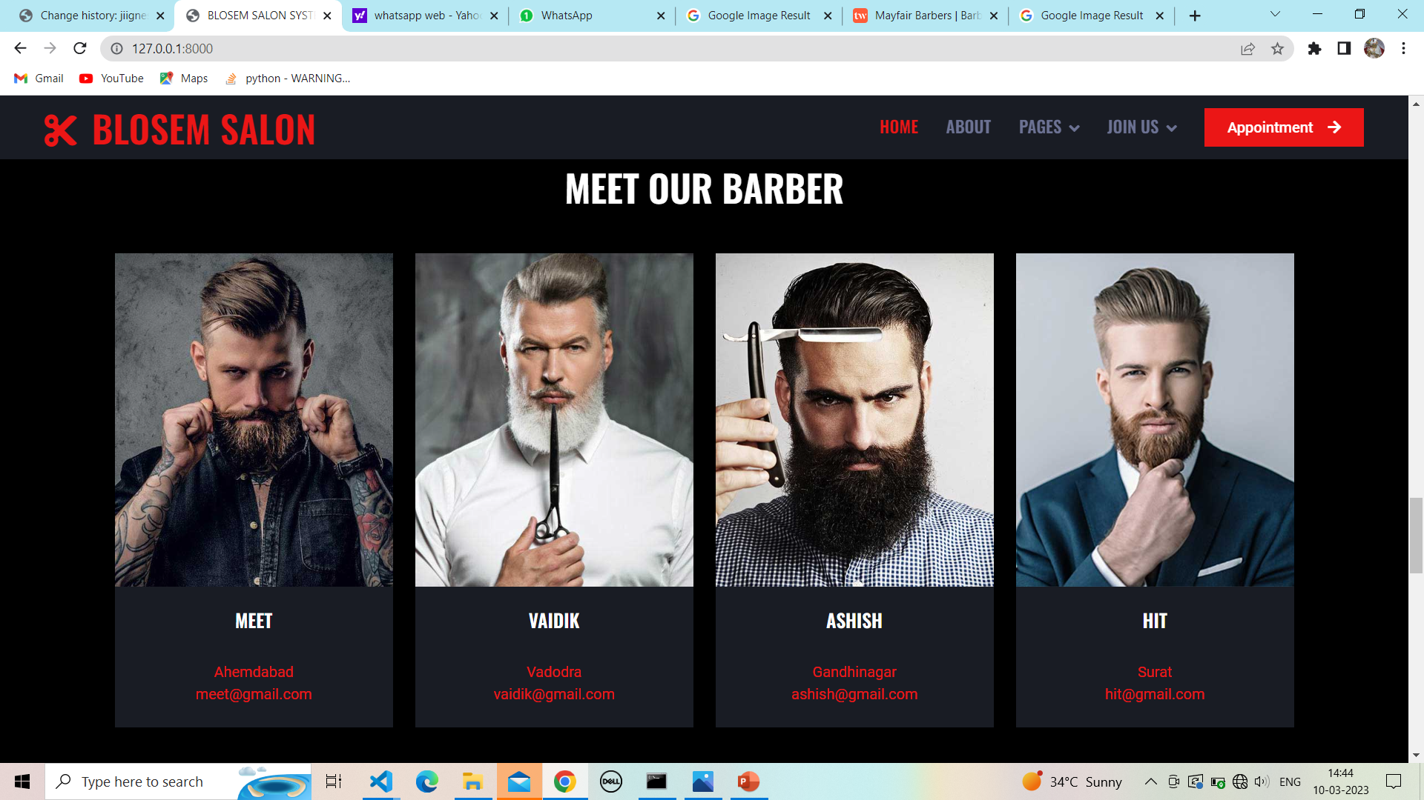

**25.2 Client home page and working hours:**

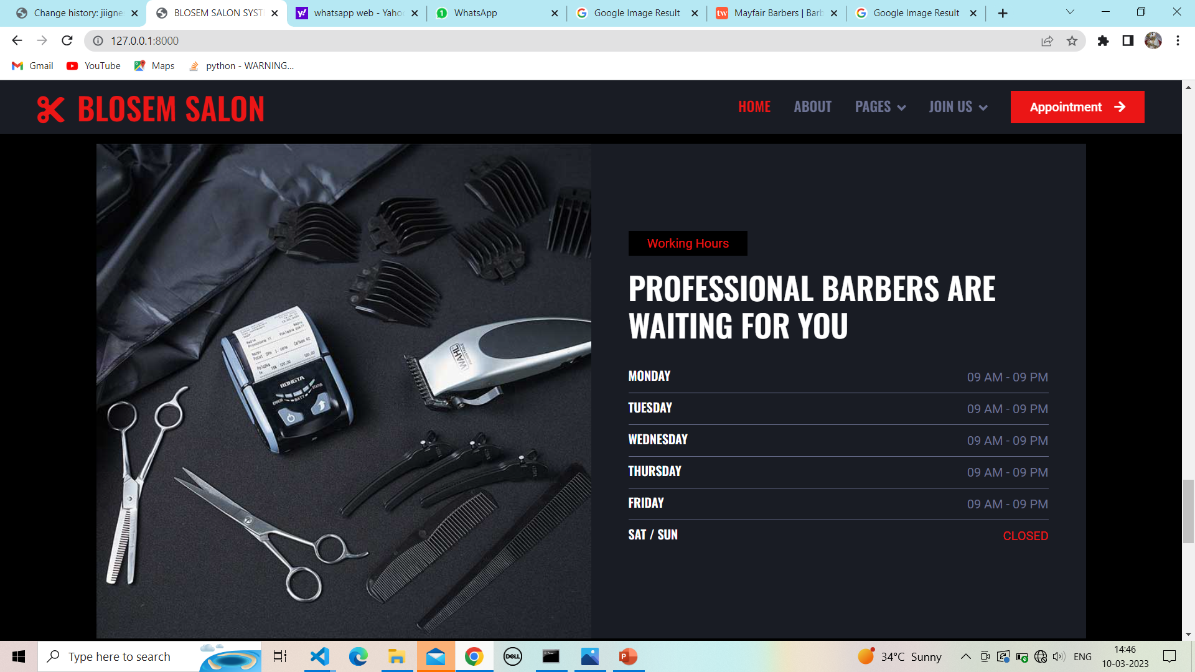

**26.Product page:**

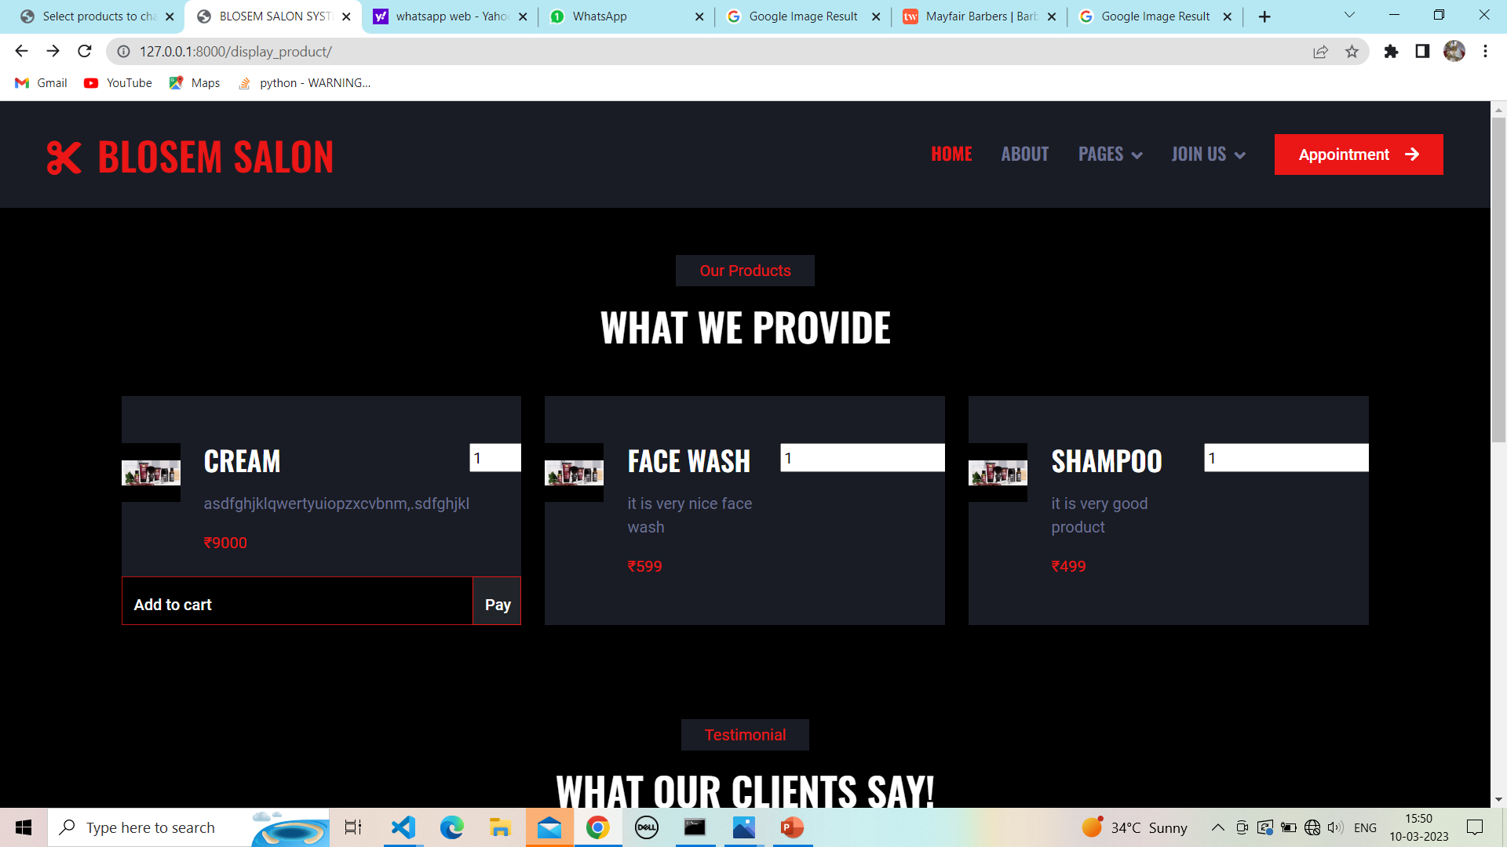

**27.Successfully payment page:**

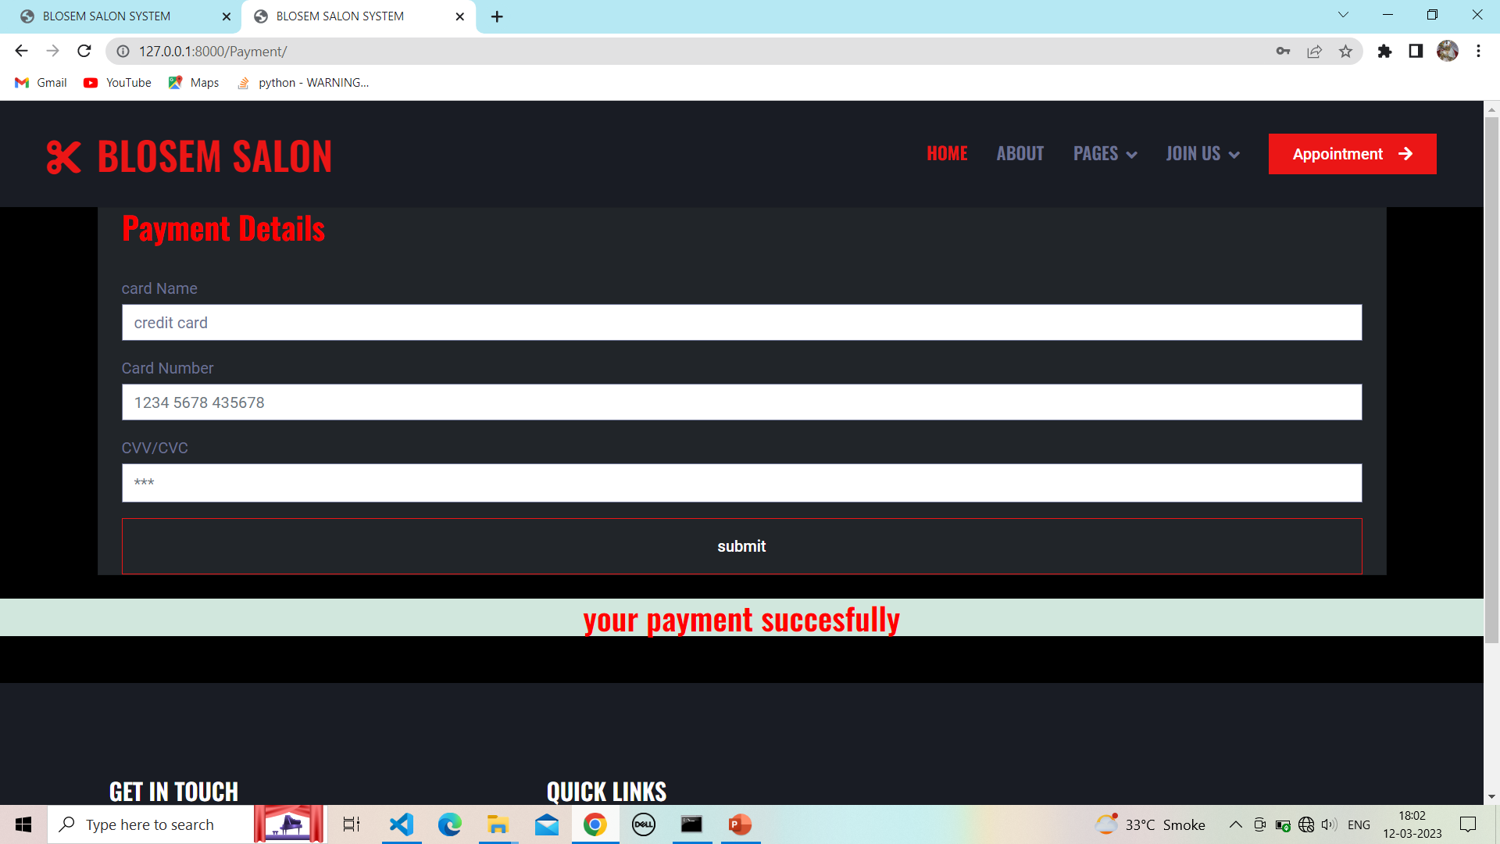

**28. Client product add to cart :**

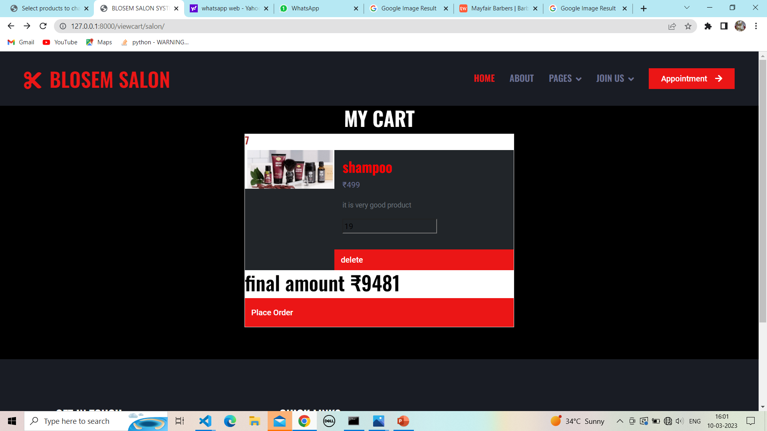

**28.1Cart product delete :**

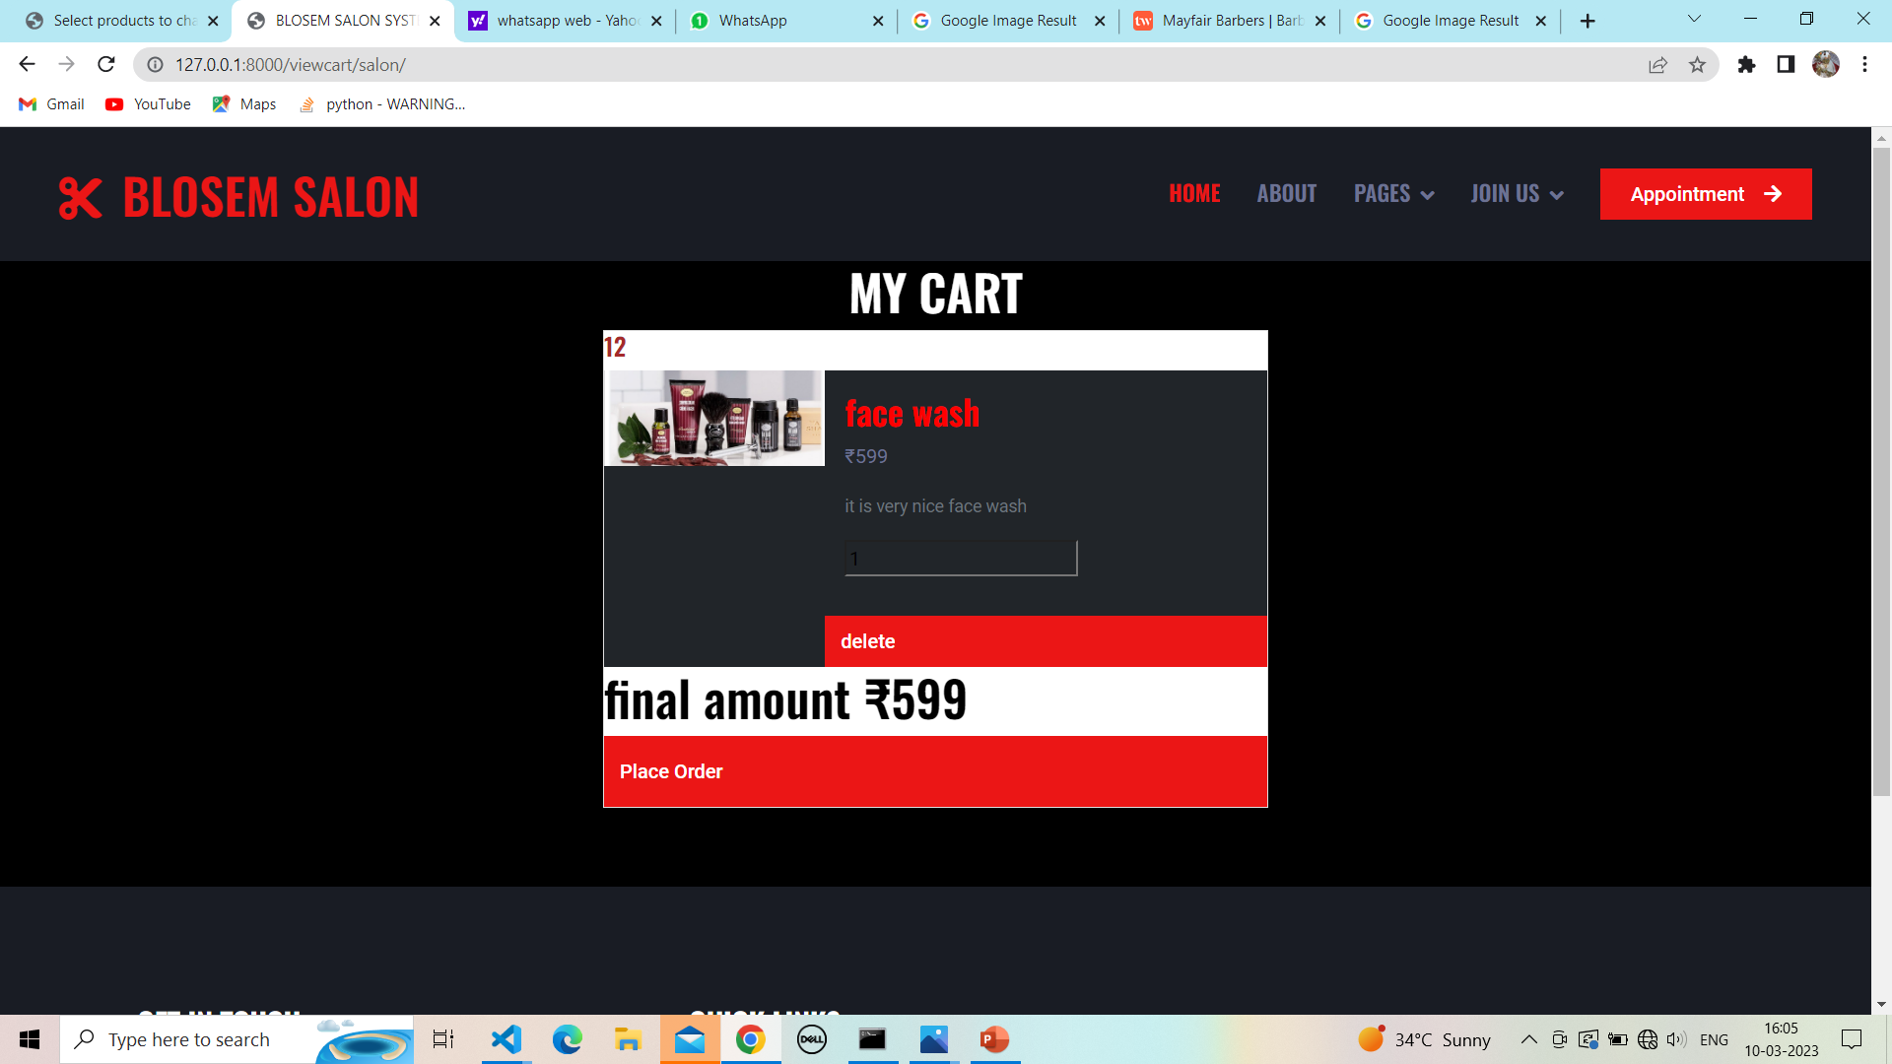

**29. Place order form:**

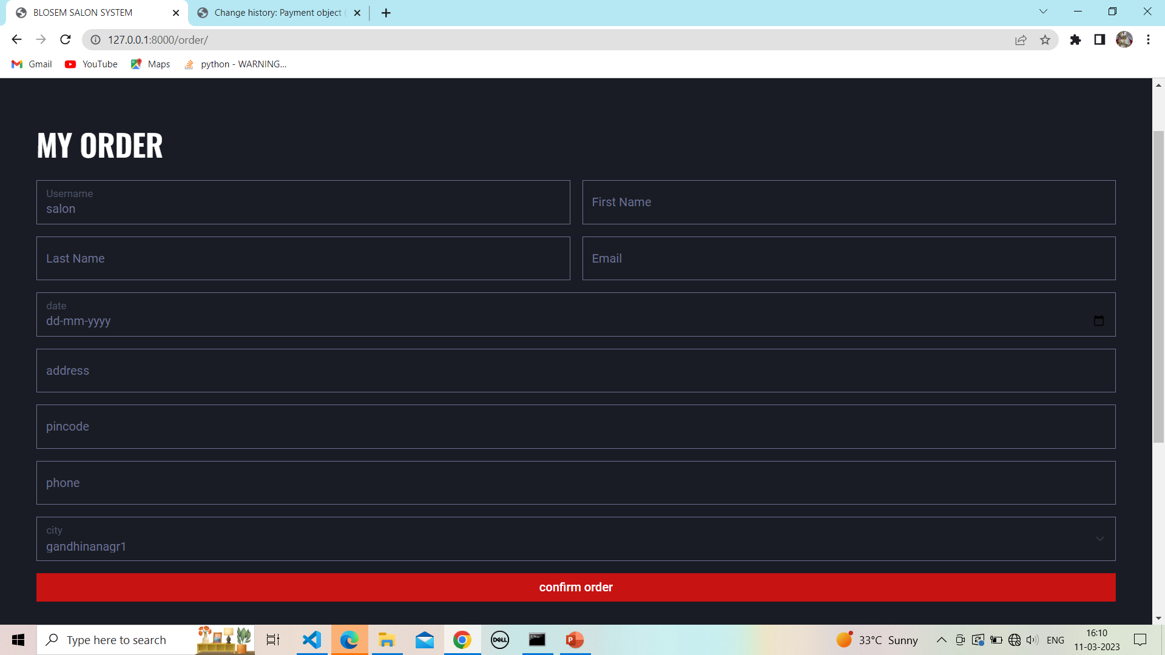

**29.1 Fill up order form :**

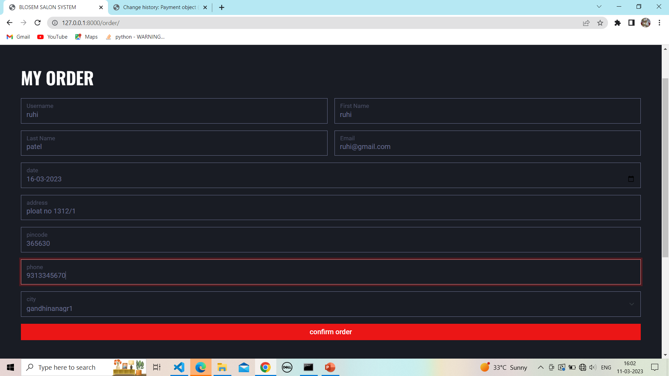

**29.2 Successfully confirm order and payment:**

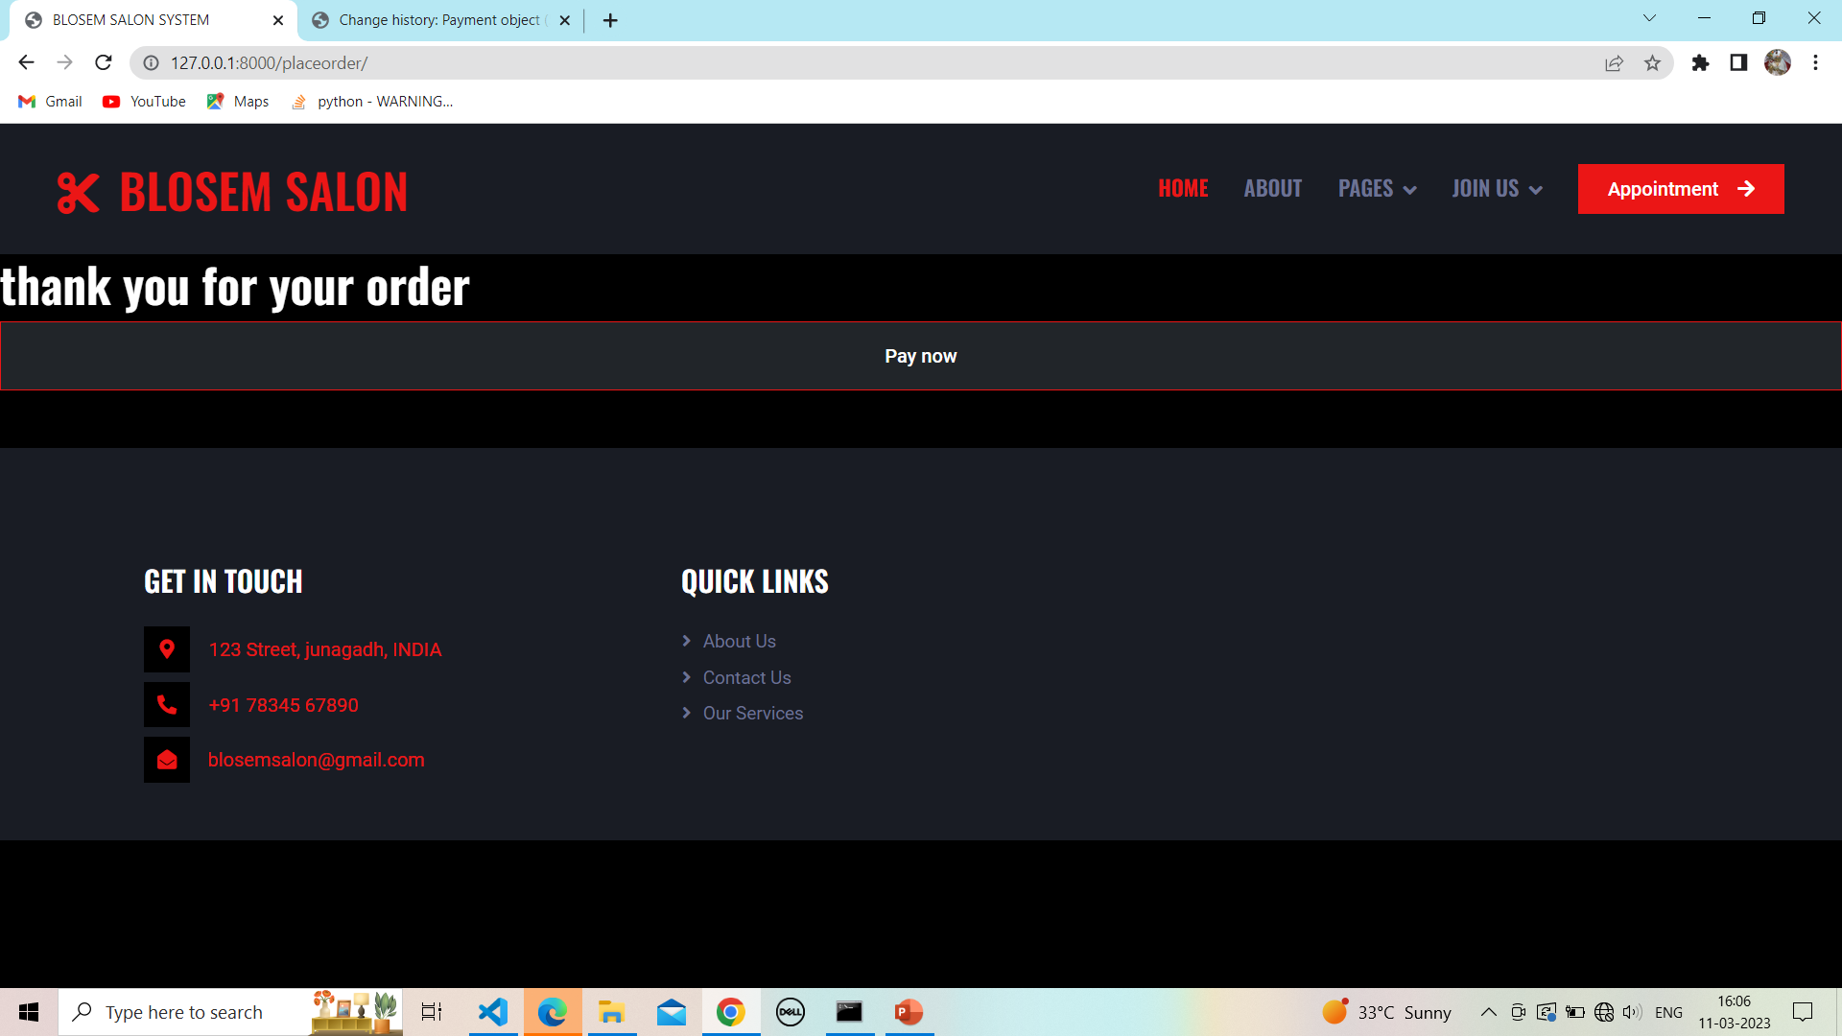

**30. Payment form:**



**31.Review form:**

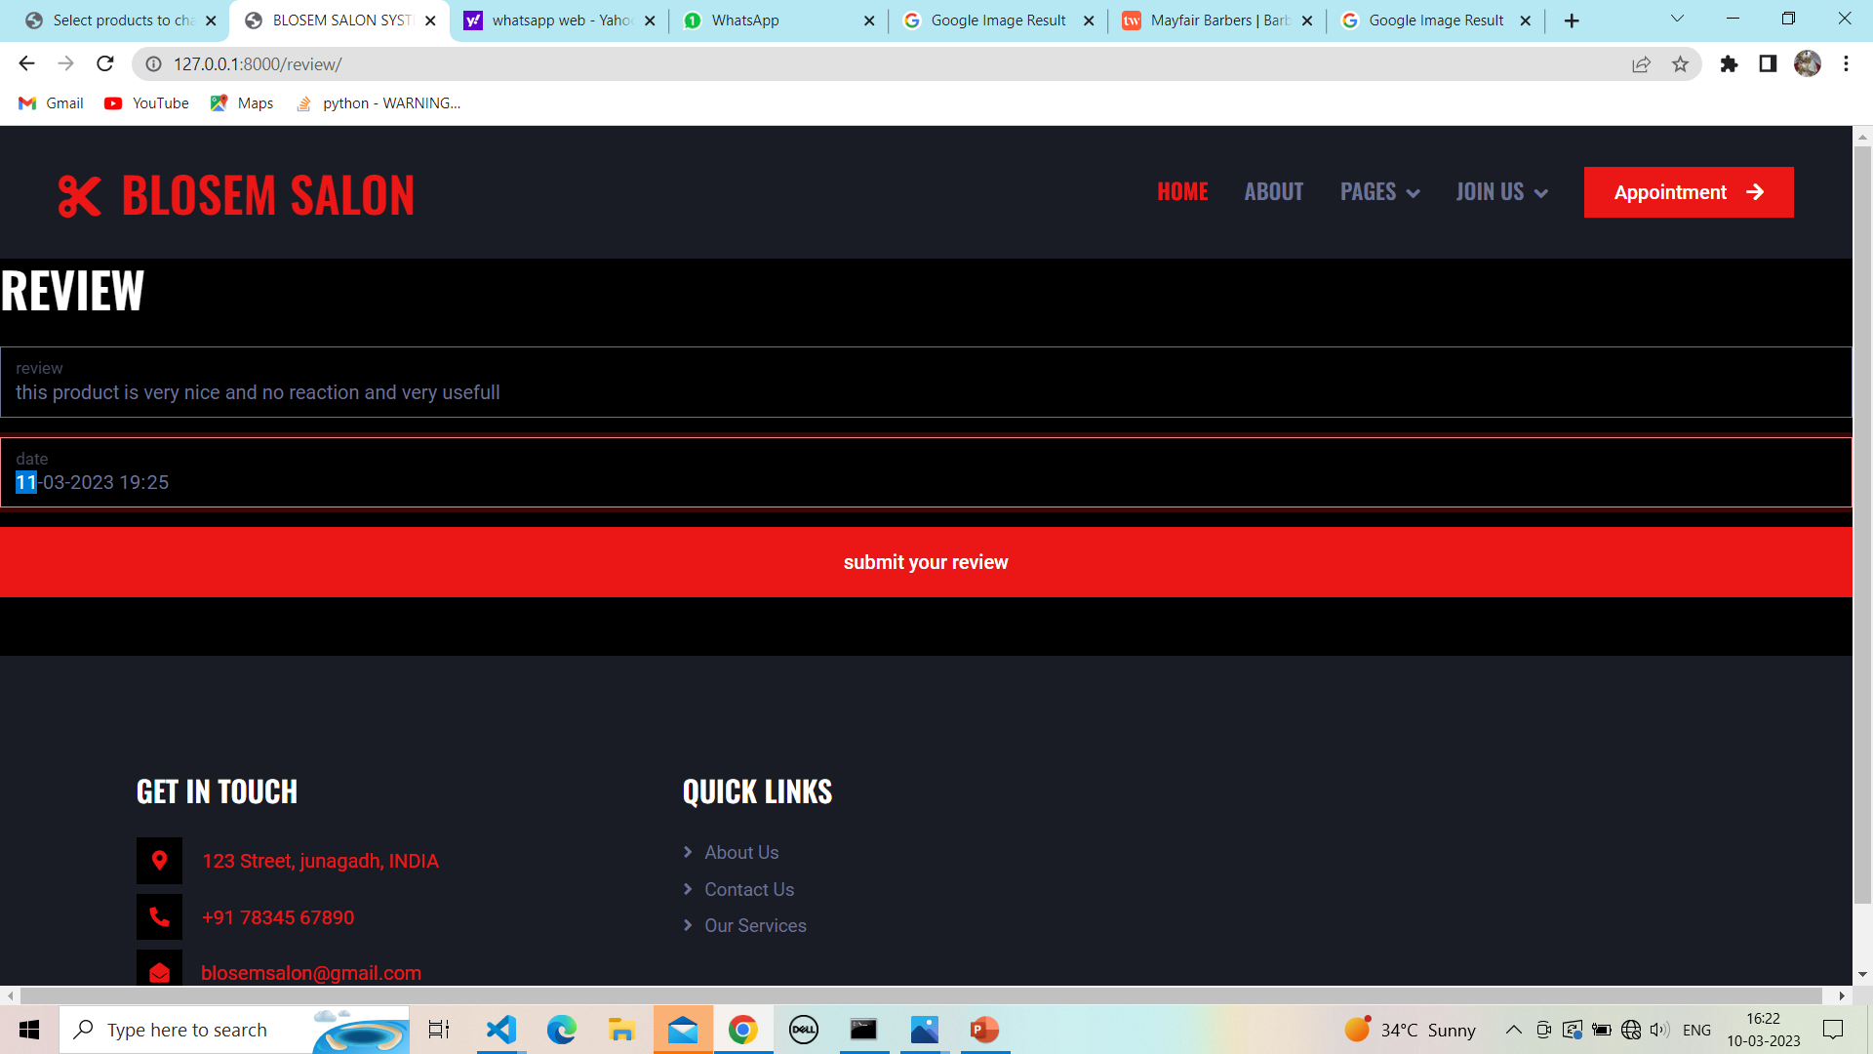

**31.1 Show review:**

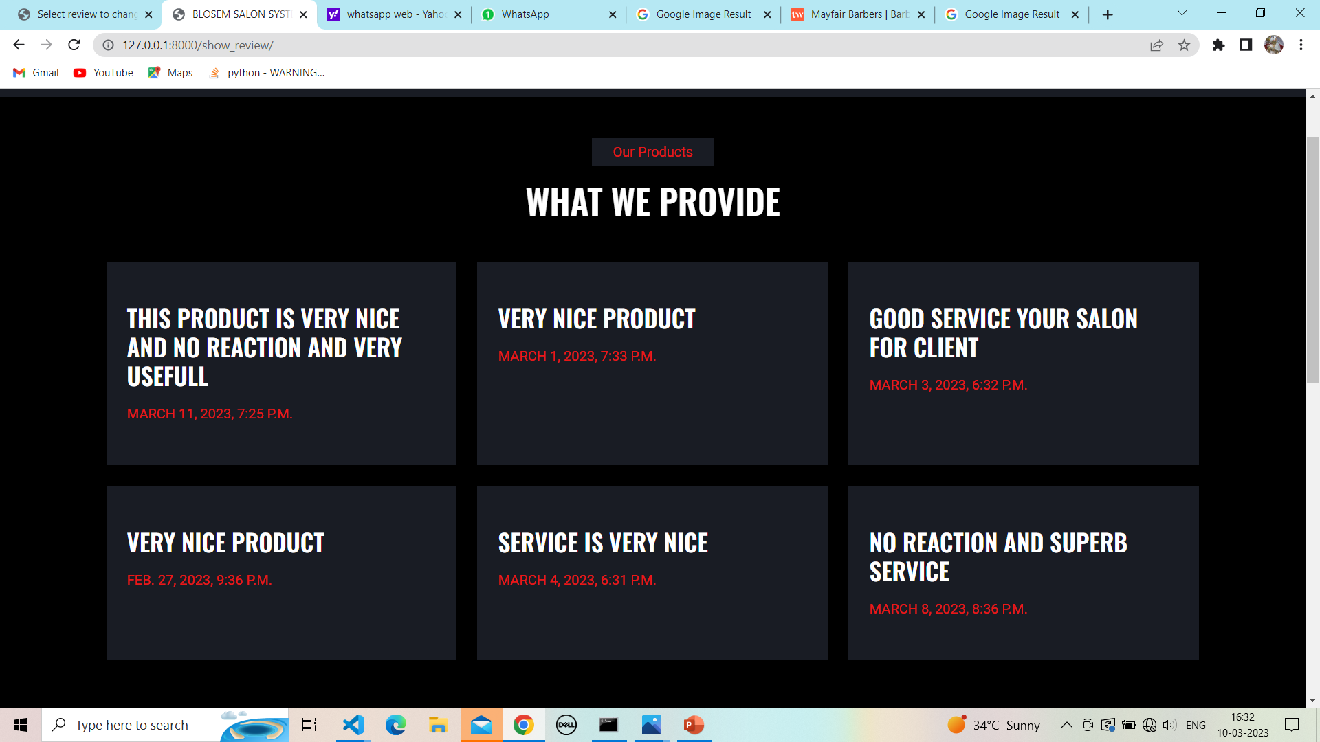

**32.Logout for site:**

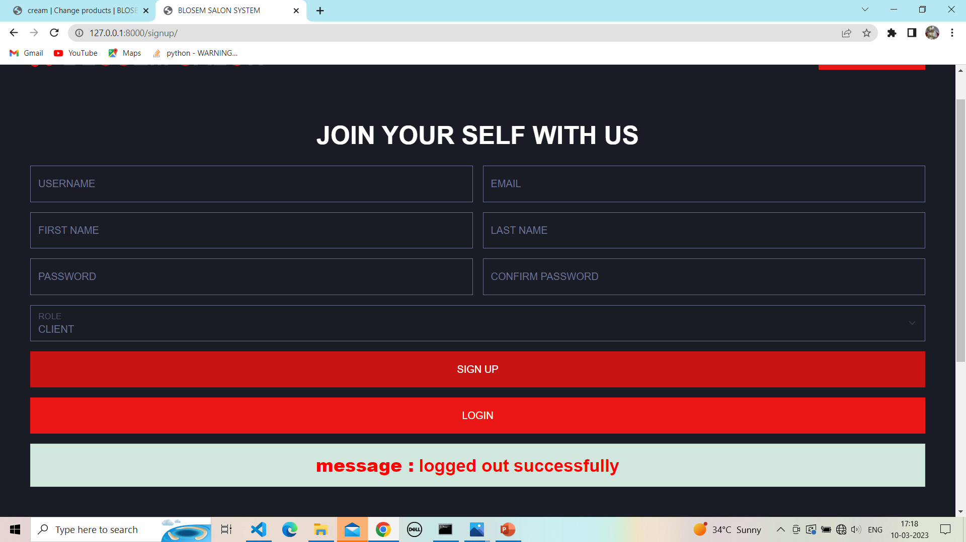

**Thank you**